**TourInf, a Tourist Information Application for a Mobile Device using the Android Operating System**

Final Report for CS39440 Major Project

*Author*: Adam Rigby ([ayr9@aber.ac.uk](mailto:ayr9@aber.ac.uk))

*Supervisor*: Rhys Parry (rrp@aber.ac.uk)

26th April 2012

Version 1.0 (Release)

This report is submitted as partial fulfilment of a BSc degree in  
Computer Science (G401)

Department of Computer Science

Aberystwyth University

Aberystwyth

Ceredigion

SY23 3DB

Wales, UK

**Declaration of originality**

In signing below, I confirm that:

* This submission is my own work, except where clearly indicated.
* I understand that there are severe penalties for plagiarism and other unfair practice, which can lead to loss of marks or even the withholding of a degree.
* I have read the sections on unfair practice in the Students’ Examinations Handbook and the relevant sections of the current Student Handbook of the Department of Computer Science.
* I understand and agree to abide by the University’s regulations governing these issues.

Signature ……………………………………………. (Adam Rigby)

Date …………………………………………………

**Consent to share this work**

In signing below, I hereby agree to this dissertation being made available to other students and academic staff of the Aberystwyth Computer Science Department.

Signature ……………………………………………. (Adam Rigby)

Date …………………………………………………

**Acknowledgements**

I am grateful to my mother Dawn Rigby for her continual support, guidance and backing throughout my University Degree, my uncle Mark Chetwood for his wisdom and inspiration, my grandparents for their motivation and great desire for me to succeed, my second parents Jamie and Lisa Parton, whom without I would never have got so far, my best friends Dan Parton and Greg Norton, all of my university friends with special mention to Adam Connah, Sebastian Graham, Andrei Stanica and Asa Carrington, and last but not least my girlfriend Sarah Evans.

I’d like to thank all the staff at Aberystwyth University, in particular Rhys Parry my final year supervisor and the numerous lecturers and support staff who have helped me acquire a fantastic education from my years in Aberystwyth.

I would like to dedicate this piece of work to my late father Robert John Rigby who is so deeply missed but shall never be forgotten. He made me into the man I am today and I hope he would be proud of my achievements and this particular piece of work.

**Abstract**

Tourist Information Centre visitor numbers in the UK are in decline. The public is increasingly using technology and other sources of information such as the Internet as primary sources of data to obtain the information provided by these centres. The use of mobile devices such as smart phones and tablet computers has greatly increased in recent years. People are now using and relying on these devices to organise parts of their lives and provide more and more information to them as quickly as possible. Users of mobile devices are now using ‘apps’, mobile applications, to do or help complete their day to day tasks.

This project was created to support this information shift and develop a mobile app that could provide Tourist Information Centre and point of interest data wirelessly to users on their mobile devices. The TourInf application created allows mobile users and tourists to quickly and easily find places of interest within their vicinity and further afield. Users of the application can use it on the move within a town or city to find areas of interest or they can research destinations and their establishments before travel.

Once a user has found a place of interest from selecting a category they are able to find out extra details about their area of interest, view its location on a map, get directions to the establishment, place a call or even view their website if applicable. The aim of the project was to achieve this functionality whilst keeping the application easy and quick to use, using a simple graphical user interface to achieve a user centred design. The application created has achieved its objectives with an app being created that offers the desired functionality with no negative impact on usability.

**Contents**

1. Background & Objectives 7

1.1. Project Overview 7

1.2. About the App and Related Works 7

1.3. Reasons behind choosing the project 8

1.4. Project Goals 8

1.5. Related Works 9

2. Development Process 13

2.1. Introduction 13

2.2. Modifications 13

2.3. Platforms Considered for Development 13

2.4. Tools 14

2.4.1. Development Environment 14

2.4.2. GitHub 15

2.4.3. Object Aid Class Diagram Plugin 16

2.4.4. Testdroid Automated Testing Recorder and Testdroid Cloud 16

3. Design 17

3.1. Overall Architecture 17

3.2. Initial Design 17

3.3. Android Application Concepts and Components 19

3.4. Detailed Design 20

3.4.1. Activity and Class Descriptions 20

3.5. User Interface Design 22

4. Implementation 29

4.1. Introduction 29

4.2. GPS 29

4.3. Graphical User Interface 29

4.4. Mapping 30

4.5. Google Places 31

4.6. Integration of Components 32

4.7. Extra Features 35

5. Testing 39

5.1. Overall Approach to Testing 39

5.2. Hardware 39

5.3. Android Unit Tests 39

5.4. Manual User Interface Testing 40

5.5. Automatic User Interface Testing 40

5.6. User Testing 41

6. Evaluation 43

6.1. Requirements Identified 43

6.2. Design Decisions 43

6.2.1. System Design 43

6.2.2. User Interface Design 43

6.3. Suitability of Tools 44

6.4. User Needs and Expectations 44

6.5. Changes in Approach 45

6.6. Extra Features and Improvements 45

6.7. Final Thoughts 47

Appendices 49

A. Original Project Planning 49

A.1. Original project planning details table 49

A.2. Original Project Gantt Chart 51

A.3. TourInf Application Functional Requirements 52

B. TourInf Application Class Diagram 53

C. Original Graphical User Interface Design 54

D. Third-Party Code and Libraries 55

D.1. Third party code 55

D.2. Libraries 55

E. Testing 56

E.1. Unit Testing 56

E.2. Manual User Interface Testing 58

E.3. Automated Testing 60

E.3.1. Testdroid Recorder 60

E.3.2. Testdroid Cloud 61

E.3.2.1. Results of Test Recorder tests being run in the Testdroid cloud 61

E.3.2.2. Testdroid cloud App Crawler Results 63

E.4. User Testing 64

E.4.1. Questionnaire 64

E.4.2. Questionnaire Results 65

Annotated Bibliography 67

# Background & Objectives

## Project Overview

For this project a Tourist Information application has been created to run on a mobile device that uses the Android operating system. The app (application) that that’s been developed makes use of several modern technologies to ensure it’s up to date with the current technology market. It has been designed with both present and future trends in mind and for use on smart phone and tablet computers. It uses a graphical user interface most suitable for the latest touch screen devices. The app makes great use of internet access that should be made available to it through these devices to provide the necessary information. It makes connections to the Internet to send requests for data and receive the relevant information back, such as tourist information data and any maps, directions etc. The app uses the Global Positioning System (GPS) or a mobile service providers networked towers to help find a users approximate location which then enables it to find tourist attractions and points of interest nearby.

After being launched the first thing the app does is gain the location of the user using the above methods, once this has been obtained or after they have entered a destination manually, the app sends a request using the Google Places API [1] and the response is used to create listings of tourist information for any category that the user selects to find out further information about e.g. Restaurants, Bars etc. Once these basic listings of place names have been produced on screen the user is then able to select a listing which will present the user with more detailed information on the organisation or place in question e.g. address and phone number. The user is also given more advanced options on the detailed listing so that they can see the destination on a map, get directions and call or view a listings website if applicable. For the mapping elements of the project the Google Maps for Android API [2] has been used in order to obtain the relevant information.

## About the App and Related Works

The app that has been created needed to be extremely easy to use for any type of user, for those who are very competent with technology and also those that are new to using apps and advanced touch screen devices. The user interfaces of other applications on the market which offer similar features and services (nearby locations, details, and maps) frequently look difficult and confusing to use, whilst others are often dull and uninteresting to use (further information about related works can be found in Section 1.5). Consequently the app needed to have a very simple and intuitive GUI for people to use as well as being attractive and appealing to the user.

After starting work and research on the project it became apparent that it was important that the app offered as broad a range of tourist and general information as possible. To ensure this was available the app needed to have an extensive amount of categories to select from. The aim of this was to try and create an ‘all in one’ application that held both tourist and point of interest information that is useful and useable for all users. The common problem found with existing apps is that some target tourist information whilst others target the local area. It appears that no one has tried to target both audiences at once. The aim of the application is to allow users to be able to use the app and its features straight away without needing instructions. It should enable users to find any place information they require within an area quickly in a few virtual clicks. The user shouldn’t have to learn how to use the application or type a large amount text to get the information they require.

## Reasons behind choosing the project

Firstly, the topic of the project was found very interesting to the developer. The amount of tourist information centre visitors has decreased quite significantly in recent years [3]. It is thought that consumers are now using other sources of information to obtain the data they once found at these centres due to advances in technology. These advances allow us to be able to access this type of data at any time of the day, as frequently as required and wirelessly through mobile devices over the internet, making it much more convenient for the user. This advancement has created a whole new digital market for this type of information. Many companies are now starting to compete in this market in order to try and establish themselves as the market leader.

The project was of great interest due to it involving the use of mobile devices and the most up-to-date technology. The developer of the project had always been interested in the latest technologies and had frequently saved up money to buy the latest gadgets and devices available on the technology market. They are a large fan of smart phones in particular. The idea of programming for such a device appealed greatly as it is an expanding technology and something that many people use extensively every day for an increasing number of activities.

This project was also chosen as it would be very challenging to complete. The developer of the project had never previously written an application for a mobile device. In order to complete this project a number of skills required would needed to be learnt from scratch. Writing software for a mobile device is quite dissimilar to writing for other platforms and extra details would need to be taken into consideration when designing and developing the application. To complete the project new software would need to be used and learnt to develop the application. Incorporating all the different features and technologies into one easy to use piece of software would be extremely challenging. An equally large challenge to writing the code would be creating a first-class user friendly interface as it is of great importance to the app and the developer did not have much experience in creating user interfaces, let alone ones for touch screen mobile devices.

The application was seen as a new and exciting challenge and therefore extremely worthwhile. The project would extend the knowledge of the software developer in all aspects of Computer Science and what they have learnt throughout their university course. The project would improve their programming skills and build on things that had been learnt from a human computer interaction module that they had completed. Furthermore it gave them an opportunity to use the project management skills they had learned throughout their course and on an industrial placement to ensure that the project was completed successfully and on time.

## Project Goals

To evaluate the success of the project the application will be measured against the core goals set out for the project. The core goals are as follows:

* The app should be simple and easy to use for the user by having a simple icon based, touch screen focused user interface.
* To have an extensive list of categories for users to choose from and find information about.
* For it to produce accurate lists of data and information linked to these categories.
* To fully incorporate the more advanced features into the app such as Mapping and Directions whilst ensuring usability.

Desirable additions to these project goals were set out and would be attempted to be achieved if the above goals were met and time was still available to complete them. These would include extra features such as the ability to display ratings/reviews of establishments listed to give users feedback on destinations. Another such feature would be the ability to display images of places listed in the app so that users could view photos of establishments when they are going through listings and trying to decide on a destination. This would be another pleasant addition and would make the app more visually appealing to users.

## Related Works

As must be expected with most software projects, there are similar competing applications already on the market, especially as the Google Play store alone holds over half a million applications [4]. Research was undertaken to look at similar applications on the market in detail, studying them in the Google Play store and downloading a select few onto a device to look at in more detail. An example of a tourist app for a singular city is the Manchester Tourist Guide by Jonaldo[5]:

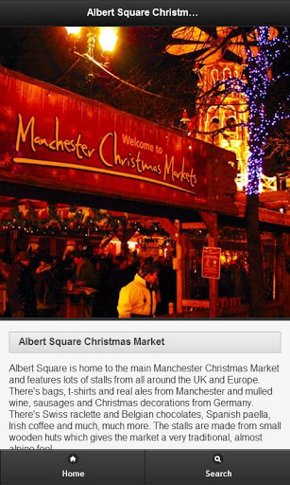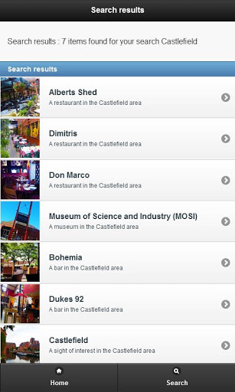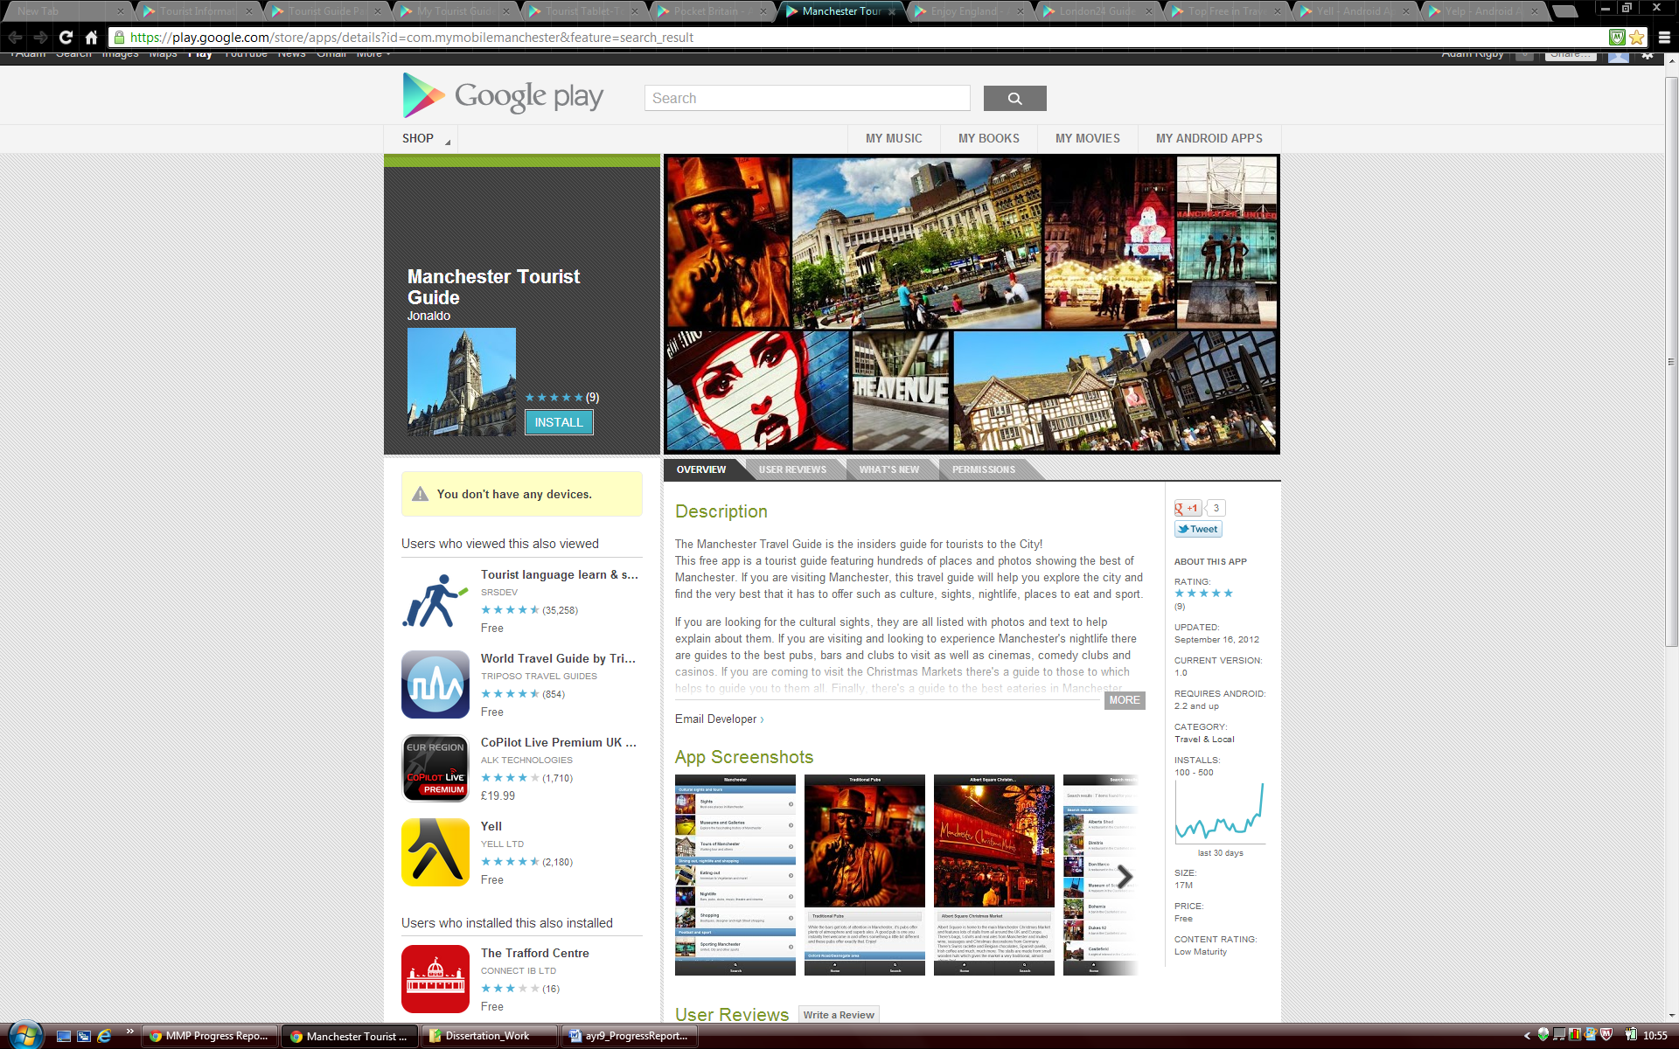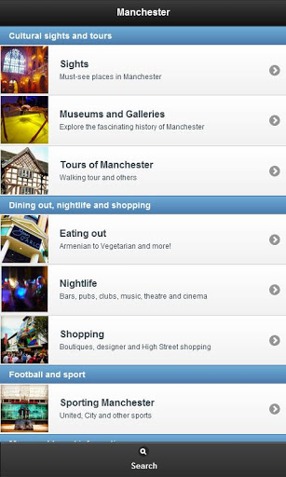

Figure 1.1: Screenshots of the Manchester Tourist Guide App’s icon and user interface.

After downloading and looking at this application it became apparent that it is quite a nice app for people to use. It uses a different graphical user interface design to what has been developed for this project in the tourist information app. The application uses what is known as a list view in Android development for its main menu which has been modified to include pictures. This is a good way to display information, however it can take up a lot of screen space when compared to using the other methods such as a grid view. For the main menu of the application that appears, it was therefore decided that a list view shouldn’t be used as it is likely to take a user longer to find the information that they want. This is because they may need to read more information and scroll further down the screen to obtain information when compared to something like an icon based application. On the other hand, for other parts of the application where more textual information needs to be displayed, it is appropriate to use a list view.

One benefit of this particular application is the depth of information it has on destinations and establishments. For each place listed it has a large description and a detailed photo. It would have been nice to replicate both of these features in the TourInf application. However, unfortunately a web service with this detailed information could not be found and used in the project within the allotted time period. As the TourInf application developed aimed to cover the whole of the UK and not just one city it would not have been possible to create and provide this information for thousands of major locations. The Manchester Tourist Guide app also has some great features/options for the user to select from such as ‘directions’, ‘view website’ and to call a particular listing. These are all features that were chosen to be included in the TourInf application created.

Pocket Britain [6] is another application that has been researched. Unlike the Manchester Tourist Guide this particular application does provide information for the whole of Great Britain. It is also dissimilar to the application above in terms of appearance.

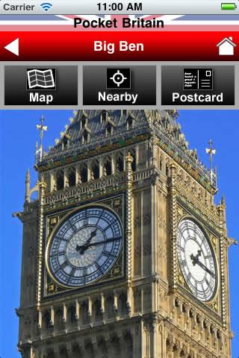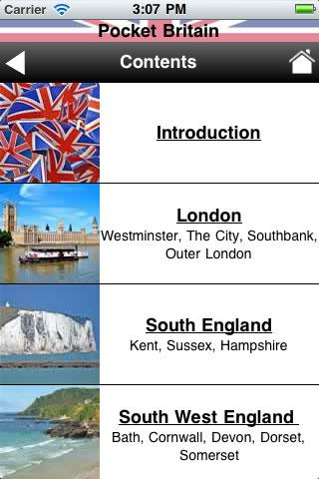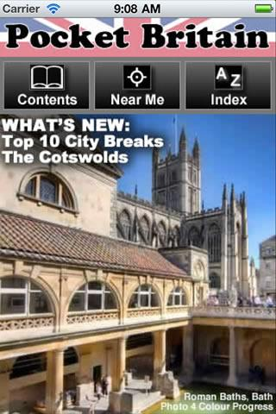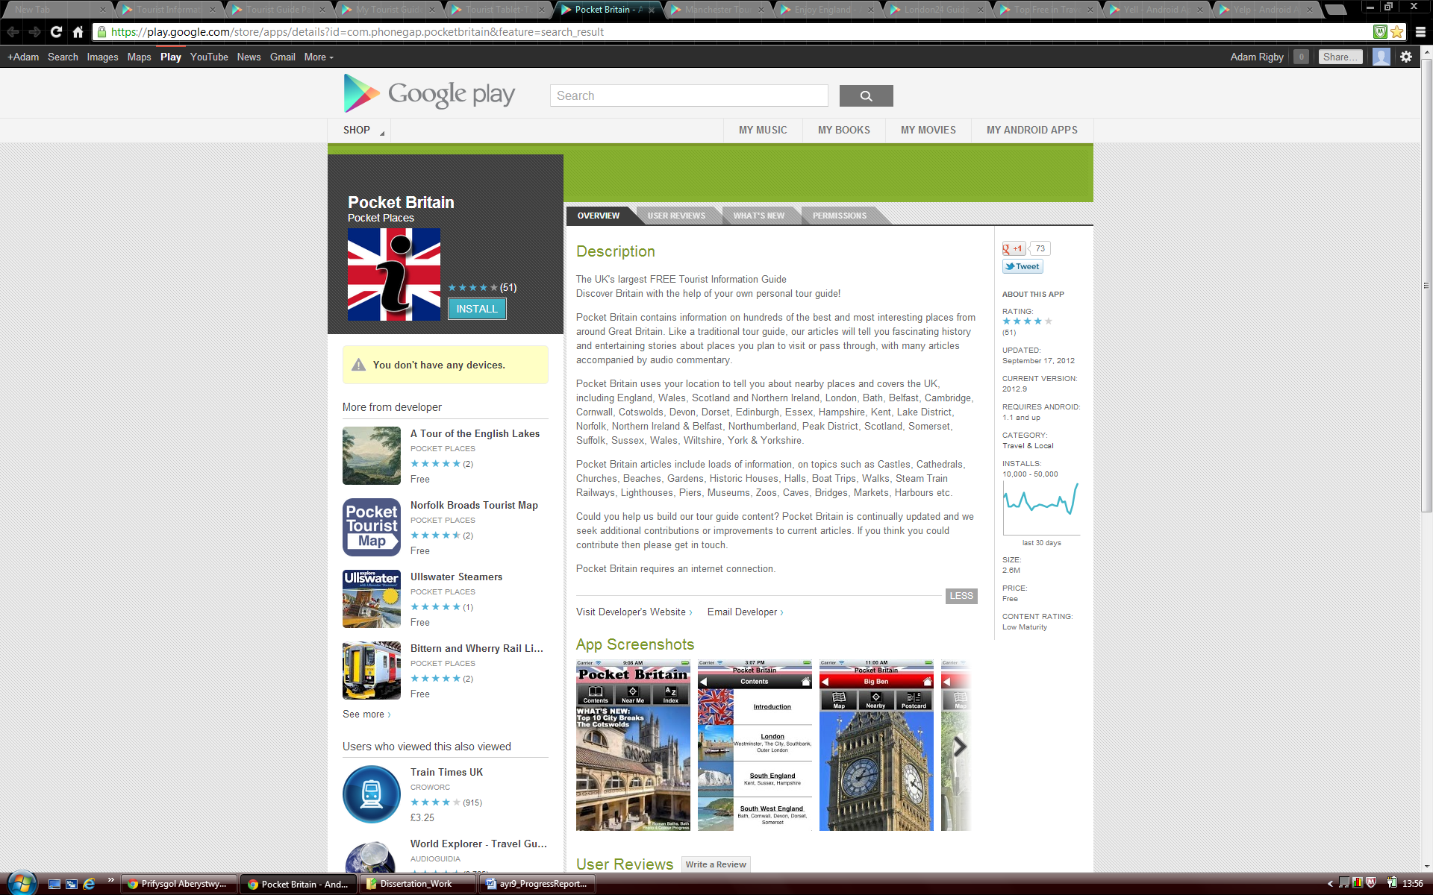

Figure 1.2: Screenshots of the Pocket Britain App’s icon and user interface.

From when this application was first downloaded the impression was that the Pocket Britain app appeared to look rather unprofessional and not well presented. First impressions can quite often count with such apps and it was thought that users would not be likely to want to continue using this application because of its appearance and poorly laid out graphical user interface. Due to the user interface the application was difficult to use and it took quite a long time to find the destination or specific place you were looking for.

However, the content of information provided is fantastic. This will appeal to some users who want in depth knowledge of an area but not others who just want an overview of their surroundings. The app also seemed to concentrate on historical buildings and museums. Whilst this is not a bad thing it is likely that most people will also be interested in finding amenities and other attractions in the local area.

This particular app has a ‘nearby’ feature which lists other towns and cities in the local area to where you are situated or a place that you have selected. You can then look at the tourist attractions linked to that place. This is a good feature and it would have been nice to include a similar feature in the TourInf application if the allocated time for the project had been longer. The app offers the user a Google Map of the listing they wish to see with street view enabled which is a nice touch, although unfortunately directions to the destination from your existing location is not supported unlike the TourInf app.

The two applications that have been reviewed and assessed above were found from doing a search for ‘Tourist Information’ in the Google Play Store. However, this research has shown that the TourInf app that has been created is more of a hybrid application mixing aspects of these apps with those found in local area guides and business listing apps. After a lot of searching the ‘Top Free in Travel & Local’ section of the Google Play Store was found and visited, and the Yell application was discovered [7].

This type of application is closer in style to what was envisaged and created with regards to this project. The Yell app uses a simple icon based structure in its main menu, similar to the one that has been implemented in the TourInf application and produces listings and listing details in a well organised and easy to use manner. However, there are a few drawbacks with the application. One is the icons on the home screen are very large and with only three per row which means you have to scroll down to find categories despite using an icon based interface. Another is that perhaps the application could be called plain with basic icons and minimal colour used in the application. Although on the other hand, this is also an advantage as it makes everything easy to read and understand.

When downloading the app on to devices a further major disadvantage was noticed. The tablet version of the application is drastically different to the smart phone version and doesn’t function as well or as professionally. This is a major usability issue due to its inconsistency. It is likely that it would be very confusing for users to operate the application if they have used one version then try and use the other. This could be quite likely as more and more people are starting to own both phone and tablet devices. In addition smart phones users may be impressed with the app and rate it highly whilst tablets users are likely to be disappointed with the app and not recommend its use.

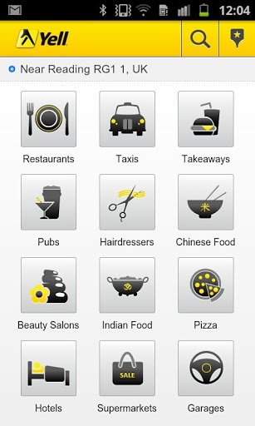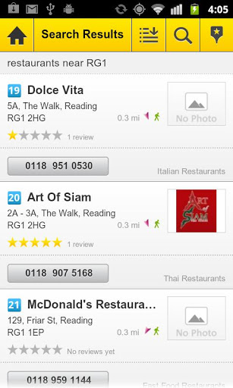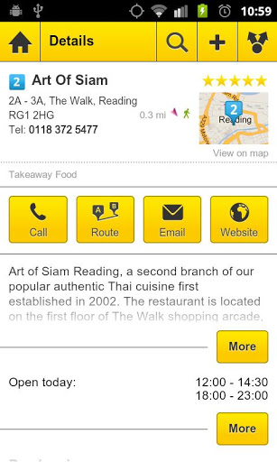

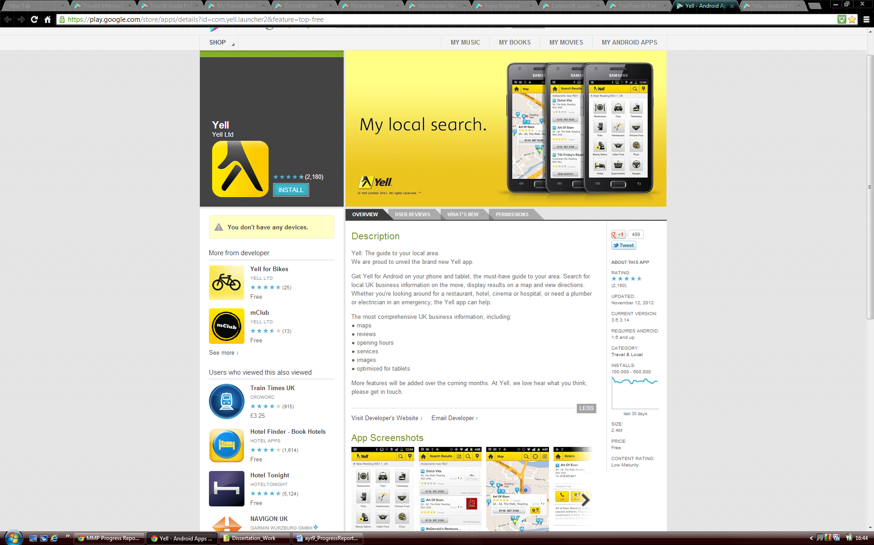

Figure 1.3: Screenshots of the Yell App’s icon and user interface.

The need for consistency across devices became apparent after seeing this example and this had to be taken into account when building and implementing the TourInf application. The app needed to cater for both phones and tablets and should compensate for all screen sizes. The app should offer the same functionality and behaviour across these devices. Unfortunately on the Android operating system the information that is displayed on screen does not automatically shrink to suit the device it’s being displayed on. This had to be remembered when designing and developing the application to make sure the applications user interface displayed correctly across devices.

Due to this research being completed a great deal was learnt about other applications available for mobile devices, their benefits and drawbacks and how they could be improved upon. This research also helped greatly when trying to understand the requirements and aims for the application that needed to be built. It also highlighted that the appearance, usability, user interface and compatibility are key elements and issues when developing a mobile app and ensured that these findings were taken into consideration throughout the project.

# Development Process

## Introduction

Originally the Waterfall Model was selected to be used as the methodology for this project. This model was chosen as it was felt that it best met the requirements of the application for the project. Agile Methodologies had been learnt by the developer in a module within university and it would have been nice to have used some of these methodologies within the project as they are methods that were only recently introduced to the developer who agrees with most of its principles. However, after analysis it became clear that these methods couldn’t be used for this piece of development as its core components couldn’t be practiced enough to make good use of the methodology. For example components such as customer collaboration and pair programming from the model could not to be used effectively.

The major project that has been completed when compared to software projects in industry is relatively small and it relies upon just one person as an individual for it to be completed, not a team of developers. For this reason the Waterfall model seemed the most appropriate model to use for the project as it keeps things relatively simple and gives a disciplined process to follow. Often other methodologies such as Agile and Spiral are more suited to larger tasks and being used in multiple team environments where projects are usually more complex. The requirements for this project should have been stable throughout meaning that the flexibility and ability to change that comes from using Agile Methodologies wasn’t particularly needed.

Due to the Waterfall model being chosen for the project, the original planning that was completed relates to this method being used and took the relevant stages into consideration (please see Appendix A.1). To demonstrate the original planned week by week planning of the project graphically a Gantt chart was created with milestones for project deliverables (please see Appendix A.2).

## Modifications

Once the project began a decision was made to change the planned choice of methodology from the Waterfall Model to a Prototype based model. This decision was taken due to the demands of the project that were only realised once project research had been fully completed. Having no experience of developing a mobile application for Android before meant that being able to produce a reasonably accurate design and test specification before starting the implementation would not have been particularly realistic. Once the basis of the application had been created from making prototypes in the implementation part of the project, the Feature Driven Development Agile Method was also loosely used to develop the remaining and extra features of the app. This was used as the items that were left remaining and needed to be implemented after the basic application had been created were all features and therefore is was much easier to break up the tasks required using this method.

## Platforms Considered for Development

When you have decided that you wish to create an application for a Mobile Device you have a number of different operating systems you can choose to develop for. Currently the most used operating systems on mobile devices that are also the most popular with mobile application development are iOS, Android, and Windows Phone. The iOS and Android operating systems are however the two dominant forces in the mobile device operating system market [8]. Due to their large share of the market (72.4% of the mobile device market use Android and 13.9% iOS) it was decided that only developing an app for one of these two operating systems would be considered and evaluated. This is because the app that was to be written needed to have the largest possibility of being used and exposed by the largest audience possible if at a later date it could be considered for release on an app store and sold. By releasing an app on one of the two largest platforms it is more likely to gain popularity and gain more money from any fees and advertisements. As a developer you do not want to spend a large amount of time producing an app for an operating system that doesn’t have a following or a large amount of users.

Ultimately it was decided that the application would be developed for the Android operating system. This decision was made for a number of reasons. Firstly, the hardware requirements for iOS development state that you must use/have a Mac with an Intel processor. In addition iOS apps can only be developed on the Mac OS X operating system [9]. There are different ways in which you can navigate around these problems such as creating a ‘Hackintosh’ to run Mac OS X on a non-apple PC using an emulator or running the operating system in a virtual machine [10]. However, if it is avoidable you do not want to do this as these methods are in most cases illegal and can often have many problems in operating correctly. As the developer for the application is a Windows user it wasn’t viable to spend a large amount of money buying a new computer specifically to complete this project.

The other major problem with writing the TourInf app for the iOS operating system was that for iOS 6 Apple decided to drop using Google Maps and start using their own mapping solution. It has been greatly publicised in the news how Apple’s new maps app launch has been very unsuccessful with the maps not working correctly and having features and destinations missing [11]. After the issues had been discovered users of Apple products weren’t sure if Apple would continue to use the new maps service or revert back to using Google Maps. At this moment in time it appears Apple are determined to carry on offering their own service although Google have now created a map app for Apple devices that was rumoured to be being made when research for the project started . With these mapping problems arising at the same time as the start of this project and with the need to use a stable mapping service for features of the tourist information app, it was more logical to develop for the Android platform. Android is owned by Google and therefore the platform is very unlikely to move away from using its owners mapping services and APIs, this decision resulted in reducing the risk of creating the mapping features of the project unsuccessfully.

The belief is that Android is the best operating system that the TourInf app could have been developed for on a Mobile Device. It is currently the most popular and used operating system on mobile devices [8] and it also allowed development to be completed on hardware that was already owned. But most importantly it has the correct services and development APIs that have allowed the TourInf application to be created successfully. Furthermore when writing for Android the programming language used is Java. Whilst learning new programming languages is very beneficial and interesting, extending knowledge and skills in the Java language that has been used throughout university is also be extremely useful.

## Tools

### Development Environment

To start writing software for Android mobile devices it is a good idea to work in an integrated development environment (IDE) due to the advanced structure of such applications. This is because Android applications are constructed from much more than just Java source files. Before development started research was undertaken into finding tools and environments you can use to help create an application for the Android platform. The options that were discovered and evaluated were the NetBeans IDE used with a plugin that can be found on the Kenai web site [13], the IntelliJ IDEA IDE [14] and finally the Eclipse IDE with the Android Development Tools (ADT) plugin [15].

After evaluation the Eclipse environment was chosen to be used for the project for a variety of reasons. One such reason is that the developer had mostly used Eclipse for development projects previously and was accustomed and familiar with using the main parts of the program. Net Beans had only been used briefly for one assignment and it was concluded that the Eclipse IDE was preferred due to its layout and ease of use. The IntelliJ IDEA IDE had only been discovered in this research and had not been heard of or used previously as it doesn’t appear it is commonly used. It was much more appealing to use a tried and tested product such as Eclipse. Additionally, the most important reason behind this choice was the fact that the development section of the official Android developers’ site highly recommends using the Eclipse IDE a long with the ADT plugin. The site also helps you install and setup the appropriate environment with some useful tutorials [16]. From browsing the web and researching this topic it also became clear that this IDE was the most popular with many other Android developers which helped assure that this was a good choice. In order to meet the software requirements for the ADT program the newest version of Eclipse had to be installed. Once this was completed the Android SDK and ADT plugin for Eclipse could then be downloaded and installed. After this had been setup and configured the development work for the application and project could start.

To start developing and getting a feel for Android development the ‘Building Your First App’ tutorial was followed and completed. This can be found in the training section of the Android Developer’s site [17]. This was a very trivial exercise, and it basically involved creating a new ‘Hello World’ project. However, it did introduce the developer to the Android toolkit, the structure and layout of what Android apps should look like, and how they start to be created. To build on this initial knowledge several of the Computer Science department’s Android programming sessions were attended at University where worksheets were completed [18]. From these sessions a lot more was learnt about the make-up of an Android application and how they are built and modified to make basic Android programs. Those worksheets were really useful in extending initial knowledge of writing software for Android. Working on these worksheets definitely helped when coding of the real project started as a good basic understanding of how to develop for the Android platform had already been learnt.

### GitHub

GitHub [19] is an online project hosting service that is often used for software development projects. GitHub is a well used source control system in this field and has many great features. GitHub was used on this project for a number of reasons. One key reason is that the service that they offer allows you to easily setup and create a

repository online which is very easy to access. GitHub also offers a GitHub for Windows application client. This is a great piece of software and was very useful as a project tool as you can simply drag and drop files into the application which then allows you to quickly commit and synchronise your work and any changes you have made before uploading the files online. The GitHub service and Windows application are also available for free as long as the code is made public and open source which was not objected.

### Object Aid Class Diagram Plugin

Complicated diagrams such as a large class diagram for an application such as the TourInf app can be difficult to create and also very time consuming. Often if these diagrams are created manually they are not well presented and can be confusing to look at. For this reason tools to automatically generate a class diagram from source code were researched. The Object Aid tool [20] was used as it seemed the most appropriate. It offered the correct functionality and was easily downloaded and installed into the Eclipse IDE as a plugin**.**

### Testdroid Automated Testing Recorder and Testdroid Cloud

In order to test the application thoroughly it was decided that on top of usual testing methods used an automatic user interface testing tool would also be used. Research was completed on the Internet about what tools were available to do this and several tools were found and evaluated. In the end the Testdroid tool [21] was chosen to be used as it best met the features wanted from an automated testing tool. More details about automated testing and why this tool was chosen over its competitors can be found in Section 5.5.

# Design

## Overall Architecture

After deciding a set of project objectives, aims and goals and creating a list of functional requirements (which can be seen in Appendix A.3), the design for the system could start to be considered. What became apparent was that there were essentially four major building blocks that needed to be built (Prototypes) and integrated together in order to create a full working system with the desired output. One of the major building blocks of the application is the user interface which is inherently important for the TourInf application for usability and ease of use. It has to let users navigate between the different screens of the app simplistically and allow easy access to its functionality. Another one of these blocks is the part of the application that uses the Google Places API as a web service to request and receive the place data information that is to be displayed within the application.

The mapping elements of the software is another major section of the application that are used to display and mark locations of the places returned from the web service on an interactive and fully detailed map. This component of the app will also let the user obtain directions to any of the places that they have chosen as a destination from their current location. Finally the last key part of the application is the modules that take care of the GPS and Internet connection. This element of the application is extremely important as without these classes performing correctly the rest of the application would not be able to function either at all or accurately as required due to the other parts of the application being dependant on the use of these classes to operate.

## Initial Design

In order to start creating a design for the application to be developed, a use case diagram was made. The use case diagram that can be seen below in figure 3.1 shows all the actions that the user should be able to perform in the application.

Show all places on a Map

Show place on map

User

Get Directions

View Website

Use Current Location

Enter Location

Select Category

Place List

Call Place

Figure 3.1: The use case diagram for the application.

After creating this simple diagram it became much clearer as to what work and features needed to be produced for the application and gave a good basis to start thinking about the design in a bit more detail. To understand how these actions could be incorporated in the application and how they would link together and operate another diagram was created. This further helped the understanding of the project and how it should be designed. Figure 3.2 below shows the diagram created. It holds a resemblance to a flow diagram and details the application flow from the home screen to the screens with more detailed features by using some of the actions listed in the use case diagram above.

Show on map - Action

Get Directions - Action

Go to website - Action

Call - Action

Home Screen - View

Main Menu - View

Use Current Location - Action

Enter Location - Action

Select Category - Action

Near Places - View

Select Place - Action

Show all place on a map - Action

Map (All) - View

Place Details - View

Map (Singular) - View

Map App - View

Browser - View

Phone call - View

Figure 3.2: A flow diagram to show the flow between different views/screens and what actions need to be instigated to navigate to other views offered.

At each level of the diagram, items are labelled as either a ‘view’ or an ‘action’ where a view needs to be a screen displayed by the application and ‘actions’ are the things that need to be performed in order to navigate between the different views/user interface screens. From this diagram the basic structure of the application had been established and allowed the design to continue developing. The diagram was very useful when designing the user interface and how it should function as discussed later in Section 3.4.

After getting this far with the project and doing the research stated in Section 1 of this report it became apparent that to create a design more appropriate to the application a different development process would need to be utilised as stated in Section 2.2.

## Android Application Concepts and Components

There are a number of terms that are given to various components of Android applications that are very important in development. For the project these components needed to be learnt about and understood for the design and implementation of the application.

The main components of Android applications are called Activities. ‘An activity represents a single screen with a user interface. For example, an email application might have one activity that shows a list of new emails, another activity to compose an email, and another activity for reading emails. Although the activities work together to form a cohesive user experience in the email application, each one is independent of the others. As such, a different application can start any one of these activities (if the email application allows it). For example, a camera application can start an activity in the email application that composes new mail that can then allow the user to share a picture.

An activity is implemented as a subclass of Activity in a java source code class’ [22]. An activity holds all the source code for a single screen and also obtains and uses an associated XML layout file to produce the user interface with the correct functionality.

Therefore, when we look at the previous diagram in Figure 3.2 everything that has been labelled as a view needs to have its own activity, very much similar to having a java class apart from it having additional properties that can be utilised to aid user interface communication and construction. To use components such as activities you often need to activate them by sending an asynchronous message called an intent.

‘Intents bind individual components to each other at runtime (you can think of them as the messengers that request an action from other components), whether the component belongs to your application or another. An intent is created with an Intent object, which defines a message to activate either a specific component or a specific type of component. For activities and services, an intent defines the action to perform (for example, to "view" or "send" something) and may specify the URI of the data to act on (among other things that the component being started might need to know). For example, an intent might convey a request for an activity to show an image or to open a web page. In some cases, you can start an activity to receive a result, in which case, the activity also returns the result in an Intent (for example, you can issue an intent to let the user pick a personal contact and have it returned to you—the return intent includes a URI pointing to the chosen contact)’[22].

Again when we look at figure 3.2 shown previously, the items that are labelled as ‘actions’ are in most cases the intents that are needed to activate the use of other components. An Android application must also have a manifest file present that is written in XML. This file must declare all components e.g. activities that are in an application and should also declare all application requirements for example the minimum version of Android required and any hardware configurations and permissions required [22].

Throughout Android projects non-code application resources (images, strings, layout files, etc.) are used via reference and are also extremely important. In the tree structure of an Android project is a directory named res (resources) where all these resources are stored in various folders. The layout files for an application are written in XML and are used by activities to display the correct user interface for the activity. These layout files are held in the layout directory within the ‘res’ folder. From these components being understood we can see that most applications being built on the Android platform will use an MVC framework. For example the XML layout files represent a view, the activities are the controllers and the model is represented by the services and data held within the application (a locally stored database or data retrieved from external sources). Therefore, this project will make use of the MVC architectural pattern as it will make use of the components described in this way.

Strings that are not declared programmatically in the application e.g. in the layout files to be displayed, are declared in a String.XML file which is within the values directory of the res folder. Lastly, images and other items to be displayed are stored in the various forms of drawable folders again held in the res directory. There are several of these folders as each folder is used for different screen resolutions, images should be sized appropriately for placement in each of these directories.

From learning and understanding all of these key Android concepts and how these types of applications are structured during implementation, a more detailed design could be completed.

## Detailed Design

In order to continue detailing and creating a more in depth design of the system a class diagram was created to show what activities/classes were needed to create the desired application with the required functionality. The class diagram for the application can be seen in Appendix B where all the activities that were used and required are shown with the relationships they have between each other along with the methods and variables that they have.

As the application has been written in Java the project has been developed with an object orientated approach. As briefly stated earlier, each view of the application outlined earlier (Section 3.2, Figure 3.2.) has its own activity, with additional classes being used to support these activities.

### Activity and Class Descriptions

**AlertDialogManager Class**

This class is used to display dialog boxes at various stages of the application when needed. They are usually used to display a message or warning when something is not present or not allowed e.g. if no places of the type selected can be found in the local area.

**AllPlacesMapActivity**

This activity creates a map using the new Google Maps for Android V2 API. The activity gets the complete list of places for a category that has been selected and sets a marker on the map where each of these places is located. Each marker is clickable so that the name and vicinity of the place selected can be seen. The location of the user can also be added to the map. To make sure the map is centred before being zoomed in, the average position of the markers is calculated.

**ConnectionDetector Class**

This class uses a system service in order for the application to be able to make a connection to the Internet. The state of the network is also checked to ensure that the connection has been successful and can be used by the application.

**GooglePlaces Class**

The GooglePlaces class connects to the Google Places API web service and makes a request for places depending on the parameters that its methods are given. The class then parses the results that it receives into the serializable classes of the application so that the information received can then be accessed, used and displayed by other classes of the application.

**GPSTracker**

The GPSTracker is a service component for the application. The service class implements Androids LocationListener class to receive notifications from the LocationManager when a devices location has changed. The service class checks what GPS and network providers are available for usage and then will use the most appropriate provider (GPS if enabled) to request location updates from them using its provided parameters to keep and update the location of the device. Methods to get current latitude and longitude values are provided so they can be used in other parts of the application where needed.

**ImageAdapter Class**

The main menu of the TourInf application uses what is called a grid layout which is defined in its classes associated layout file. However, for the main menu to display the images and text correctly in the grid a custom adapter needed to be written. This class uses an additional layout file to create an individual tile for each image and its associated text to be put into. These individual tiles are then put inside the grid view, another layout file, to be displayed. The size of these individual tiles have been optimised so that the main menu that it helps create can be displayed correctly on multiple screen sizes.

**MainActivity**

The MainActivity class essentially creates the application home screen that you see when the application launches. It forwards the user on to the main menu a long with any location that has been entered manually by the user for the application to use.

**MainMenu Activity**

As suggested by its name this activity displays the main menu to the user by making use of the ImageAdapter class described above. The activity contains a HashMap of key value pairs where an int grid position of the image is associated to a Google place type. Once an icon has been clicked this place type is forwarded to the MainPlacesActivity class for it to make a places request. If a manual location was entered previously, this is again forwarded to the same class for the request to be made.

**MainPlacesActivity**

The main places activity is one of the major components of the application. It makes calls to the ConnectionDetector, GPSTracker, and GooglePlaces classes in order to produce a list of places for the type selected by the user. The list is displayed on screen and when one of the places is selected the reference to get the further details of that particular place is forwarded on in an intent to the SinglePlaceActivity to get more details about the place selected.

**MapActivity**

Similarly to the AllPlacesMapActivity this activity creates a map using the new Google Maps for Android V2 API, but only for a singular place, having only one marker present.

**Place class**

The place class is a serializable class in which the key JSON values obtained through the Google Places web service request are stored. All the keys can then be accessed and used inside other activities. It can be observed how the majority of these values are used and displayed in the SinglePlaceActivity.

**PlaceDetails Class**

This is another serializable class that holds the status of the JSON which has been parsed and its complete result (its details) for a single place/location in the form of a Place object.

**PlacesList Class**

The last serializable class used in the application is the PlacesList class that again holds a status for JSON that is attempting to be parsed and also its results for one or more places within an area, as an array of Place objects

**SinglePlacesActivity**

The SinglePlacesActivity makes a call to the Google Places class to getPlaceDetails in order to get more details about one of the places that the user has selected from the list. The activity displays the key details for a place e.g. name, address, rating that are stored in the Place serializable class. If an image of the Place is referenced in the JSON returned from the web service then this will also be displayed in the graphical user interface. The activity also hosts the more advanced features such as ‘Show on Map’, ‘Get Directions’, ‘View Website’ and ‘Call’ a Place. These are displayed to the user with a button which when clicked will perform one of those actions. To show the place on a map, the MapActivity gets called, whilst for the other three features, intents are sent. Some buttons for these features are set to display as invisible if the required data isn’t present, for example the website and call button will only be displayed if the place in question has a phone number or website URL in its place results.

## User Interface Design

As this project is about creating an Android application the graphical user interface design is of great importance. This is due to the nature of the operating system and the fact that virtually all Android applications are displayed graphically. Two of the core project goals for the application were to ensure that:

* The app should be simple and easy to use for the user by having a simple icon based, touch screen focused, user interface.
* To have an extensive list of categories for users to choose from and find information about

In order to achieve both of these goals the design of the user interface needed to be of a high standard and take the above points into consideration. When users download an app they want and expect an application that will be easy to use, not complex and confusing to operate. They would like it to be simple and for it to function and perform as they expect, giving them the output that they sought after.

As has been detailed earlier in this report, the goal of the project was to try and use the latest technologies and most up to date techniques. Because of this it was decided that the application would be designed predominantly with the use of a touch screen mobile device in mind, whether it be a tablet computer or a mobile phone. This was decided as it appears that all tablet computers available on the market use a touch screen and the large majority of phones and smart phones now use touch screens, especially those that can download and run applications from the Google Play Store.

To create a good graphical user interface the design of it should not only be simple and appropriate for the device in use, but also appealing and aesthetically pleasing to the user. All these aspects were kept in mind when designing the graphical user interface. Before the implementation of the project some mock ups of what the graphical user interface may look like were created and can be seen in Appendix C. Some changes have been made to these original designs for reasons identified during the implementation (Section 4) and these will be detailed in the description of the different screens/views discussed below.

The home screen for the application has been designed to be very simple as it doesn’t need to offer the user much functionality. The home screen only gives the user two options, to either use their current location in the application, finding places within their immediate surroundings, or to enter a location in order for the application to find places surrounding the town/city name or postcode entered. The home screen of the TourInf app can be seen below in figure 3.3.

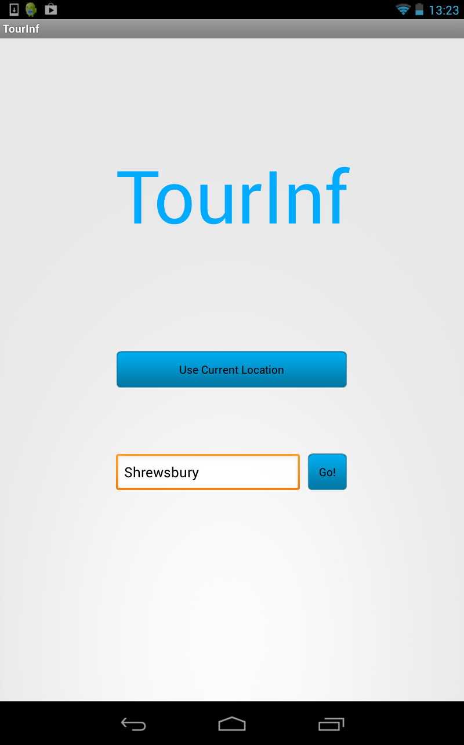

Figure 3.3: The TourInf applications home screen.

The design of the next screen that the user is forwarded to was very important as it is the main menu for the application. It displays all the categories of places that can be selected which allow the user to see if any places are in the surrounding area for that category. For this screen to be displayed an icon based design was chosen as it gives the user a quick graphical representation of the different categories. This allows them to quickly identify what they are looking for and make a quick selection. Another reason this type of layout was used is that although it uses graphics it also uses screen space efficiently allowing a lot of categories to be displayed to the user at once. This enhances the usability of the app due to it being simple to operate and quick to use. Furthermore an additional advantage of using this layout is that a lot of operating systems such as Android and iOS used on tablets and smart phones use this type of interface to launch applications from their home screens. This should give the user a sense of familiarity when using the application and allow the user to easily navigate to the category that they want to select.

Finding appropriate icons for the design of the application was a difficult task. At first different images from Google searches were used and tested. However, the prototype created did not create the vision of a professional application. The images were all of different styles, contained different colours and had to be cropped to size. It was therefore decided that a set of icon images were required to bring consistency across the icons and give the professional look and feel that was sought after. Icon sets/packs, are extremely difficult to find, especially those that are well designed and in the correct size. They are rarely available for free and without licensing. After a lot of research and searching an open source project set of icons was found [23]. These looked far more professional and were importantly offered in vector format. This allowed them to be easily resized appropriately. Not all icons needed were present so a couple had to be created from scratch and some combined together, but thankfully the majority were offered. The main menu from the application can be seen below in figure 3.4:

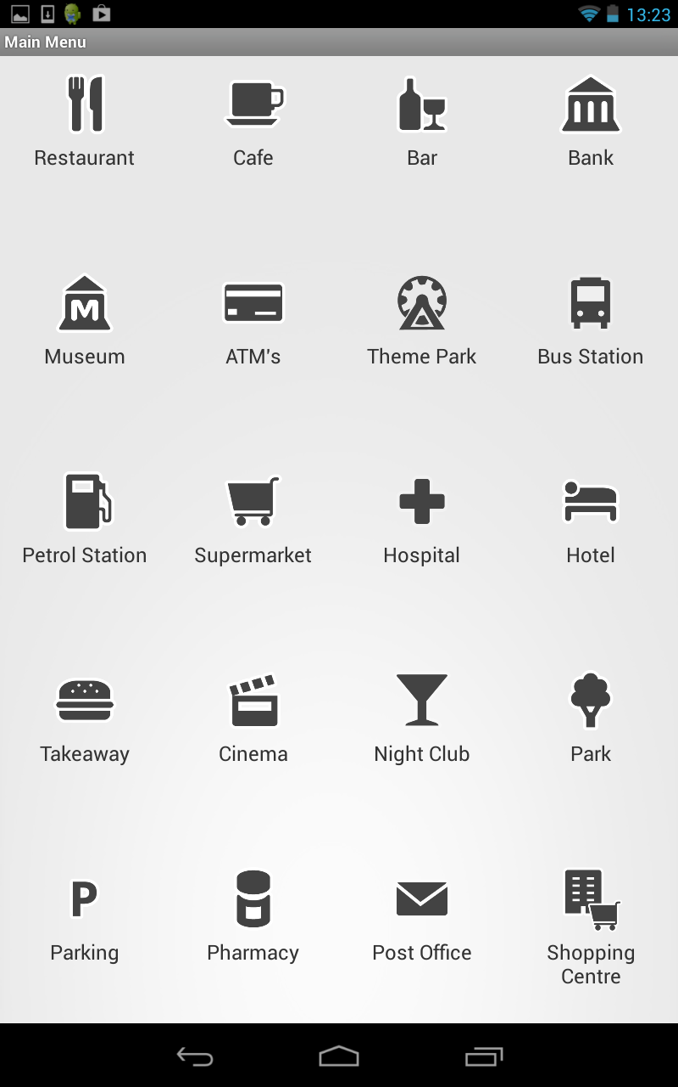

Figure 3.4: The TourInf applications main menu.

Once the user has selected a category in the main menu, a list of the places related to the category chosen then needed to be displayed. After analysing and evaluating the different methods to do this, the often used Android ‘list view’ was selected to be used in the layout file for this activity as it is a simple, clear and effective way to display lists of data. This decision is actually in contrast to what was drawn up in the initial mock-up designs of the graphical user interface (Appendix C, mock-up 4 and 5). In the original design an expandable version of list view was used. However, this method of displaying the data was unnecessarily complicated. It is very difficult to create a well laid out user interface using such a view. It also offers the users less space to view the places associated details. Additionally it may also be harder for the user to understand and select a place, when compare to having the more detailed information on a separate screen. For this reason instead of having one page that displayed the place name and expanded to show place details, these item were spread out between two different screens, with the details and more advanced features being displayed on another screen separate from the list. The final application user interface design for these screens can be seen here in figure 3.5:

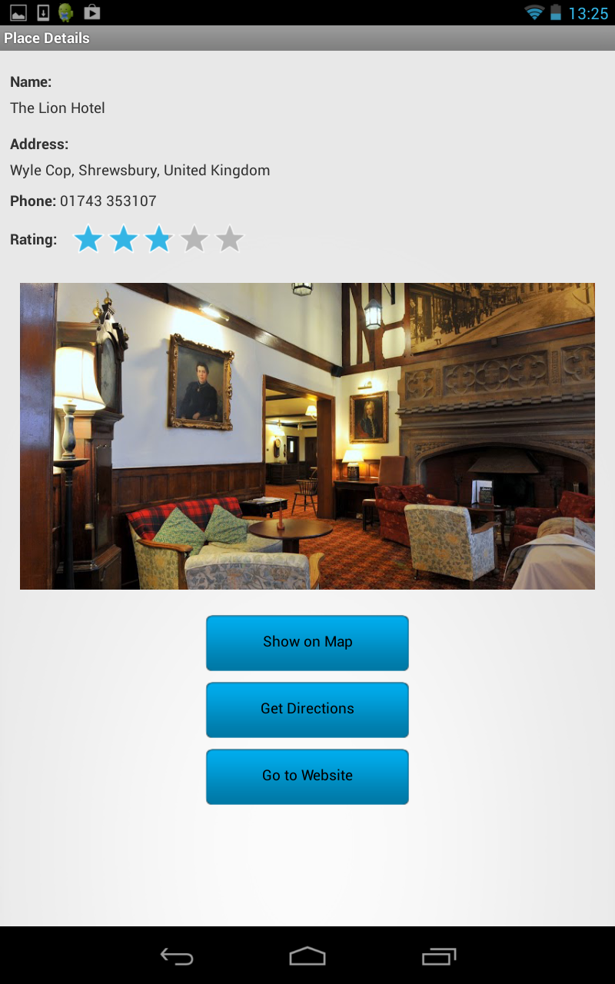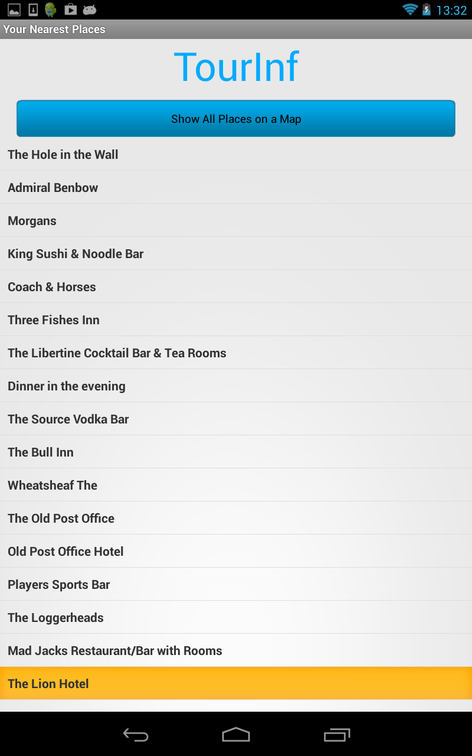

Figure 3.5: A list of places for a category type (left) in the application, when an item from the list is selected, it opens the place details screen (right).

The list view that has been used (screenshot above, left) is a view group that allows a user to see a list of separated and scrollable items from which they can then click and select the item that they want. This layout was selected due to it offering simplicity to the user and the design. Similarly to the main menu screen, by using this type of layout in the view more categories could be seen at once and users would not be puzzled by the layout. Furthermore, it allows the application to easily move on to the next screen of more detailed information as each item is selected. Once clicked the place details information screen is shown for the place selected.

At the top of this screen/activity is also a button that allows the user to see all the locations of the establishments listed below it on a map at once. This then allows the user to see where the locations of the listed places are with retrospect to their own location. This is an additional feature that was not expected to be included and therefore was not included in the original screen mock-ups. The button to access this feature was put at the top of the screen so it is immediately seen when the screen is displayed and has been coloured in blue to match the house style of the brand that has been created for the application. The button was not put at the bottom of the list as users may not have realised the feature existed if they selected places at the top of the list. An example of a map that has been created by this feature in the user interface is shown here in figure 3.6:

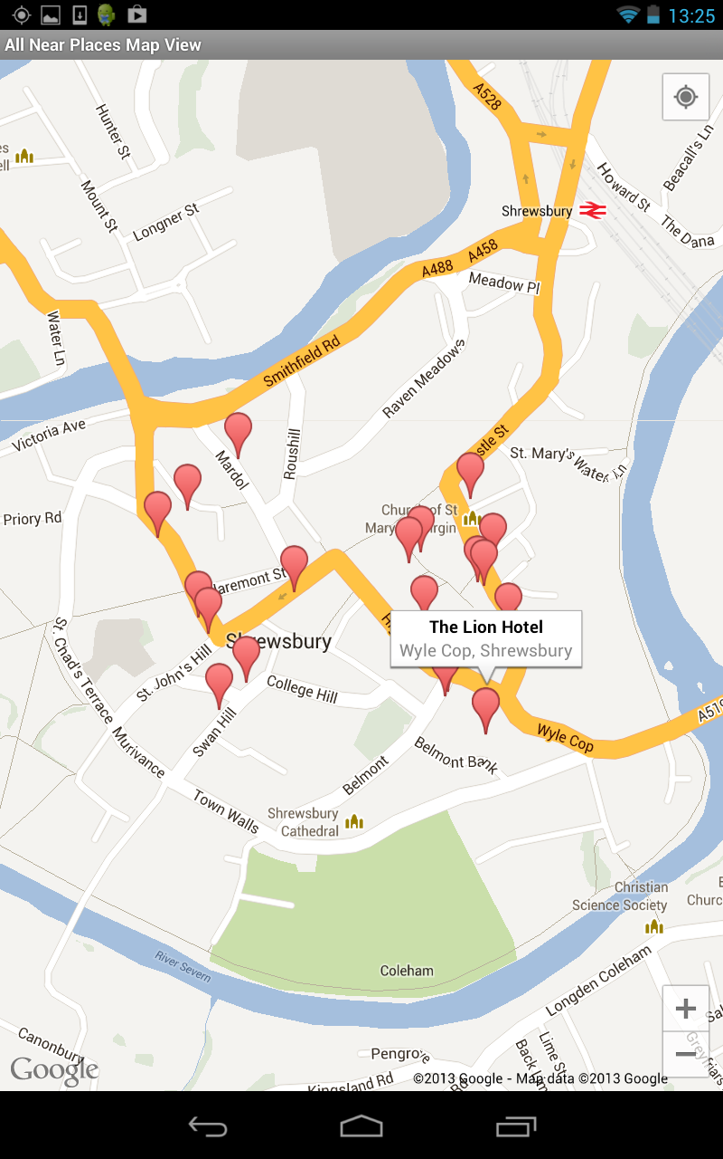

Figure 3.6: An example of a map produced by the app showing the location of hotels in Shrewsbury. One of the markers has been clicked to show the places name and vicinity.

The last screen that the user of the application can navigate to with the most detailed place information is the place details screen. This has a fairly simple design because it is the part of the app that needs to display more textual data and therefore has to be well organised and easy to read for the user so that they can understand and use the information that they are being given. The place details screen uses a relative layout to ensure that everything can be positioned in an ordered and structured manner and where items are placed according to their siblings that are also in the layout to maintain their structure.

Several additional features have been added to the application when compared to the original user interface design mock-ups and these have had to be included and displayed in the user interface. An image of a place selected is displayed on this screen if a reference is found to one within the results of the Google Places request. In addition a rating bar has been created to show the average rating that has been given from reviews on Google if reviews have been given. Several buttons that offer the more advanced feature of the app (show on map, get directions, view website) are clearly placed below the textual information and are again blue in colour to keep consistency with the house style of the application and highlight that the item is a button that will launch another feature. The ‘Call’ button has also been added to the screen to use the additional call feature that has been added. Although it must be remembered that buttons such as ‘Go to Website’ and ‘Call’ will only be displayed if the place in question has a website to visit or phone number to call. This is also true for the rating bar, if no rating is present, simply no stars will be coloured in. An example of the details screen for a place is shown below in figure 3.7:



Figure 3.7: An example place details screen.

The three buttons shown on the screen shown above in Figure 3.7 can be pressed to launch the more advanced features. Examples of these are show here in figure 3.8:

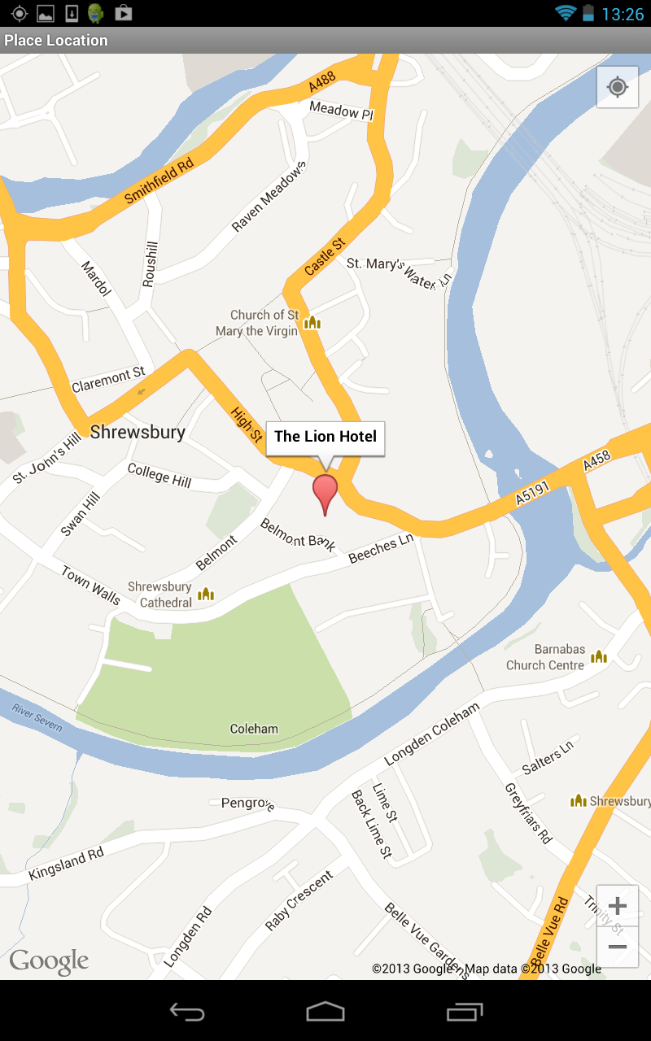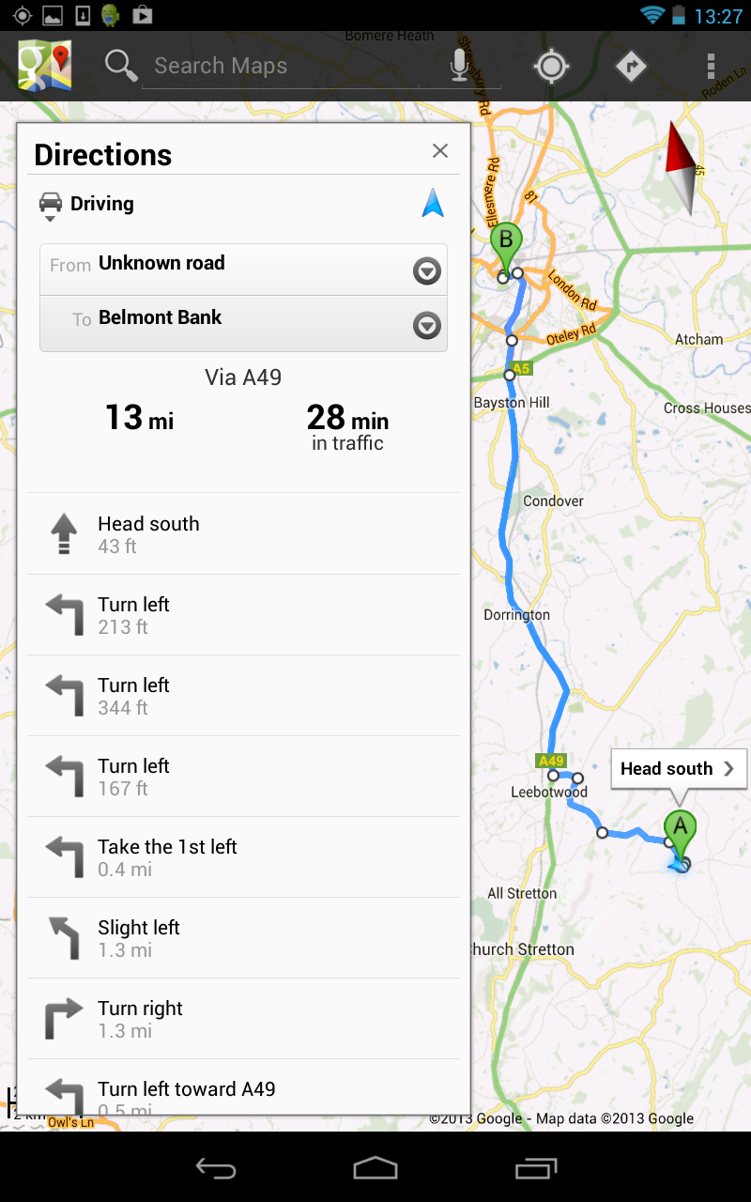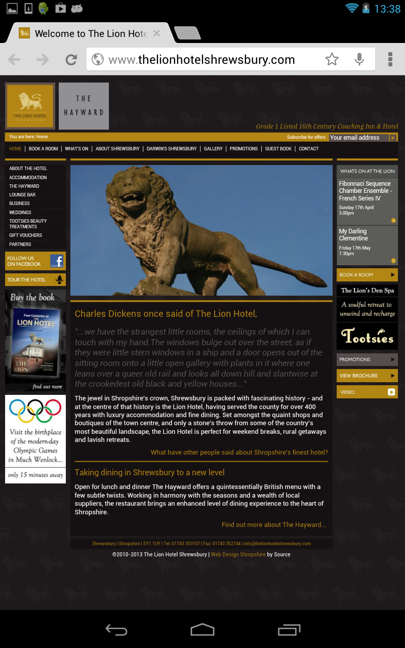

Figure 3.8: The results of the three buttons being clicked for the place shown in figure 3.7. The singular place map view of the places location (left), directions to the place from user’s location (centre) and the establishments website (right).

# Implementation

## Introduction

As described in Section 2 earlier in the report the development process for the implementation of the application developed into a hybrid process between several different types of development process. Originally it was anticipated that the waterfall model would be used. Some elements of this model were used as quite a lot of planning and design went into the project before the implementation started. However, after it became clear that all parts of design and how the application would be tested could not be premeditated before implementation, the process became closer to a Prototyping model to start with. Once the initial platform of the application was created it could be said that the Feature Driven Development (FDD) Agile method was then used in order to build and develop the additional features needed in the application.

In Section 3.1 the overall architecture of the system is described. It states how that there are four major building blocks/modules to the application, the GPS and Internet connection component, the graphical user interface elements, the Google Places search request modules and lastly the mapping elements. The decision was therefore made to research and where possible create working prototypes of these four major elements and then to integrate them together and build on them to give a completed application that met the projects aims and objectives.

## GPS

The first part of the application that was researched and targeted for development was the component that would make use of GPS or other location services to find the users current location. This element of the application would need to be able to find a device’s location by using traditional GPS built into the device or a mobile phones network providers network depending on which services were available on the device being used. In Android terms GPS is described as a fine-grained location provider whereas a phone network is known as a coarse grained location provider due to their accuracy. Firstly, in order to start working on this part of the application, Section 8.1 of the Hello, Android text book [24] was read and gave a good idea of what work needed to be completed. Following on from this, it was thought that it would be useful to find out more about using GPS and location services for Android on the Internet where a guide was found on the Android developer’s website [25]. After reading this information a sample application for using GPS and Android’s Location Manager was found in the training section of the Android developer’s website [26]. This was downloaded and run to see how it performed and was used. The source code was then analysed to see how it had been created and with what methods. From looking at the sample application, what needed to be done for this part of the application became apparent and focus could be turned to creating the user interface due to the confidence gained in being able to create the GPS module needed in the application.

## Graphical User Interface

The first piece of graphical user interface that was designed and developed was the MainActivity, both the controller and the view aspects were created i.e. the java file and the XML layout file. Due to the simplicity of the layout of this view, this wasn’t too difficult to complete although Android can be quite awkward in allowing you to position things exactly as required. Developing the MainMenu activity, however, was a quite a lot more difficult, especially when the developer has no experience in programming for Android. Due to the design incorporating an icon based main menu the application needed to use a grid view. Although a layout file for the grid view alone wasn’t enough for this feature to be implemented, a custom adapter had to be written in order to display images and text within the grid view created. The grid view guide on the Android developer’s website was really useful in initial understanding of how the view can be used [27]. The example given on the website really helped in understanding how this type of view worked and formed the basis of the activity that was created. Despite this, the basic activity created from looking at the example provided needed to be modified to include text labels for each icon. You would assume that this would be a rather easy task, but it turned out this was not the case and it was more difficult to do than originally anticipated.

In order to display text underneath an associated icon, not only do you need to have a customer adapter, but it was discovered that you need the adapter to inflate yet another layout file. By inflating a layout, the elements in the layout XML file are instantiated and can then be used programmatically. The additional layout file (gridview_row.xml) in the application is used to provide the layout for each individual tile in the grid (image and text). So effectively there is a layout file that is indirectly held inside another layout file to produce the final finished main menu gird view. The procedure to evaluate how this could be designed and implemented proved to be more time consuming than initially thought. Once the grid view had been successfully created, the formatting of the grid also took some time to be completed successfully. This is because the screen needs to display correctly on multiple screen sizes and devices. Therefore, various column widths and vertical and horizontal spacings had to be trialled on the two devices that were used for testing (Section 5.2) to produce a layout that displayed appropriately on both devices(and should on others). Despite these time consuming issues, the outcome produced was of a professional manner and created an aesthetically pleasing main menu, independent of the device being used. This meant that an objective for the project was met as the menu was easy to use and was compatible with multiple devices.

## Mapping

The next major segment that was researched and understood for development was the mapping aspect of the application. Before starting this part of the implementation, Section 8.3 of the Hello, Android textbook [24] had been read to get an understanding of what needed to be done and find out how maps could be embedded into Android applications. To improve this understanding, the documentation for Google Maps for Android was discovered and read [2]. However, unfortunately this aspect of the system then became a setback in the project. It was discovered that version one of the Google Maps Android API had become officially deprecated on December the 3rd 2012 [28] in the middle of the project .The API web page also stated that ‘No new features will be added to Google Maps Android API v1’ and despite that apps using v1 will continue to work on devices ‘Existing and new developers are encouraged to use Google Maps Android API v2’. This meant that most of the research and information already gained about embedding maps in Android applications had become void. This was especially apparent when research on version two of the API was taking place, the way in which mapping works on Android had changed greatly, although for the better, as it allows more advanced and interactive maps to be created.

Being able to create an Android application that uses the new Android maps API unfortunately involves quite a number of steps, and has a lengthy setup procedure [29]. Firstly, the Google Play Services software development kit had to be downloaded, installed and configured for usage on top of the Android SDK which had already been installed [30]. The Google Play Services library project then had to be put into the source tree where the TourInf Android app project was held. This then allows the client library to be referenced for use in you Android project. Luckily, adding a library file to an Android project is fairly easy to do in the Eclipse IDE where any libraries needed are simply added in the properties for the project. Further information about what library files were used can be found in Appendix D.

Once these stages had been completed a Google Maps API Key had to be obtained in order to use the Google Maps servers. This key is then used in your application so that when calls are made to the API your credentials can be approved. Again, the procedure to get an API key was a lengthy procedure and more difficult to obtain than expected. It also delayed making progress with the development and understanding of the mapping element of the application.

To get a map API key, firstly you have to get your applications digital certificate known as its SHA-1 fingerprint. In order to do this you have to locate your keystore file and run a command in the command line to open the file and get the fingerprint which is a sequence of 20 two-digit hexadecimal numbers separated by colons that can be seen in the list. Once the SHA-1 fingerprint has been obtained you can then resister to use the Maps API and other Google APIs in the Google API Console found online [31]. Although to sign in to the console you need to register for a Google account. When you are logged in, a new project has to be created for your application. You can then go to the services page and switch the Google Maps Android API v2 on by clicking a switch indicator. The last process is then to actually obtain the map API key. To do this you have to visit the API access page and create a new key using your SHA-1 fingerprint and your application package name. The API key is then returned and can be used in your application where it needs to be declared in the AndroidManifest.xml file along with a number of permissions e.g. Internet, GPS, and OpenGL etc.

After this process had been completed the sample app for the new Maps API was imported into my Eclipse workspace from the Google Play Services SDK that it’s bundled into [32]. The sample app demonstrates the use of a number of different maps, what can be done with them and their features. After analysing the source code of the sample project and being comfortable with what needed to be completed, it was decided to move on and look at developing the part of the project that would use the Google Places API to obtain place information data for the application. The decision was made as it had been established how to create the maps needed and confidence had been accrued that this could be done at a later stage after the Google Places aspect of the application had been implemented.

## Google Places

In the initial phase of research and development for the Google Places part of the application it was remembered that to use the API it would also have to be switched on in the Google Developers console [30] and a separate API key for Google Places obtained. Following on from this, research needed to be done on how the Google Places API was used. After reading the documentation for the API [1], it became apparent how the web service provided worked and what web URL’s would need to be created in the application to request the data, parse it back for usage and display it in the app. However, what wasn’t clear was the best method to make the connection and get at the data returned in an efficient manner and that could easily be reused. To try and get some inspiration on how to go about the task, the Internet was searched for examples of using the Google Places API in an Android application.

After quite a lot of searching, an example of an Android application that used the Google Places API was found on the AndroidHive website [33]. The website gave a detailed step by step tutorial of how the app that used the Places API shown in the video on the page could be created. The tutorial was read with great interest and was extremely useful and helpful in understanding how the Google Places API would be used in the project. In academia it is taught to make use of works that are particularly useful and already available as long as they are correctly referenced and not licensed. Therefore, in this case it was decided there wouldn’t be much point in recreating another version of the code discovered on the AndroidHive website and referencing it as it would be almost identical to what was already provided and therefore illogical. The decision was taken to use this tutorial to build the Google Places module and the basis of the application as it successfully allowed you to create an app that used the Google Places API (more details about the code used can be found in Appendix D). To use the third party code provided by AndroidHive, the code had to be thoroughly understood to make successful use of it and to be able to make the modifications necessary to integrate the other components needed with it.

The tutorial was followed with the source code provided being used step by step in a new project that was set up in Eclipse and then run once completed. The Android application ran with the Google Places search returning places in the local area, although it only listed cafes and restaurants as the type of places to be searched had been hard coded into the program. The application included a button that should have showed a map displaying the location of all the places that were listed. This feature was not originally thought of being included, but after seeing the idea it was thought that it should now be incorporated. Unfortunately this element of the tutorial code did not work as the application made use of the old version of the Android Maps API which uses map views. Therefore, the API key that had already been obtained for the TourInf app and input into the project did not work as it could only be used with version two of the API. As stated at the start of the project, the project aimed to make use of the latest technologies. Also, earlier in the implementation the decision was made to use version two of the Android Maps API as it was the latest version of the API and the old version had been deprecated. So consequently, the mapping aspects of the tutorial application that had been made had to be deleted and would have to be redesigned and recreated to use the new version of the API so the app could be future-proof in the short term.

## Integration of Components

All the major components had now been covered by research completed and source code had been written or understood for these components. However, all of these elements needed to be integrated together in order to create the finished application that had been designed. The first thing that needed to be done was to delete the classes and layout files that were not needed from the code produced from following the Google Places Tutorial detailed above e.g. map classes and extra layouts. Once this had been done the first thing to be integrated with the Google Places module was the user interface activities that had been partly written already so that the home and main menu screens had a layout and the home screen forwarded the user on to the main menu.

However, to get the expected results from the application, the user interface needed to be further developed to integrate and communicate with the Google Places part of the app. The functional requirements for the application (Appendix A.3) stated a number of items that needed to be fulfilled such as:

* The user being able to use their current location
* The user being able to enter a location to search from
* The user should have a variety of categories to select from

Being able to use your current location to get nearby places had already been implemented in the Google Places module, however, the option for the Places code to search and return different categories of places depending on what had been selected in the user interface had not been catered for so this was then developed first. The application needed a type of place (from the allowed list by Google [34]) to be associated with an icon image and its text. To do this a HashMap was used to hold a key value pair between the integer position of the image held in the main menu’s grid and the place type string value. Therefore, when an icon was clicked on screen, its int position in the grid was used to obtain the associated place type to the icon selected. The place type then had to be sent in an intent to the MainPlacesActivity so that the type required could be used in the web service request rather than a hard coded place type. Once this code had been written, it was tested manually on the device to ensure it performed correctly.

The next feature to be developed was for the user to be able to enter their location manually. For this to be able to work in the context of the app, the app would have to convert the location entered (town/city name or postcode) into a geographic lat/long value. Fortunately, earlier in the implementation when looking how to create the GPS module for the app, an example of being able to do a similar function but in reverse had been seen(location example[26]). The actual name of this process is called geocoding and the example that had already been seen made use of reverse geocoding. From this example it was found that thankfully Google have an API class that can help perform geocoding operations [35].

It was decided that for the best design the geocoder should be implemented in the MainPlacesActivity as this is where the initial request to the Google Places web service is made through a call to the GooglePlaces class. In order to make use of the geocoder in that class, any location that was entered in the home screen needed to be forward in an intent to the MainPlacesActivity via the MainMenu activity, so this also had to be implemented. The asynchronous task that was being used in the load places class within the MainPlacesActivity to get places using another thread in the background, then had to be modified so that it could make use of a location that had been entered manually, as well as the user’s current location depending on which option had been chosen by the user. If a location had been forwarded to the activity within the intent to start the activity then the string location entered would be converted into a lat/long value by the geocoder implemented. The values that were returned would then be used in the parameters to call the search method in the GooglePlaces class. Whereas if the current location option was chosen from the home screen then the activity would make a call to the GPSTracker service to get the devices lat/long location and use that in a search request instead. Again, this was thoroughly tested on a device to ensure the changes made to the program had been made successfully.

Now this had been completed, the basis of a complete application had been made. The views had been created for each activity screen, with a home screen, main menu, list of places and place details page all working and being linked together. Therefore, it was time to develop some of the more advanced features of the application that needed to be included. The place list and place details views both required maps to be displayed after pressing a button in their views and as a major part of the system this aspect was tackled first. The view that would display all the place listings for a category on a map was created first. Having an example of using the new API (sample provided with the SDK [32]) helped greatly with understanding and using the new fragment based map activities.

This map feature was created with a map fragment (map component) being used in the layout file and with a loop being used in its class to add a marker to the map at the location of each place held in the PlacesList serializable class. When the map was tested on a list of places in Aberystwyth however, the result was not quite as desired. The map had decided to centre over just one of the markers on the map meaning that not all markers and locations could be seen on the map at once, this needed to be rectified. In order to correct this, the map needed to centre so that all the places could still be displayed and at an appropriate zoom level. To resolve this issue the average latitude and longitude values from the places held in the places list had to be calculated. Then what is known as the camera in the API, was able to zoom in on this average lat/long value in order to centre the map around the markers present, making as many as possible visible to the user.

The fragment map class that would show the location of a single place, and be launched from the place details screen could then be developed. The MapActivity class was implemented a bit more quickly than expected after already creating a similar class to display a map for all the places in the list and the fact that the map layout file from the AllPlacesMapActivity could be reused. The map to show a single place was also slightly simpler to create as it just needed to set up and centre a marker on the map at the lat/long value that was passed to it from the SinglePlaceActivity. Once this had been completed the application could then show both singular places and lists of places for a place or place type on a map. Following on from these map classes being developed and completed, it was natural and logical to continue with this theme and start working on the ‘get directions’ function as the next feature that should be implemented and integrated.

When trying to start implementing the directions feature to complement the maps already created, another problem in the implementation arose. It was found after more research that the new Google Maps API for Android did not include any built in methods to get directions between locations. In all honestly is must be admitted that this was slightly overlooked earlier in the project as it was presumed that a method would be included for this, especially in the new API. An example had also been seen previously in initial research for the project showing directions working in version one of the API, although it turned out this was bespoke solution and no API calls had been used. It transpired that there is a way to still programmatically get directions displayed on an Android Google Map although it is very complicated to implement in a professional manner. The method found [36] involved making a call to another Google API, Google Directions, and passing it the lat/long/values of the two points between which directions were needed. This would return another JSON query that would need to be parsed. For each direction entry (node) in the JSON returned, what is known as a polyline (a line drawn on top of the map) would need to be added as an overlay to a map. The text for each direction would also need to be received, parsed and displayed.

Several other similar examples of getting directions were evaluated and it was felt the outcomes of other developers’ attempts to get this feature working were again not particularly ideal. To get results to be presented in a well organised fashion using this technique would have been extremely difficult and complicated. Another problem with this method of implementation is that it appears that by implementing this type of solution detailed above, Google’s Terms of Service for using map APIs maybe broken unless a paid for license agreement has been made with Google. Section 10 [37] of Google’s Maps Terms of Service concerns licensing restrictions with section 10.2 being particularly relevant stating the following:

‘10.2 Restrictions on the Types of Applications that You are Permitted to Build with the Maps API(s). Except as explicitly permitted in Section 8 (Licenses from Google to You) or the Maps APIs Documentation, you must not (nor may you permit anyone else to) do any of the following:

(c) No Navigation, Autonomous Vehicle Control, or Enterprise Applications. You must not use the Service or Content with any products, systems, or applications for or in connection with any of the following:

(i) real time navigation or route guidance, including but not limited to turn-by-turn route guidance that is synchronized to the position of a user's sensor-enabled device.’

For these reasons further research was completed to try and find another way of being able to include the ‘Get Directions’ feature in the application. Eventually a solution was found when looking at what could be done with Android intents [38]. There are two methods in which directions can be obtained using intents. One way is to launch a VIEW Intent Action which launches a browser to a URL it is given, (e.g. Google Maps website) with the lat/long values being passed in the URL. The other option was to use a geo URI which opens the maps application to a given location or query. It was decided to use the first option for a number of reasons. Firstly, the Geo URI scheme is not fully supported yet and is still under development. Therefore, a benefit of using the browser intent method is that it should be supported on all devices that can run the TourInf app, including the older devices that may not have a built in map application. This means that the directions feature of the app should be reliable. Another benefit to this method was also discovered when this feature was implemented. When a browser intent is launched to the Google Maps website on a lot of devices, they are intelligent enough to launch the built in map app they have using the URL provided to present the directions or map instead of the browser if the map application is installed on the device. The results of using this solution were really pleasing as the directions feature that launches from the application displays a really professional appearance. It was also especially pleasing after the earlier setbacks in implementing this feature.

In order to meet the initial requirements for the project all that needed to be completed now was to include a button to launch a selected places website if the establishment selected had one. To do this a modification was made to the Place class to hold a key for a website if one was found in the JSON that was parsed in the Google Places request. After that change had been made a button was created in the SinglePlaceActivity that would be set to visible only if a website was present for the establishment. If the button is present and clicked, an intent is fired to launch the website in a web browser. Now this had been completed the functionality which had been originally set out for the application had been achieved. Fortunately however, despite this being achieved, there was still some time remaining to continue enhancing the application before this final report needed to be started.

## Extra Features

There were a number of extra features that were considered for development to help improve the TourInf app, and a select few were chosen to be implemented. The first extra feature to be added was the ability to call the place shown in the place details view if the establishment had a phone number. This feature was selected as it’s likely to be useful to users as they may want to phone the place in question to get more information or make a reservation etc. However, there was a slight obstacle in implementing this feature, not all Android devices i.e. most tablet devices, have a sim card and can make phone calls. Therefore, the feature should only be made available to devices with a phone enabled. It was not known how you could detect this so methods were researched on the Internet and luckily a post on stack overflow was found that helped create a solution [39]. Making this device check meant that the button for this feature would only be made visible if the device could make a call and the telephone feature was found in the devices package manager. The modified version of the application was then run on both of the devices used for testing (Section 5.2), with the button being displayed on the phone but not the WIFI only tablet device as desired.

It was detailed in Section 1 that originally it was stated that if there were time at the end of the project it would be great to include a rating for places listed in the Google Place results. For that reason, this extra feature was selected to be developed next. For this feature to be implemented another key had to be added to the Place class to hold the rating value for a listing if one were present in the JSON place information. Rather than just displaying a number on screen for the rating, it was thought that it would look more professional and pleasant if the app displayed the rating using stars in a rating bar. In Android there is a standard component for this and the rating could quite easily be set on the rating bar from the rating obtained, if no rating was given, then simply no stars would be coloured in. The ratings returned from the Places API are the overall average rating given to the establishments from users of Google +.

After completing the additional two features detailed above there was time to complete one last extra feature. Due to the app containing only textual data there was a feeling that it would be great to include some more visual elements in the TourInf application to split up the this data and make the app more appealing. Whilst looking at the JSON returned for detailed place requests it was noticed that some places had a photo reference available. This key could then be used to access a web address that contained a photo of the place selected. It was thought that users would really appreciate being able to visually see what some of the establishments they are finding information about look like as it would perhaps help them make a verdict on whether to make a visit to the place listing. For this reason it was decided that the ability to display a photo of places should be implemented, although the implementation of the feature was quite difficult.

Firstly, another static class had to be added inside the place class to handle photos, and a key in the main part of the class was added for an ArrayList of photos to be held. The main coding then needed to be completed within the SinglePlaceActivity where the photo would be displayed. To get a photo from the Google Places API another request was required to be made to the Places API web service as detailed in the API [1]. The code to do this also needed to be written in another separate thread, (running in the background in another asynchronous task) as otherwise if it was run on the user interface thread it would be likely to cause the application to crash. The task would be likely to block the user interface thread due to its operations, at which point the system would declare the application as non-responsive and have to be closed. Fortunately, asynchronous tasks had already been used in the project to make other calls to different aspects of the Google Places API so background knowledge had already been learnt on how this could be implemented.

The use of another training guide on the Android Developer’s website [40] was again helpful in understanding how this photo feature could be created by providing a similar example. After learning from the example, the code was then written to get a places image. However, when the feature was tested it caused problems with the layout of the user interface as the images returned for different places were all different sizes. Further problems were also discovered when trying to correctly display the photos across multiple devices as when tested on a tablet and phone the photos had not scaled down correctly on the phone when compared to the table device. The photos needed to be displayed at the same aspect ratio across different screen sizes. To resolve these issues the ImageView in the layout file for the SinglePlacesActivity had to be modified again. To ensure that the photos were always displayed at the same size for each place and different screen resolutions, a height for the photo aspect of the view was set manually at 300dp (density independent pixels) and a ‘centerCrop’ scale type was set on the image as well as some layout gravity properties and margins. This meant that the size of the image would automatically adjust relative to the density of pixels in the screen it was being displayed on. In addition, to get the images to display and fit correctly on screen, the layout had to be embedded in a scroll view so that when the content was viewed on a phone with a small screen, the content could be scrolled if needed to, to ensure access to all of the features in the view produced.

Now this extra feature had been implemented and with not much time left for implementing any more new features, it was decided that concentration would be turned to neatening up the appearance of the application to make sure it looked as professional and aesthetically pleasing as possible. It is very difficult to display things neatly and accurately in Android. Many additional layouts had to be created and embedded within other layouts to get rid of alignment issues and other formatting problems that had been found. These changes allowed views to be presented properly on different screen sizes, resolutions and orientations.

Some other small changes that needed to be made to the app that were expected to be rather trivial were also not so. An example was trying to change the background colour of a standard Android button. To do this you cannot just simply set a hexadecimal colour property on the button as it loses all its shape properties and shadow. To implement the change of colour, the background had to be set to a 9 patch image which has to be created and an XML selector file has to be written to determine what colour the background of the button should be when pressed and not pressed. An article [41] that was found from searching the Internet was used as a tutorial to implement these changes, with the blue and white images and XML selector file being used from the article in the TourInf application. The button style created and used in the tutorial was not used as creating one would have been unnecessary.

The application had been re-evaluated after the initial design had been completed early, extra features had been added and its appearance enhanced, the TourInf Android application was now complete and ready for extensive testing.

# Testing

## Overall Approach to Testing

To test the TourInf Android application comprehensively and extensively a number of testing methods have been used in an attempt to make sure the application should perform correctly and as required. Firstly, as you would expect for an object orientated project, unit testing has been applied where appropriate using Androids own testing framework. Despite the application being tested through the user interface throughout the project, user interface tests needed to be done more thoroughly to make sure the application was functioning appropriately from a user’s perspective. To do this, two different methods of testing were used. Firstly, an expansive test table was created and tests were run manually on the device. Additionally, an automated test tool was used called Testdroid [21] which uses a recording of user input previously entered in the user interface to be re-used to automatically navigate through the application, testing all views, communication between activities and functionality. Finally, some user testing was completed where random individuals were asked to sample using the TourInf application and fill in a questionnaire afterwards.

## Hardware

Being an Android app, the application created should work on the large majority of devices that are capable or running apps. To test the app appropriately, it needed to be tested on the two major types of device that use the Android operating system; a mobile phone/smart phone and also a tablet computing device. This needed to be done for several reasons. The first thing that comes into mind when testing on two different devices is how the graphical user interface of the application is going to be displayed and laid out. The application should display appropriately on both devices regardless of the large difference in screen size and screen resolution. More importantly, it must also be ensured that the functionality of the application is withheld on both devices. This was very important in the testing of the TourInf application.

The application uses a connection to the internet in order to provide its features. Many tablet devices are WIFI only whereas mobile phones and some tablets are able to use their network provider’s phone network alone to get Internet access as well as being able to use WIFI. Therefore, in order to test the application appropriately, testing was completed on a Google Nexus 7 WIFI only tablet device with a 7” high resolution screen running the latest version of the Android operating system, and also a Samsung Galaxy Ace mobile phone with a 3.5” medium resolution screen running a much older version of Android (2.3.6).

## Android Unit Tests

Unit tests were written for the application where appropriate to ensure that individual units of source code written for activities were fit for use. The developer of the project had written unit tests before in the form of JUnit. However, this specific framework could not be used as despite the source code being written in Java it contained Android specific methods and libraries meaning that it could not be tested using normal JUnit. This meant that other forms of unit testing had to be discovered that could work with Android source code. Thankfully the Android Developer’s website offers a lot of advice on how this can be done with a testing fundamentals page being especially useful in initial understanding [42].

The Android testing API is based on the JUnit API but it has been extended with Android-specific testing classes. However, unlike normal JUnit test cases there are different categories of tests that have to be used in order to test different types of components. For example, it has component specific test case classes for activity testing, content provider testing and service testing.

It was discovered that this approach to testing was also slightly different to normal JUnit testing. In Android testing, a test project has to be set up which links to the project that is being tested, this test project has to then contain a test package which holds individual test cases. The Android SDK uses test tools to load the test package and the application project under test, and then executes an Android-specific test runner [42].

For this particular project the main concern was testing that activities implemented were fit for use from a system perspective. However, not all classes and activities were could or were needed to be unit tested. There are a few instances of this such as the map views/fragments. There is no component specific test case in Android which could have tested these classes. There was also no point in testing the ConnectionDetector or GooglePlaces classes as their methods are called from other classes that were to be tested. Again, the ImageAdapter class couldn’t really be tested due to no component specific test case being available for Adapters and also the fact that it didn’t need to be tested as it is an adapter and essentially just sets the information it’s given. While the serializable classes (Place, PlaceDetails and PlacesList) were not tested individually as they just hold place data as a model and therefore had to be tested through other activities as well.

This resulted in six unit test cases being created in a test package (Tourinf.test). Five of these tests were for activities whilst another tested a service (GPSTracker). The list of activities/service classes tested is as follows; AlertDialogManager, GPSTracker, MainActivity, MainMenu, MainPlacesActivity and SinglePlacesActivity. The last two tests in the list are the most important as those activities contain the large majority of features and functionality. The results of these tests can be seen in Appendix E.1 where it is shown that all the tests that were written pass successfully.

## Manual User Interface Testing

Although the TourInf application created was tested throughout the development cycle through the use of the user interface to ensure that the application and its features were working as expected, an extensive test table was created to further test the app through its user interface. The test table created tests every aspect of the application from a user perspective and details the actual and expected results of the tests that were carried out. The full testing table with results can be found in Appendix E.2.

## Automatic User Interface Testing

To completely test the functionality of the user interface and the communication between activities it was felt that another method of user interface testing should be carried out. In order to do this effectively and in a manner that was different and complimentary to the user interface testing that had already been completed, these tests would be done automatically.

There were a number of different automated testing tools that were evaluated for the testing of the project. These tools were the MonkeyTalk tool from Gorilla Logic [43], Testdroid [21], its recorder and cloud service, and lastly Androids own monkeyrunner tool [44]. All the automatic testing tools that were evaluated appeared to be useful tools, but after reading and analysing what all the tools could offer, the Testdroid tool was selected to be used for the project.

‘The monkey runner tool provides an API for writing programs that control an Android device from outside any Android code. Monkeyrunner lets you write a Python program that installs an Android application or test package, runs it, sends keystrokes to it, takes screenshots of its user interface, and stores screenshots on the workstation used’ [44]. The monkeyrunner tool was not used for the project as it seemed much more difficult to use than the other tools on offer. Python programs had to be written in order to create tests. To do this the Python language would have to have been learned from scratch. In addition to this the only evidence that could be provided of a test passing successfully, were screenshots which could be taken. Screenshots would not necessarily have proved that the application is performing acceptably and that all functionality was working as desired.

The MonkeyTalk automatic testing tool uses a graphical user interface to allow the user to write tests in something similar to a spreadsheet test table manner, using their own simple scripting language statements or JavaScript. The program looked quite easy to use, however, the more advanced features didn’t seem very well documented on their website or shown in their demonstration video. The website also didn’t display in detail what feedback and confirmation you would get returned from test cases. These details being missing helped make the decision to use the Testdroid tool.

Testdroid was the automated user interface testing tool selected for this project. The software on offer appeared far easier to use than both the competitors described above. Test cases were simply created by recording user input and keystrokes entered into the application itself. No programming or scripting was required as the software automatically reverse engineers the recordings taken to create Android JUnit test code by using the Robotium framework. Robotium is an open source test framework for creating automatic test cases for Android applications [45]. It uses code similar to Androids own for unit testing but with extra functions for user interface testing. The benefits of the tool were extremely useful in testing. Because the tool was easy to use, it was easily understood and tests were created at a reasonable speed with few problems despite the tool not being used before. Furthermore the program produced source code tests of the official standard, Android JUnit, which is the test framework that had been used earlier in the project for unit testing. This meant that the tool provided official evidence that a test had passed. The results of the tests created in Testdroid using the Testdroid recorder can be seen in Appendix E.3.1.

Testdroid also lets you try using one of their complementary products to the Testdroid recorder, Testdroid Cloud, when taking out a free trial. Testdroid cloud [46] is another really helpful tool/service in automated testing. It allows you to upload your test package online to their website where you can then select a range of devices for which the test cases uploaded will be run on. This allows you to test the application across multiple devices, device types and API levels quickly and easily, and most importantly without needed to have or own the devices. The Testdroid cloud also lets you use its ‘App Crawler’ service. This type of test exercises the application systematically by advancing the application through each of its views held in the view hierarchy to ensure the app is performing properly. The test results from the Testdroid Cloud and its App Crawler test can be seen in Appendix E.3.2.

## User Testing

To ensure that the application developed was fit for use and met potential user’s needs and expectations, some user testing was completed. To do this a questionnaire was created using Google Forms [47] which asked the users simple questions about what they thought of the application, what comments they had about it, and how it could be improved. The questionnaire was given to many different types of user e.g. different ages, computer competency, genders etc to try and get an unbiased view point. The questionnaire created and its results can be viewed in Appendix E.4.

Eleven people completed the questionnaire and thankfully a lot of positive responses were received about the TourInf app. All users agreed or strongly agreed that the application met its aim and objectives of being easy to use and navigate, offering a good range of categories and let them find the essential information they wanted to acquire quickly. There were also a lot of positive comments about these aspects and the mapping features. Many constructive points for improvement were also given which were very interesting and useful to find how the app should be developed further. The main improvement noted was to include more graphics and colour in the user interface. This was noticed by the developer, and if given more time they would have like to improve these aspects, however due to the time restraints of the project, focus was on including working features. The questionnaire created and a full summary of its results can be viewed in Appendix E.4.

# Evaluation

## Requirements Identified

Now the project has been completed it can be assessed whether the requirements of the application were correctly identified at the beginning of the project. Looking at the original list of functional requirements and aims and objectives, it appears that in the large majority of cases that these were indeed correctly identified. This is confirmed by the fact that the requirements didn’t have to change, being stable throughout the project. This is because the functionality and requirements originally set out for the application were accurate and therefore didn’t need to be changed to produce an application of a high standard that was fit for purpose.

However, on the other hand, there was one requirement that was incorrectly identified. One of the functional requirements that was set out at the beginning of the project stated that ‘each category of tourist information will have a sub category if applicable e.g. for food; Chinese, Indian, Thai, Japanese’. Unfortunately after doing more in depth research into the Google Places API in the implementation of the application and after the requirements for the project were set, it became apparent that implementing this sub category feature would not be possible using the clean system design set out for the system. The Google Places API has a list of supported place types [34] for searches and this list does not include any of the sub category’s that the application would have wanted to use, such as those listed in the food example above. There is a workaround solution for this, although it would have involved keeping a list of search terms for each subcategory. Unfortunately there was not enough time for this to be implemented or researched in detail in the project.

## Design Decisions

### System Design

Looking at the design of the system and the structure of the application created, it is felt that the application has been designed in an appropriate manner. In an Android application it is typical to have an activity for each view that the application has, with additional supporting classes on top of these. The design has followed this pattern and the MVC architecture pattern to match the recommended design for an Android application. Perhaps some source code files such as the MainPlacesActivity and SinglePlaceActivity classes could have been made a bit smaller with some methods being moved into other separate classes. However, this is not typically done in Android applications, where often methods that are used by an activity are kept inside that activity. Despite small differences in functionality, the two different map fragment classes in the application could also have been combined together in one class to save a small amount of duplicated code. This idea was evaluated, however it was felt that to keep the design simple it would be better to have a class for each map view. Also by implementing it this way, it would be much easier to change the functionality of the map views individually in the future if needed, making it easier to maintain.

### User Interface Design

Reflecting back on the user interface design it appears that most of the design decisions taken were correct. In order to achieve the aims and objectives of the project, the application needed to be simple and easy to use for the user to operate. Ultimately the user interface design that was chosen and created has ensured that this objective has been met and that the app is fit for purpose. The decision to use an icon based menu was particularly appreciated by users in user testing as it was stated that it was a lot quicker to use because of this feature and also a lot more aesthetically pleasing. The results of the user testing (Appendix E.4) helped confirm the feeling that good decisions were made in the design of the user interface.

Despite this, the user interface design could still be improved from the solid basis that’s already been built. Without the time constraints to complete the project it would have been nice to have gone ahead with the original list item design developed earlier in the initial research of the project (Appendix C, mock up 4 and 5) where the list has expandable icons to show place details. Although on the other hand, being able to display the information in this way is very complicated and wasn’t really necessary for the TourInf application. The modified user interface design created is still fit for use and actually meets some design objectives more accurately than the original design e.g. keeping simplicity. The ability to show an icon image of a place to the side of the list of places items which could be clicked on and enlarged is another great feature that would have been great to add to the existing interface.

## Suitability of Tools

In general the tools that were selected to complete the project were well suited to what the project was aiming to achieve and were fit for purpose. The tools used in the project were extremely useful in the development of the application. The Eclipse IDE with the ADT plugin installed [15] was especially helpful and useful throughout the development process as it has been designed to be able to handle the development of Android applications. The user interface part of the development environment was particularly helpful as it allowed you to preview what the XML layout files would make the activities display like when the application was launched without actually having to launch it. This meant that changes could be made to the layout easily and the results of these changes could be seen quickly, allowing for more efficient development. In this instance I don’t feel that any other development environment could have offered as much to the project as the Eclipse package.

The decision to use GitHub to backup the project in the cloud was also a successful one. Again, the support tool saved time and effort by making the development process faster. The GitHub for Windows [19] application is a great extra add-on to help keep your repository up to date and in sync. Another subversion product could have been used, however it is unlikely that any other service would have offered any additional benefits, whilst the bonus of having the Windows application to make commits to your repository much quicker and easier suggests that the best choice was made. Although it is understandable that some developers are put off using GitHubs free service by their repository’s been displayed publicly.

The Testdroid testing tool [21] that was used to complete automated user interface testing is a highly impressive tool. After evaluating other automated testing tools and using the Testdroid tool it became clear that this was the best automated testing tool that could have been used on the project, especially as it was available to use for free. The plugin for eclipse was extremely easy to use and helped greatly in creating thorough automated user interface tests.

## User Needs and Expectations

After analysing the responses of users in user testing (Appendix E.4) of the application it became clear that in most cases the software met the aims and objectives of the project and also the expectations of the users. In general users were impressed with how quickly they could operate the application and find the essential information about local and distant places. They liked the general layout and organization of the application and how the process of finding different places was logical and allowed them to easily drill down through different screens to get more detail on the items they had selected. The large majority of users also expressed that they thought that the mapping features of the application were highly impressive and were very useful in operation due to them being highly interactive, allowing them to use gestures to manipulate the map how they wanted to.

On the other hand users of the application did comment that the application could look more aesthetically pleasing to the eye. Whilst they liked the simplistic nature of the app and the clean minimalistic design, they also felt that more colour and graphics could have been used throughout the application. Another feeling was perhaps the application had too much white space available that could have been taken up with additional content or a layout that made better use of the additional space. Many observations were made regarding the appearance of the icons used. The view of the users in testing was that they liked their simplicity and the fact that they could easily identify different categories through the use of the icon images. However, again the opinion was that perhaps the icons could have been different colours, or have contained colour in their designs. If more time had been available, changes would have been made to help eradicate these feelings.

## Changes in Approach

If I were to start the project again I would have approached the project differently. One of the things that I would change is my approach to the project. At the start of the project I spent quite a lot of time researching about Android apps and how they are structured and developed. The knowledge that I gained from this was rather useful throughout the project, however looking back to that time, I was perhaps looking at the area in too broad a perspective. In the end, a few of the topics and items that were learnt initially were not needed for the project or not needed until much further down the development cycle. This meant that unfortunately my time was not used as efficiently as it could have been to create the TourInf app for the project. It also meant that some of the things I researched and read about at the beginning of the project had to be revisited and gone over again when I was developing those particular parts of the application in order to remind myself about research already done on certain aspects of the design and implementation.

If were to start the project again I would have spent less time doing my initial research and I would have started developing parts of the application earlier. In most cases things would only be researched when particular items and aspects were needed to used or when any problems occurred in the implementation of the application that could not be resolved. Ultimately the time spent doing research could have been utilised better and may have enabled me to add some more extra features that I would have liked to have included in the completed application. I would also have made use of using the prototyping methodology from the start rather than planning with a Waterfall model in mind and initially trying to design the application before development. Again, by doing this, time would have been saved and an improved outcome could have been achieved in the same time period.

## Extra Features and Improvements

I am very pleased with the outcome of the TourInf application that has been developed and what I have achieved. However, after completing the application a number of ideas for how the app that has been created could be improved in the future have been thought of. There are a number of features that I would have liked to have included in the application but sadly did not have time to complete. One such feature would be for the app to display the opening hours/times of any shops and business’ which had them readily available on their Google Places listing. I would have also have liked to display a simple indicator on the user interface to show whether the establishment is open at the time the user looks at the establishment in the place details screen. I think this would have been another valuable feature and would have enhanced the functionality of the app. Users would have found this useful as they do not want to make a trip to visit any of the listings displayed if they are not open at an appropriate time.

Another more advanced feature that I would have like to have developed is the inclusion of reviews in the app. Some listings have been reviewed on Google Plus and this information is returned in the data that is returned by the Google Places web service. It would have been nice to have been able to pull out and display this information in the app to give the user an indication on what the respective place may be like and let them get a clearer indication on whether they would like to visit the establishment. In addition to this it would have been really good for users of the app to have been able to add reviews of the places listed themselves so other users of the app could read their feedback. This would have been quite a complicated extra feature to implement as it would require the use of a database for storage, which would also need to be hosted.

The ability to upload photos of places listed is another feature that I would have liked to have added to the application. Recently users of apps are not just using them to access information, they’re also enjoying returning information back to the application or to somewhere else on the Internet for others to see and use. Apps and social networking sites such as Instagram and Twitter have made uploading images to the Internet popular in our society and day to day lives. This makes me think that the ability to upload photos into the app would be appealing to a large number of users. It would allow users to take photos of the places and business’ that the app lists and also of any of their products or services. For example someone could take a photo of the exterior of a restaurant and also the food that is available for others to use and pass judgment. Therefore, this feature would have been useful, helping users to make a better judgment on making a visit to an establishment or organisation.

On the topic of social media, it would be fantastic if the application could be linked into user’s social networking profiles to allow the application to fully integrate with social network features. These sites are being increasingly used by the general public and commercially by companies. When a user is placed within the vicinity of a place listed, visits a place or uploads a photo or review of a listing, this information could be displayed and shared on social network sites. Not only would this be a great feature for application users to make use of, but it would also help promote use of the app.

Lastly, I have also thought about how I could make the application commercially viable and how the app could be monetised. One obvious way of generating money from the application is uploading the application to the Google Play Store and charging users to download and use the application. This is unlikely to be a popular decision with most users as currently the majority of apps on the Play Store (especially utility apps) are free to download and use. It is worth noting that to release the application on to the play store more development work would need to be completed, notably further testing e.g. different Android API versions and a greater range of different sized displays. The usage agreements of the Google Places web service and Google Maps API would also need researching in much more detail. Google do have usage limits for obtaining the data that has been used by the app and these limits are likely to be exceeded if the app was being used by many individuals after being made available to download on the Play Store. Google are also likely to charge a small amount for this data due to the large amount of usage. Despite this, after these things had been fully analysed, evaluated and rectified it would be great to put the TourInf app on the Google Play Store for Android users to download and make use of, even it did have to be made available for free to meet customer expectations.

What I would have liked to have implemented to bring in revenue from the application is the ability to show advertisements in the application. This is because it is a method with would allow the app to be offered for free whilst the developer still gets an income from it. These adverts could have perhaps been shown before the app has launched and also displayed along the bottom of the screen or elsewhere. Google have already created a tool available on the market that allows mobile app developers to easily add advertisements into their application. This tool is called the Google AdMob Ads SDK [48]. This kit allows the app to show readymade advertisements to the user with very little code needed to be written and embedded in the app by the developer. The owner of the application then receives revenue from the adverts when they are clicked on and visited. I feel that using this SDK from Google would have been a great way to quickly and efficiently monetise the application in a professional manner. It is also a method that would be unlikely to cause users to stop using the app or not download it in the first place, unlike making them pay for the application initially which often puts potential users off. In most cases I feel that users aren’t too concerned about having advertisements inside their apps as long as the app is free to download and they aren’t too intrusive, taking up a large proportion of the screen. I therefore believe that using the AdMob Ads SDK would be a great way to monetise the application developed and I would have liked to have integrated this feature into the application had the development phase been longer.

## Final Thoughts

For this project not only did I wish to create a tourist information application that achieved its aims and objectives, I also wanted to learn about developing for the Android operating system and mobile devices in general. Gladly after completing this project I feel that I have learnt a great deal about developing for Android and how it differs from a typical software project. I feel that I have a good understanding of how these types of applications are built and how my own project can be improved. I have enjoyed completing the project and I’m glad to have been able to add some extra features to what was originally planned for the TourInf application. I plan to continue developing the application that has been created in my own time to include the extra features I would have liked to have added and to continue to improve the skills that I have gained throughout the project.

# Appendices

* 1. Original Project Planning

## A.1. Original project planning details table

This table was produced at the start of the project to try and complete a week by week plan of what needed to be done for the project. Unfortunately this plan could not be followed in the actual implementation where the development process was changed as detailed in Section 2.2. This table was also used to create a Gantt chart of the project plan in the next Appendices section.

|  |  |  |  |  |
| --- | --- | --- | --- | --- |
| **Tasks** | **Task Detail** | **Start Date** | **Duration (Days)** | **End Date** |
|  |  |  |  |  |
| **Project Analysis** | Investigating technology and API’s, researching similar apps in detail and what they have used, feasibility studies, requirements analysis. | 22-Oct-12 | 21 | 19-Nov-12 |
| Project Plan | Give an outline in terms of dates and deadlines for the project specifying key tasks. Keep up to date, modifying entries when appropriate. | 15-Oct-12 | 7 | 22-Oct-12 |
| Requirements | Draw up a list of functional requirements, making it clear what the app needs to be able to do for the user. Draw up a basic use case diagram. | 22-Oct-12 | 7 | 29-Oct-12 |
| General Research | Internet research, reading of Android book, completing Android workshop worksheets from the University. | 15-Oct-12 | 28 | 26-Nov-12 |
| Competitor Research | Look at apps on Google Play store similar to my planned app. Analyse features. Write up notes. | 05-Nov-12 | 14 | 19-Nov-12 |
| **Design Specification** | Showing all aspects of design, with a description of components, user interface design and diagrams. | 12-Nov-12 | 14 | 03-Dec-12 |
| User Interface Mock-Ups | Produce some screen mock ups of GUI so I can fully understand what I am building and what I will need to work on to get the required functionality working easily for the user. | 22-Oct-12 | 7 | 29-Oct-12 |
| **Progress Report** | Project Summary, Current Progress, Planning, Annotated Bibliography. | 12-Nov-12 | 7 | 19-Nov-12 |
| **Test Specification** | Testing Methods e.g. Unit tests, are documented. | 19-Nov-12 | 14 | 10-Dec-12 |
| **Software Development** | Do some more additional spike work regarding mapping. Build the actual piece of software. | 03-Dec-12 | 84 | 25-Feb-12 |
| Spike Work | Start with trying to get GPS location. Once complete experiment with Google API code, try to write some for Places before doing any other coding, and try to make sure everything needed will work. | 12-Nov-12 | 21 | 03-Dec-12 |
| **Mid Project Demonstration** | Show my supervisor progress made by early Semester 2. | 31-Jan-13 | 1 | 01-Feb-13 |
| **Test Data** | Ensure requirements are met, the software works as expected, users are satisfied, Unit test results. | 18-Feb-13 | 14 | 04-Mar-13 |
| **Final report** | Full write up of complete major project 10-20k words. Process used, Requirements, Design, Testing, Reading, Critical Assessment, appendices etc. | 04-Mar-13 | 35 | 25-Apr-13 |
| **Final Demonstration** | Show the completed Mobile Device application (corresponding to the project description) in its entirety to my project supervisor and a supporting member of staff. | 28-Apr-13 | 1 | 29-Apr-13 |

Table A.1: A table of the original project plan, detailing tasks to be completed and predicted dates and durations

## A.2. Original Project Gantt Chart

This Gantt chart was produced at the start of the project to visually display a week by week plan of what needed to be done for the project using the project planning table seen previously in A.1. Milestones were added to the chart to represent when project deliverables needed to be completed by.

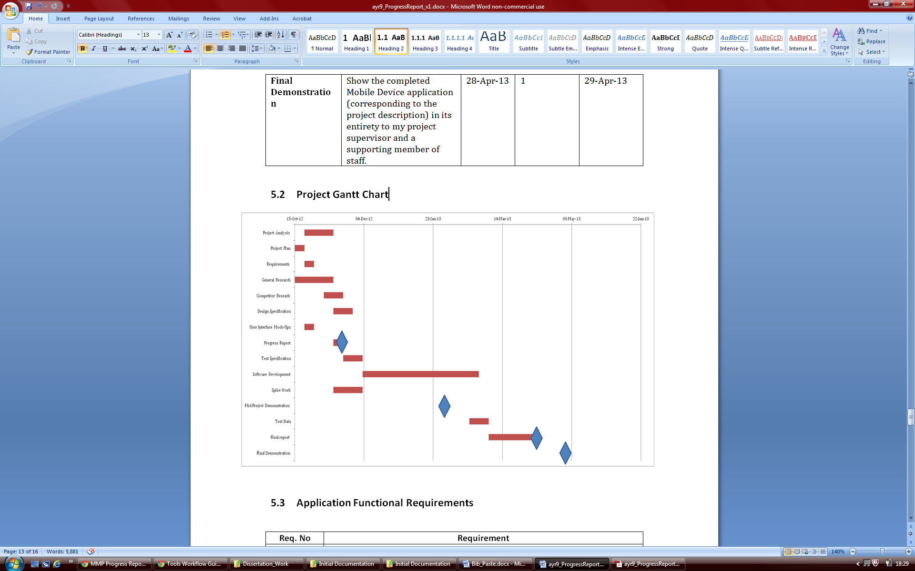

Figure A.1: The Gantt chart created from the original project plan table (Table A.1) used to visually represent the plan and show milestones for deliverables.

## A.3. TourInf Application Functional Requirements

|  |  |
| --- | --- |
| **Req. No** | **Requirement** |
| 1 | The app will be designed for users of touch screen mobile devices. |
| 2 | The application must give the user the option of using a current location or using a city or postcode (by user entering text). (UI mock-up 1, below) |
| 3 | If asked to find a user’s current location, the app will use the mobile devices on board GPS to gain the location. |
| 4 | The app will list different categories of tourist information for the user to select, for example, food, shops, museums, points of interest etc. (UI mock-up 2) |
| 5 | Each category of tourist information will have a sub category if applicable e.g. for food; Chinese, Indian, Thai, Japanese. (UI mock-up 3) |
| 6 | Each category and sub category will have an individual graphical icon for the user to select that category (using the touch screen). (UI mock-up 2, 3) |
| 7 | For a category/sub category selected, information about each business/ establishment will be listed and the user will be able to scroll through all the listings available. (UI mock-up 4) |
| 8 | The basic information for a listing will include; their name, address and phone number. |
| 9 | Each listing will be expandable or have its own separate page to display more information. (UI mock-up 5) |
| 10 | Once a listing has been expanded the user will have more advanced options such as viewing their website, a map of their location or directions from your current location. (UI mock-up 5) |
| 11 | The application needs to save state if the app is minimised so that progress and data in the app is not lost if a user returns back to the app at a later date. |
| 12 | If a user selects to see a map of the location of a listing, then another window/ page in the app will display a Google map of the surrounding location with a marker at the listings exact location point. |
| 13 | If a user selects to ‘Get Directions’ then again another window/ page of the app will be brought up and a list of directions with a map will be provided. |
| 14 | If a listing has an associated website, then a button in the expanded listing will act as a link to their site. |

Table A.2: The original list of functional requirements for the application. Mock up references are referring to the original mock-ups for the user interface seen in Appendix C.

* 1. TourInf Application Class Diagram

# 

Figure B.1: The class diagram for the finished TourInf application.

* 1. Original Graphical User Interface Design

1. 5.

**TourInf**

Honoured Guest

Address Lines

Address Lines

01970 123 456

**-**

Hot Dumplings

Address Lines 01970 123 456

Kam Sing

Address Lines 01970 123 456

**+**

**+**

Website

Map

Directions

**TourInf**

Food

Shops

POI

ATM’s

Example

Example

Example

Example

Example

Example

Example

Example

Example

Example

Example

Example

Example

Example

Example

Example

Can’t find it...Search here

**TourInf**

Chinese

Indian

Thai

British

**Use Current Location**

Enter City, Town, Post Code...

**TourInf**

2. 3. 4.

**TourInf**

**+**

Honoured Guest

Address Lines 01970 123 456

Hot Dumplings

Address Lines 01970 123 456

Kam Sing

Address Lines 01970 123 456

Mandarin

Address Lines 01970 123 456

**+**

**+**

**+**

Seafront Palace

Address Lines

Figure C.1: The mock-ups above show the original graphical user interface design for the application.

**TourInf**

**+**

Honoured Guest

Address Lines 01970 123 456

Hot Dumplings

Address Lines 01970 123 456

Kam Sing

Address Lines 01970 123 456

Mandarin

Address Lines 01970 123 456

**+**

**+**

**+**

Seafront Palace

Address Lines

**TourInf**

Food

Shops

POI

ATM’s

Example

Example

Example

Example

Example

Example

Example

Example

Example

Example

Example

Example

Example

Example

Example

Example

Can’t find it...Search here

**TourInf**

Chinese

Indian

Thai

British

* 1. Third-Party Code and Libraries

## D.1. Third party code

It has been stated throughout the implementation section (4) what third party code has been looked at and used, where and how it has been used and for what reason. **The source code for the project has been commented with Javadoc author tags in each Java file which details the main author of the code and any modifications that have been made to the 3rd party source code provided in the project.** However, to reiterate this information the following sources have been used in the project in a way detailed below:

An Android tutorial for creating an Android application that uses the Google Places API (also listed in the implementation [33]).

<http://www.androidhive.info/2012/08/android-working-with-google-places-and-maps-tutorial/>

This tutorial listed above was completed and the majority of the code provided in the tutorial was used in the project. The classes and views that produced maps were discarded to create new versions using the new Android Maps API. Some Java and XML files provided were used with no modification, whilst others were modified to varying extents. More details of what has been used and what has been modified can be seen in the Javadoc of the source code.

## D.2. Libraries

The following library files from Google APIs Client Library for Java were used in the project:

* google-api-client-1.10.3-beta.jar
* google-api-client-android2-1.10.3-beta.jar
* google-oauth-client-1.10.3-beta.jar
* google-http-client-1.10.3-beta.jar
* google-http-client-android2-1.10.3-beta.jar
* google-http-client-android3-1.10.3-beta.jar
* gson-2.1.jar
* guava-11.0.1.jar
* jackson-core-asl-1.9.4.jar
* jsr305-1.3.9.jar
* protobuf-java-2.2.0.jar

The Java client library is used in the application created for accessing Google APIs using JSON and being able to parse the Google Places API response. The client library files work on the Android platform as it’s supported by the Java language. The latest version of the Google APIs Client Library for Java can be researched and downloaded here: <https://code.google.com/p/google-api-java-client/wiki/Setup>

The other library that was used was the Google Play services SDK which allows you to develop using the Google Play Services APIs. This client library was needed to order to be able to use the new version of Google Maps (Google Maps Android API v2). To download and install the SDK which provides the client library files the setup instructions that can be found below were followed [30]:

<http://developer.android.com/google/play-services/setup.html>

* 1. Testing

## E.1. Unit Testing

The Android JUnit tests of which the results are shown below can be found within the TourInf.test folder in the uk.ac.aber.ayr9.tourinf.test package on the disc provided with this document.

AlertDialogManagerTest- This test launches an instance of the MainActivity and then creates an instance of the AlertDialogManager class to create and show an alert dialog box. These details that have been used are then checked.

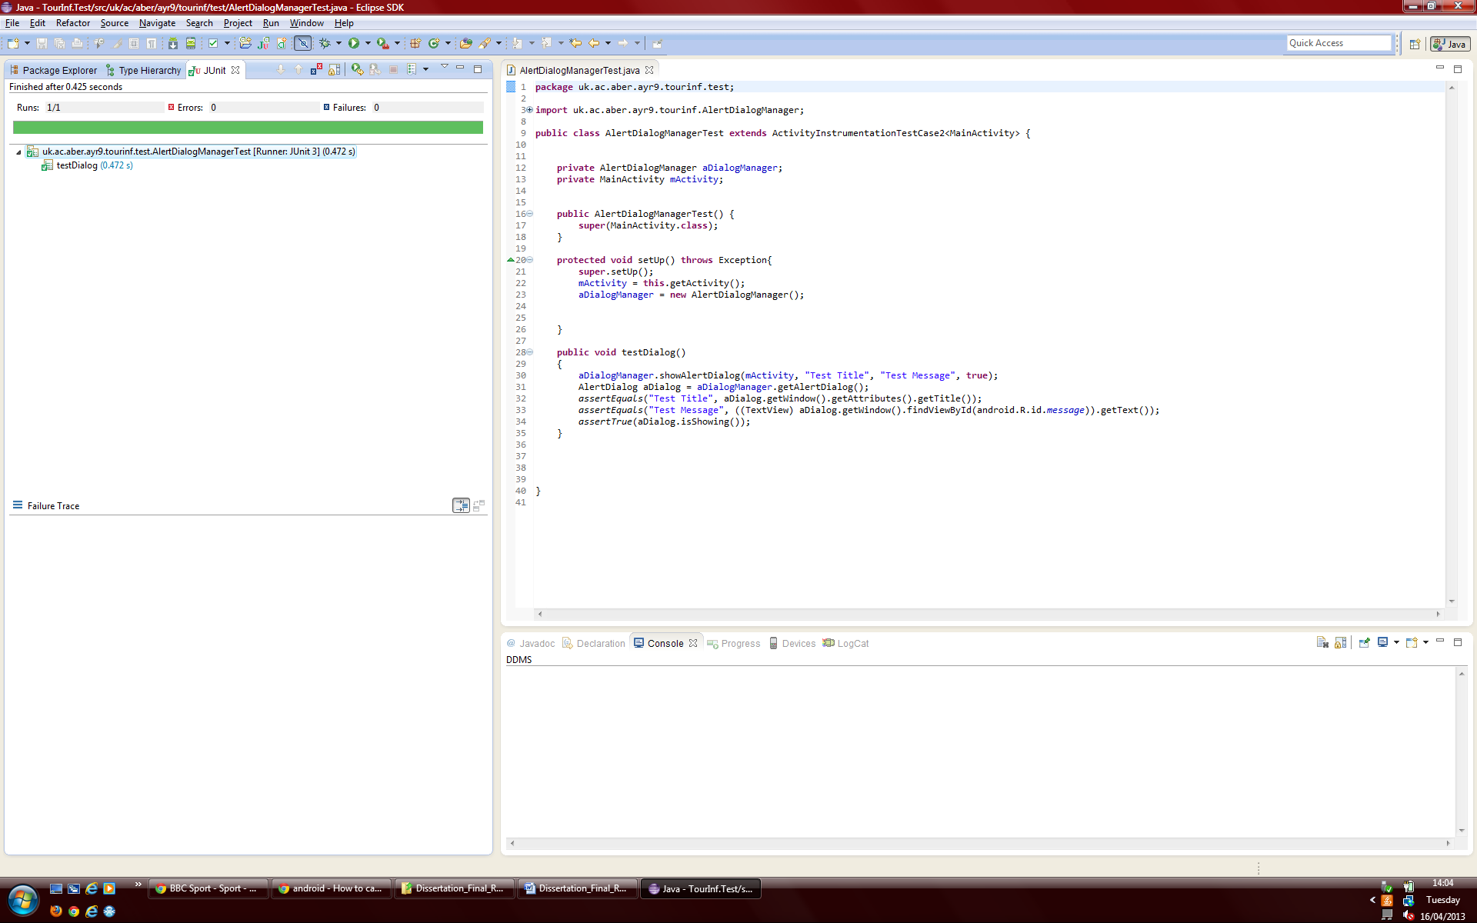

Figure E.1: Evidence of the AlertDialogManagerTest passing

GPSTrackerTest- This test creates an instance of the GPSTracker service class and tests that GPS Lat/long values are being received

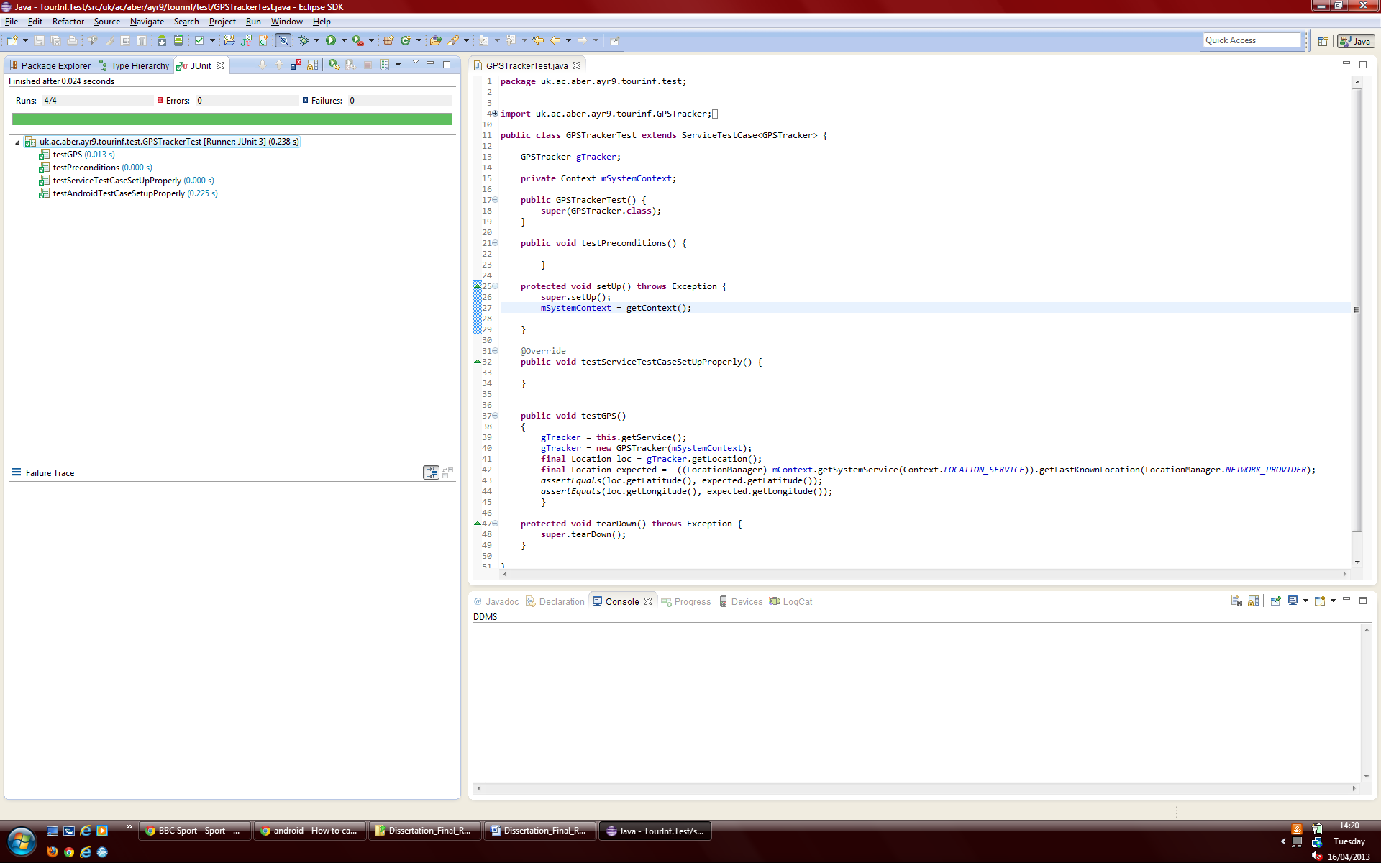

Figure E.2: Evidence of the GPSTrackerTest passing

MainActivityTest- This test checks the view is displaying correctly.

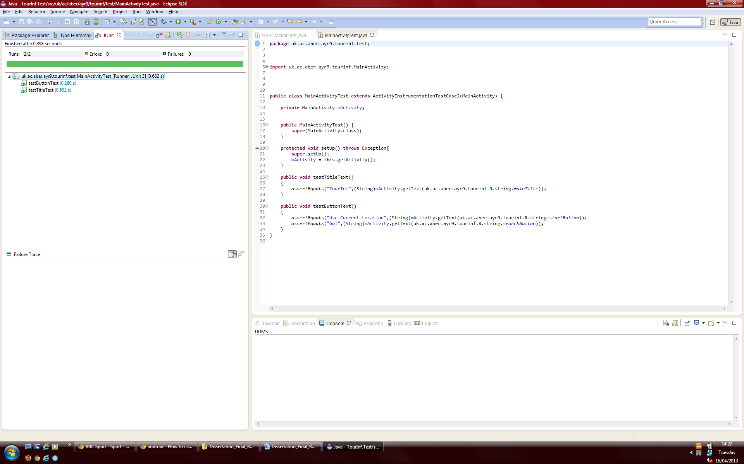

Figure E.3: Evidence of the MainActivityTest passing

MainMenuTest- This test checks that an intent being sent to the activity would be received correctly

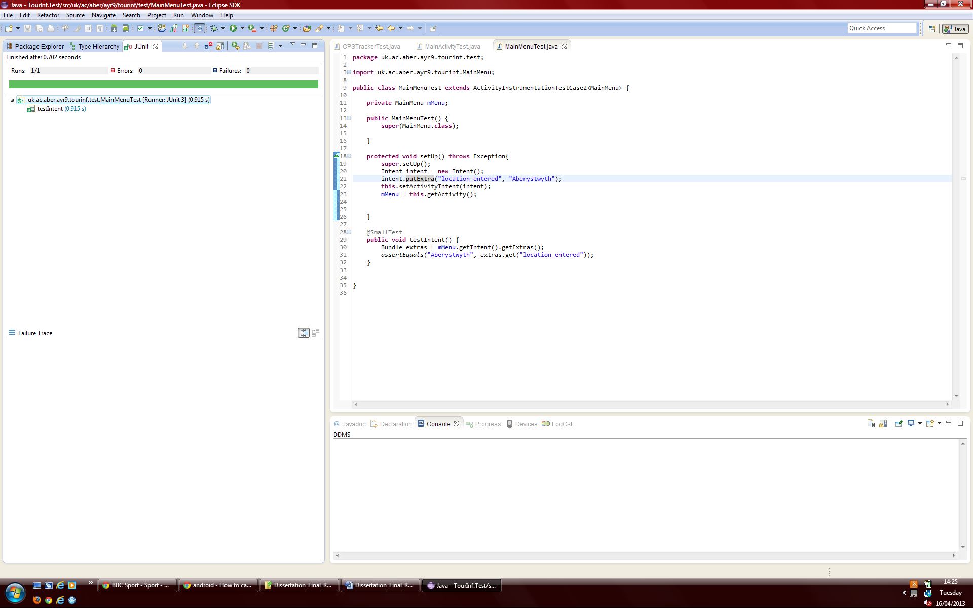

Figure E.4: Evidence of the MainMenuTest passing

MainPlacesActivityTest- This test injects a location and place type into the MainPlacesActivity using intents, it is then checked that these have been received and a request is made to the Google Places API with this data. It is then checked that a list of results is returned from the API and a specific place is held in the list obtained.

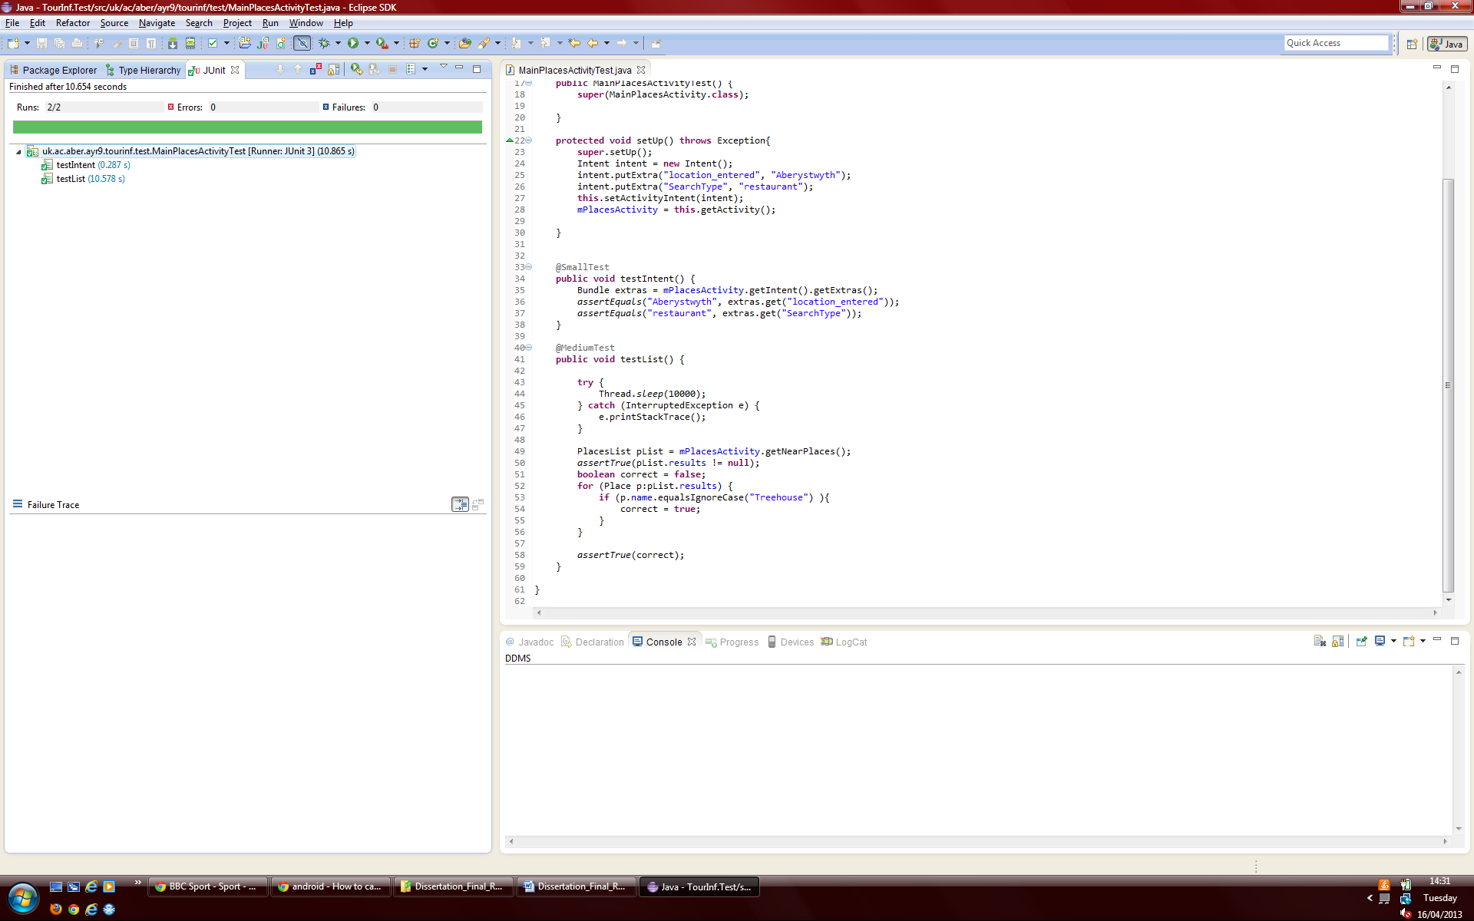

Figure E.5: Evidence of the MainPlacesActivityTest passing

SinglePlaceActivityTest- This test injects a reference key into the SinglePlaceActivity using an intent, it is this then checked to make sure it has been received and a request is made using the detail URL scheme to the Google Places API with the reference. The name, formatted address and phone number of the place returned are then checked to make sure they match the place reference that was given to the API.

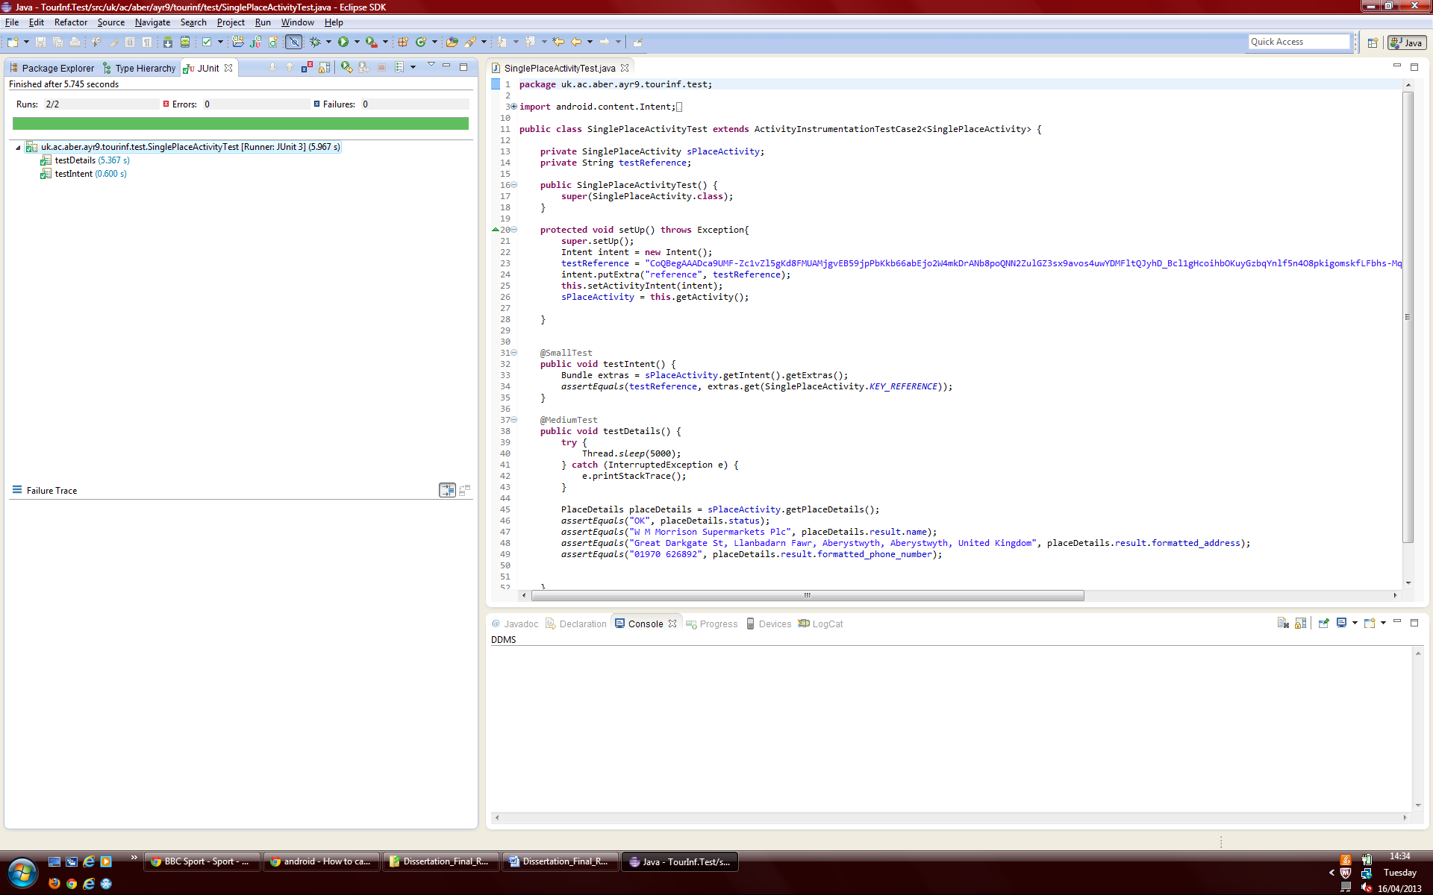

Figure E.6: Evidence of the SinglePlaceActivityTest passing

## E.2. Manual User Interface Testing

|  |  |  |  |  |
| --- | --- | --- | --- | --- |
| **Test No.** | **Test Details** | **Expected Result** | **Actual Result** | **Pass/ Fail** |
| **1** | Home screen displayed correctly. | Screen displayed correctly | Screen displayed correctly | Pass |
| **2** | Click ‘use current location’ button on the app home screen | Forwarded on to main menu, category selected lists places relative to user’s location. | Main menu displayed. Correct places for user’s location found. | Pass |
| **3** | Enter location manually on home screen (Town/City/Postcode) | Forwarded on to main menu, place listed for category selected relative to location entered. | Main menu displayed. Correct places listed for location entered found. | Pass |
| **4** | Main menu screen displayed correctly | Screen displayed correctly | Screen displayed correctly | Pass |
| **5** | Select Category from main menu | Category Selected. Place displayed for category selected. | Category Selected. Place displayed for category selected. | Pass |
| **6** | Places list page displayed correctly. For category selected. | Screen displayed correctly | Screen displayed correctly | Pass |
| **7** | Click ‘Show All Places on a Map’ button | Map view displayed. Markers added to the map for all places in the list | Map displayed. All markers for places in the list were present | Pass |
| **8** | Click on a marker in all places map activity | Place name and vicinity displayed in dialog box. | Place name and vicinity were displayed in dialog box. | Pass |
| **9** | Check map features for all places map function correctly | Touch gestures work, zoom buttons work, current location button works | Touch gestures worked, zoom buttons worked, current location button worked | Pass |
| **10** | Select an individual place from the places list | Individual place selected. Forwarded to place details screen. | Individual place selected. Forwarded to place details screen. | Pass |
| **11** | Place details screen displayed correctly | Screen displayed correctly | Screen displayed correctly | Pass |
| **12** | Place details information correct | Information correct | Information correct | Pass |
| **13** | Click ‘Show on Map’ button for selected place | Map view with single marker for place selected displayed | Map view with single marker for place selected displayed | Pass |
| **14** | Check map features for single places map function correctly | Touch gestures work, zoom buttons work, current location button works | Touch gestures worked, zoom buttons worked, current location button worked | Pass |
| **15** | Click ‘Get Directions’ button for selected place | Map application or browser launched to display directions between user’s current location and place selected. | Map application/browser launched to display directions between user’s current location and place selected. | Pass |
| **16** | Click ‘Go to website’ button for a selected place if the button is present e.g. if the place selected has a website | Website for a place selected launched in a browser. | Website for the place selected was launched in the default browser. | Pass |
| **17** | Click ‘Call’ button for a selected place if the button is present e.g. if the place selected has a phone number | Starts dialling the selected places phone number. | Starts dialling the selected places phone number. | Pass |
| **18** | Select a category with no results | Alert dialog box to be displayed saying ‘Sorry no places found. Try to change the types of places’ | Alert dialog box to be displayed saying ‘Sorry no places found. Try to change the types of places’ | Pass |
| **19** | Try and run the program with no Internet Connection | Alert dialog box displayed saying ‘Please connect to a working Internet connection’ after a category has been selected | Alert dialog box displayed saying ‘Please connect to a working Internet connection’ after a category has been selected | Pass |
| **20** | Try and run the program using an empty manual location | Shows a quick notification message stating ‘No location entered’ | Displayed a notification message stating ‘No location entered’ | Pass |

Table E.1: This table details the results of all manual user interface testing that has been completed for the project.

## E.3. Automated Testing

The Android JUnit tests of which the results are shown below can be found within the TourInf.GUItest folder in the uk.ac.aber.ayr9.tourinf.GUItest package on the disc provided with this document.

### E.3.1. Testdroid Recorder

SetLocationCheckPlaceTest- This automatic user interface test manually enters a location in the MainPlacesActivity, it then selects a category from the MainMenu activity and selects a place. The places details in the place details screen are then checked to make sure the correct place has been selected. It then goes back to the list, selects another place and checks these places details as well before navigating back to the home screen.

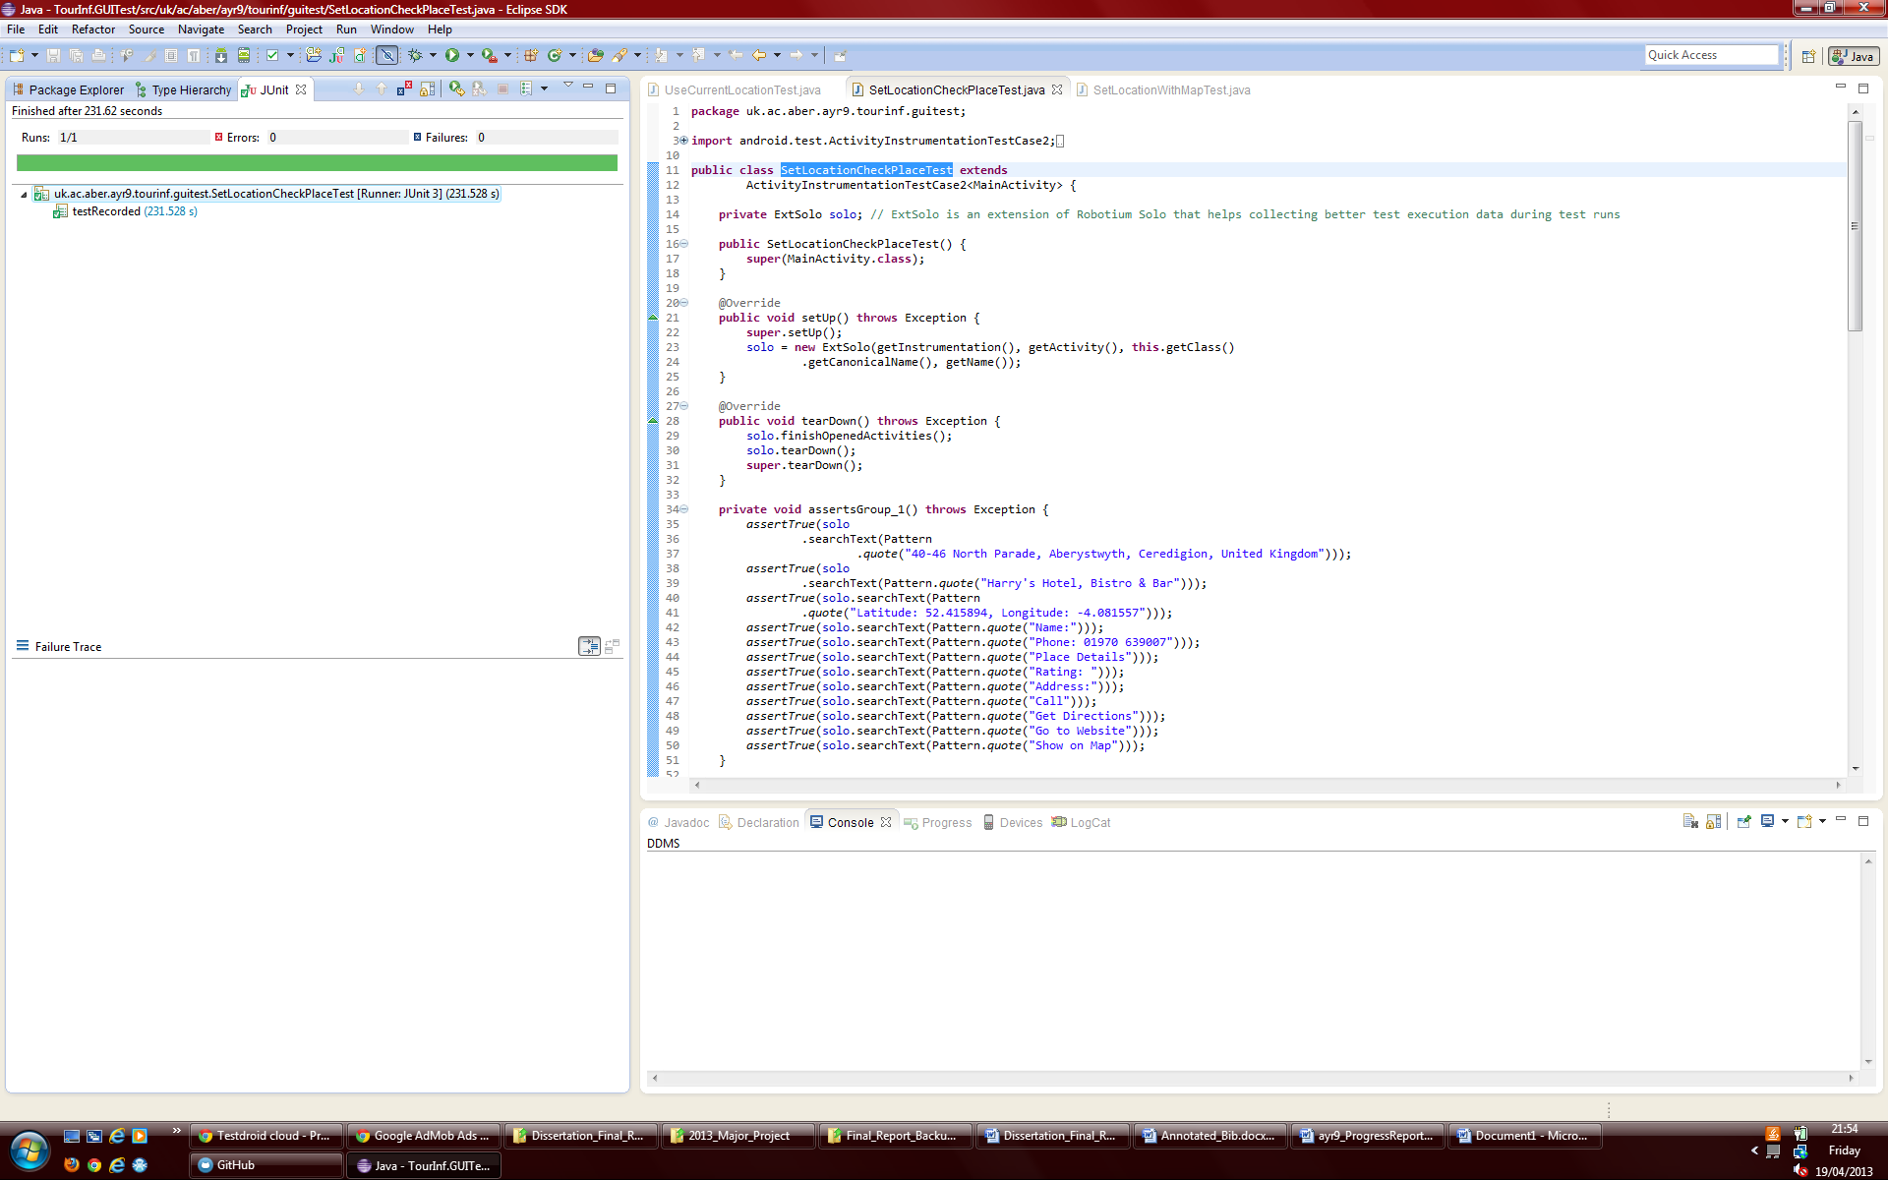

Figure E.7: Evidence of the SetLocationCheckPlaceTest passing

SetLocationWithMapTest-This automatic UI test navigates through the view hierarchy from the MainActivity to the SinglePlaceActivity and also views the MapActivity as this could not be unit tested. Two places are looked at for a category before returning to the home screen with no errors to make sure the app is behaving as expected.

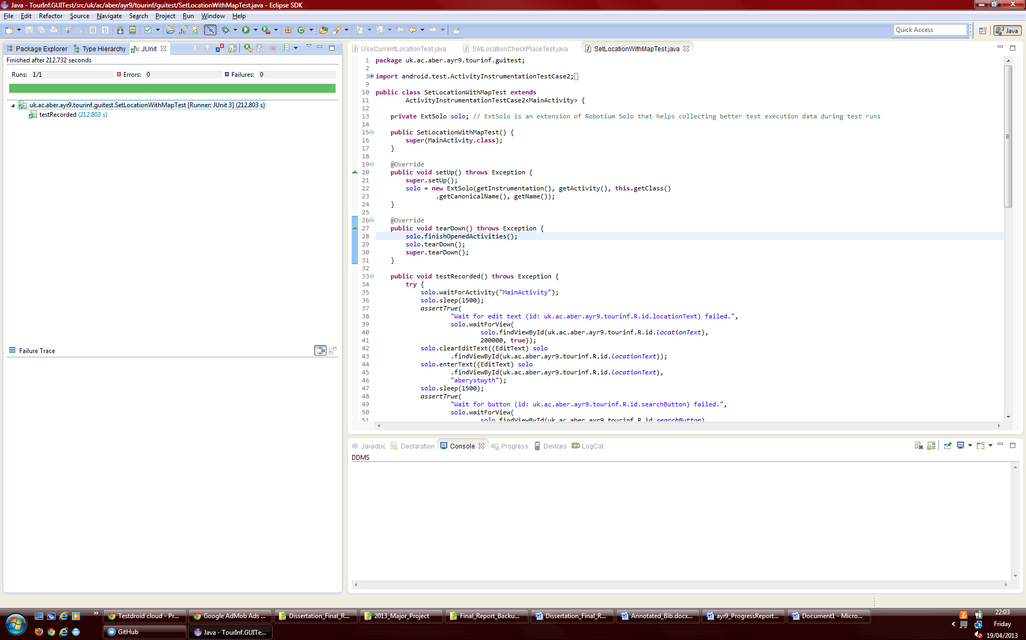

Figure E.8: Evidence of the SetLocationWithMapTest passing

UseCurrentLocationTest- This automatic test uses a mock GPS location so that the ‘use current location’ feature can be tested. Again the test navigates through the view hierarchy from the MainActivity to the place details screen and map view and back again using this mock location to make sure the application functions correctly.

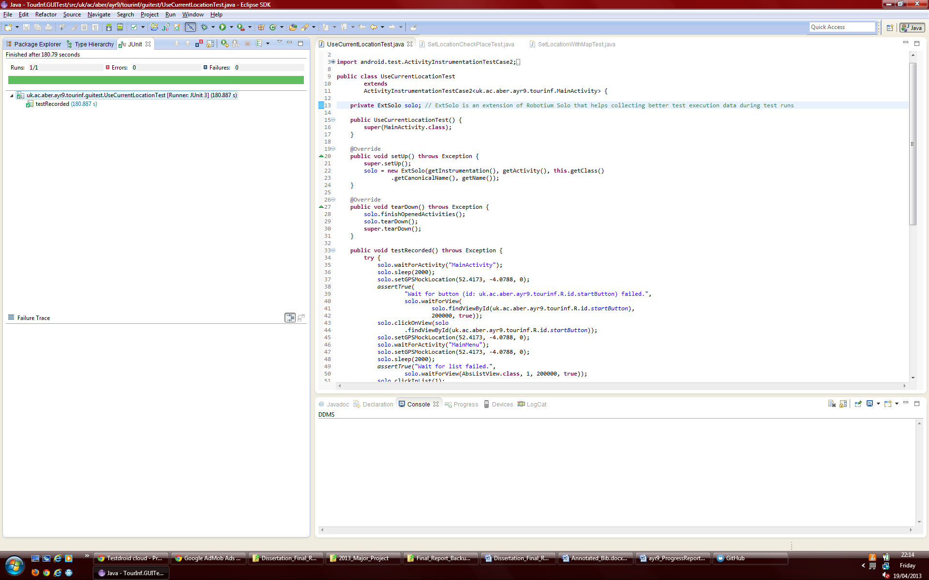

Figure E.9: Evidence of the UseCurrentLocationTest passing

### E.3.2. Testdroid Cloud

### E.3.2.1. Results of Test Recorder tests being run in the Testdroid cloud

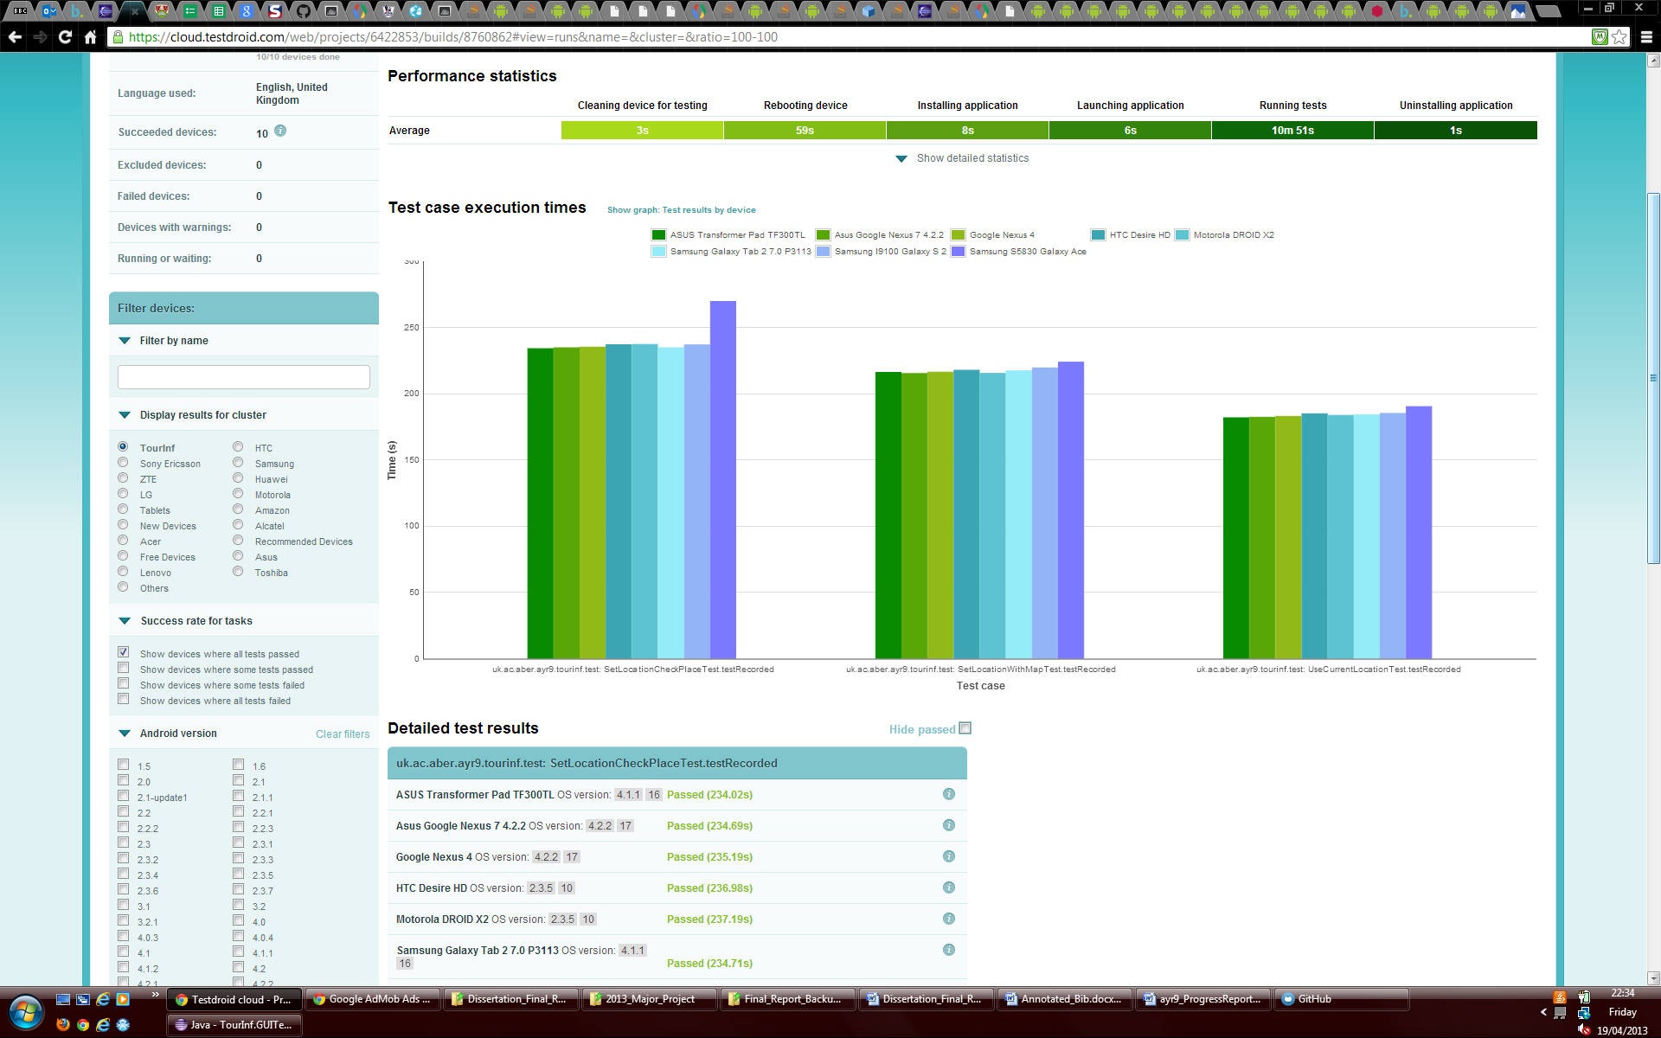

Figure E.10: Graphical evidence of the all three tests recorded in Testdroid Recorder passing on 7 different devices using a selection of API versions in the Testdroid cloud.

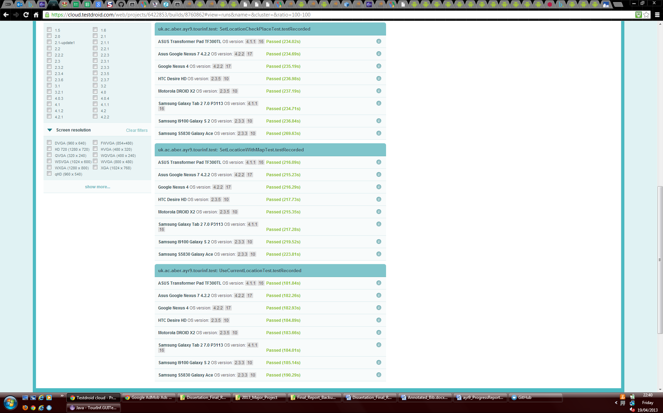

Figure E.11: Textual evidence of the all three tests recorded in Testdroid Recorder passing on 7 different devices using a selection of API versions in the Testdroid cloud.

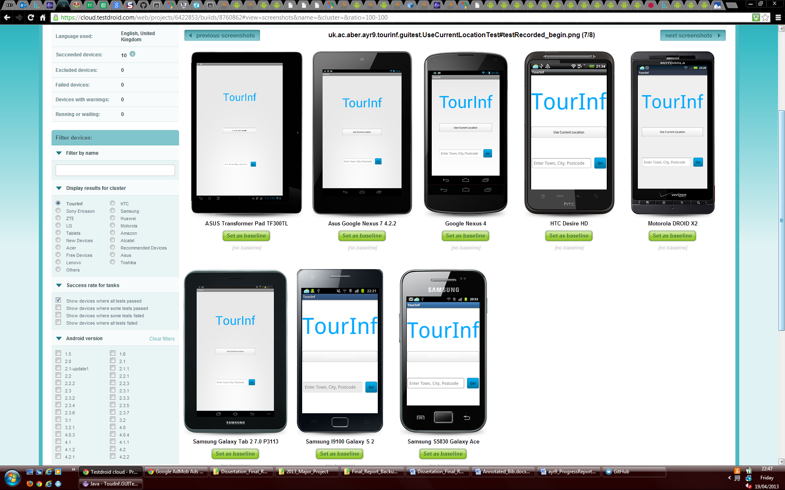

Figure E.12: Screenshots recorded in Testdroid Cloud tests showing the applications home screen across devices.

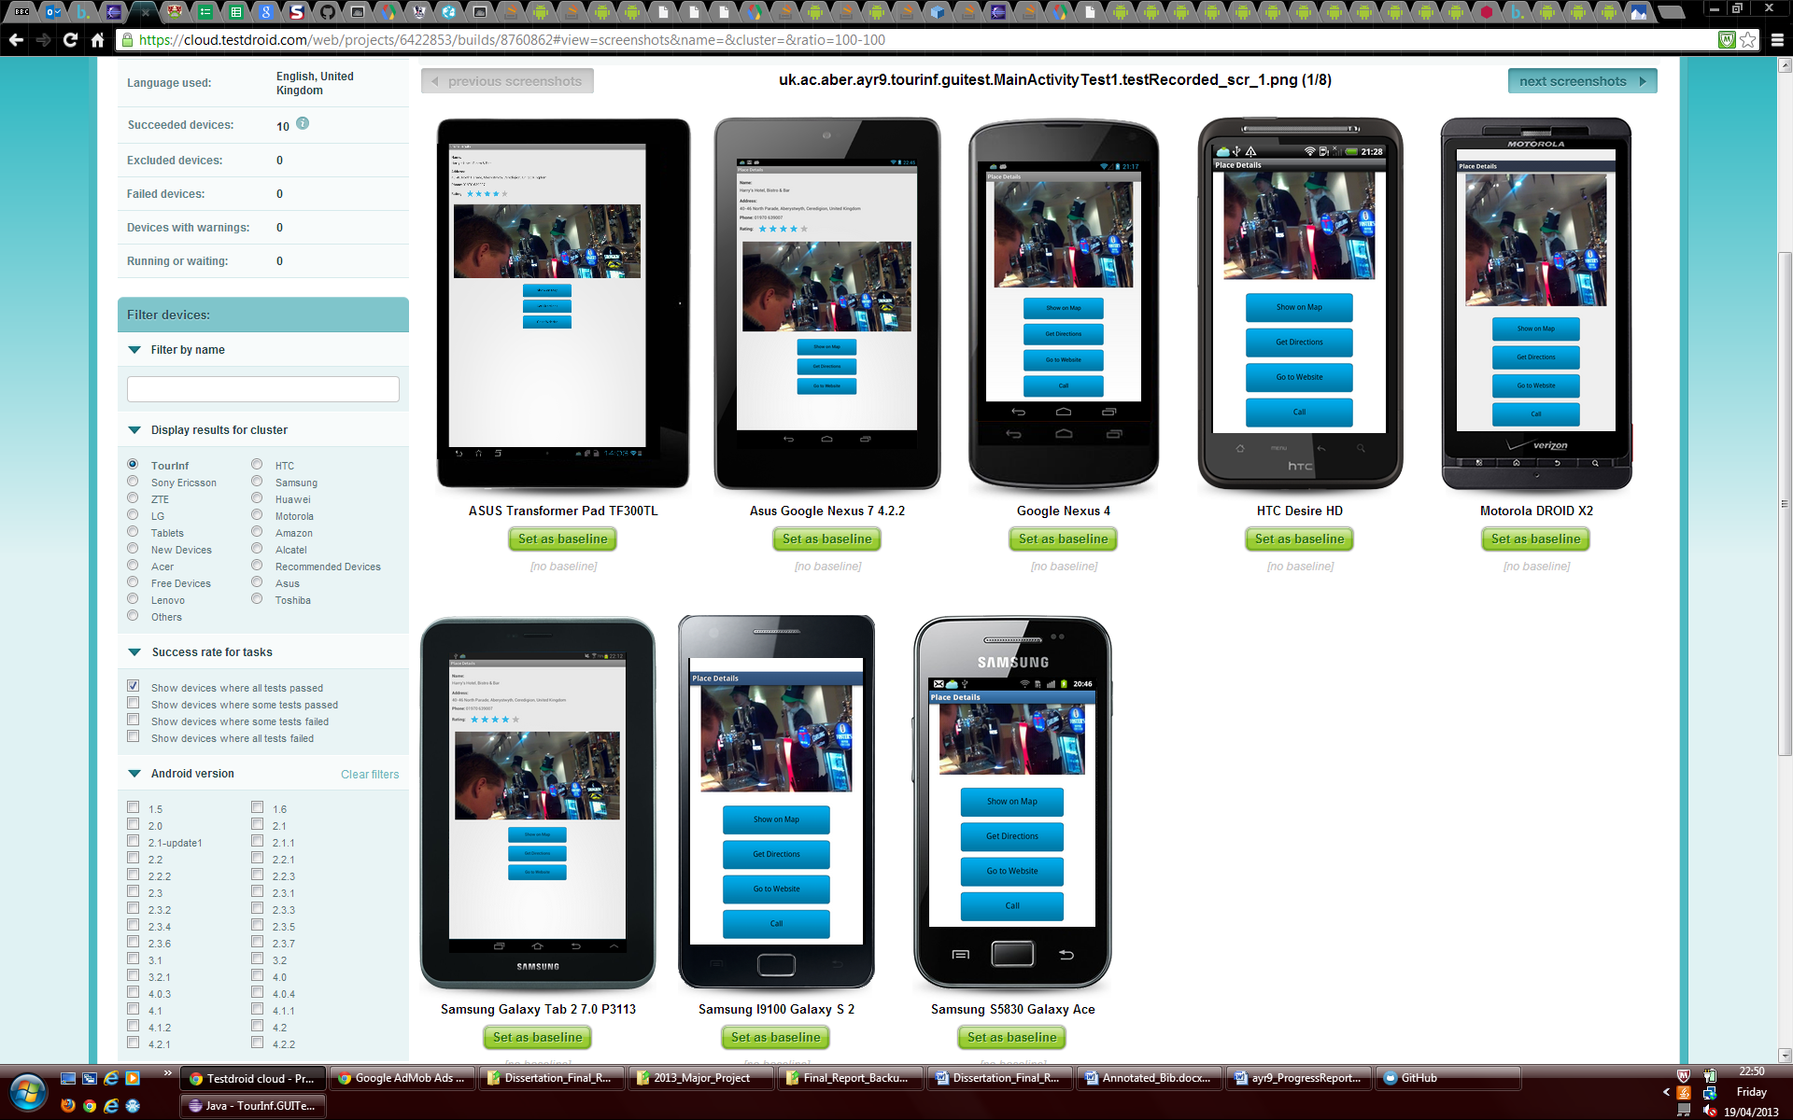

Figure E.13: Screenshots recorded in Testdroid Cloud tests showing the applications place details screen across devices with the view scrolled down if need to look at the buttons provided.

### E.3.2.2. Testdroid cloud App Crawler Results

The Testdroid cloud App Crawler systematically goes through all views in the application view hierarchy to ensure they are fit for use.

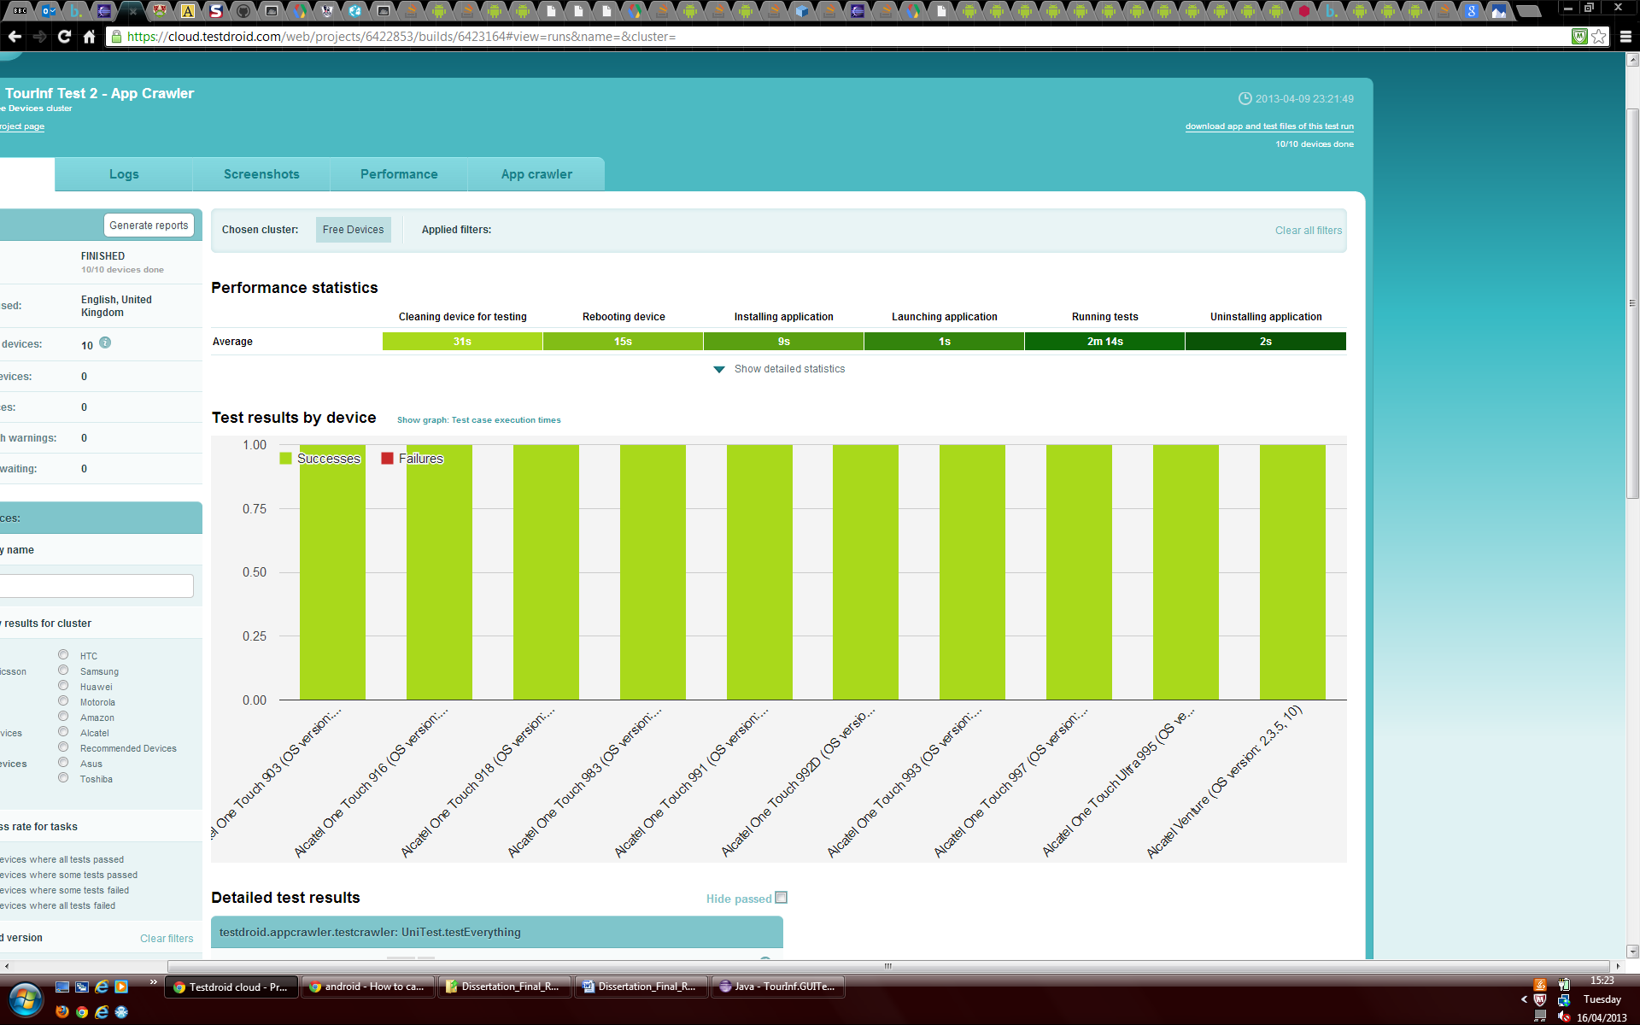

Figure E.14: Graphical evidence that the app crawler which checks all views in the view hierarchy passed on all devices it was tested on.

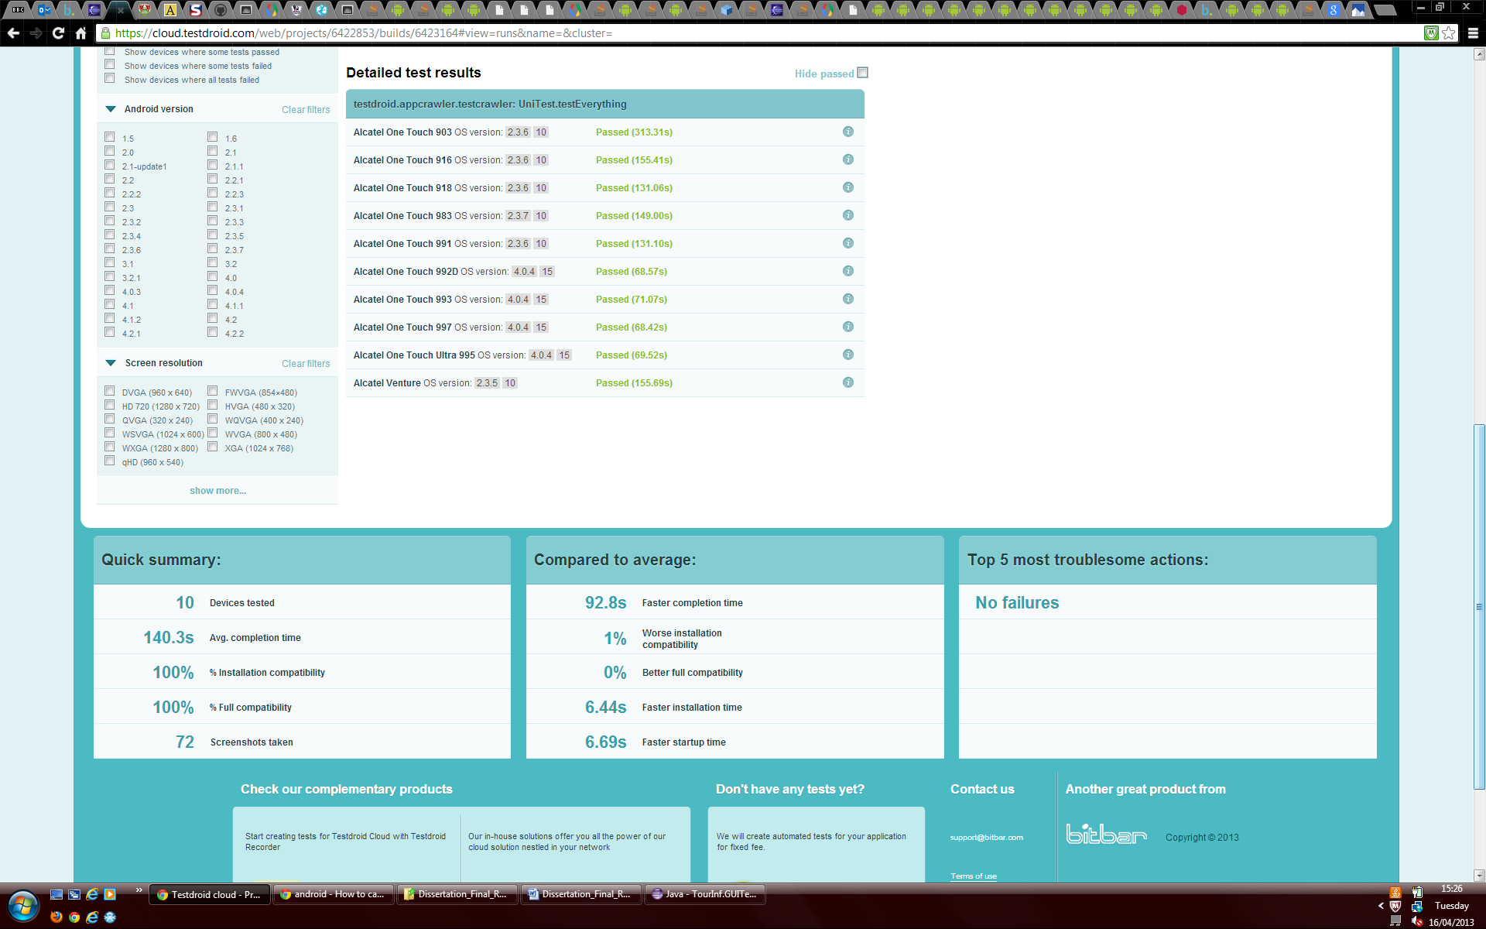

Figure E.15: Textual evidence that the app crawler which checks all views in the view hierarchy passed on all devices it was tested on.



Figure E.16: A summary of the application statistics, and confirmation that there were no failures.

## E.4. User Testing

### E.4.1. Questionnaire

For user testing the following questionnaire using Google Forms was completed by potential users:

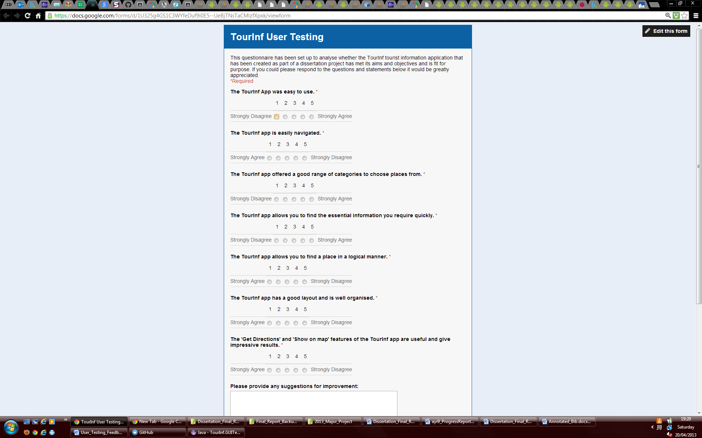

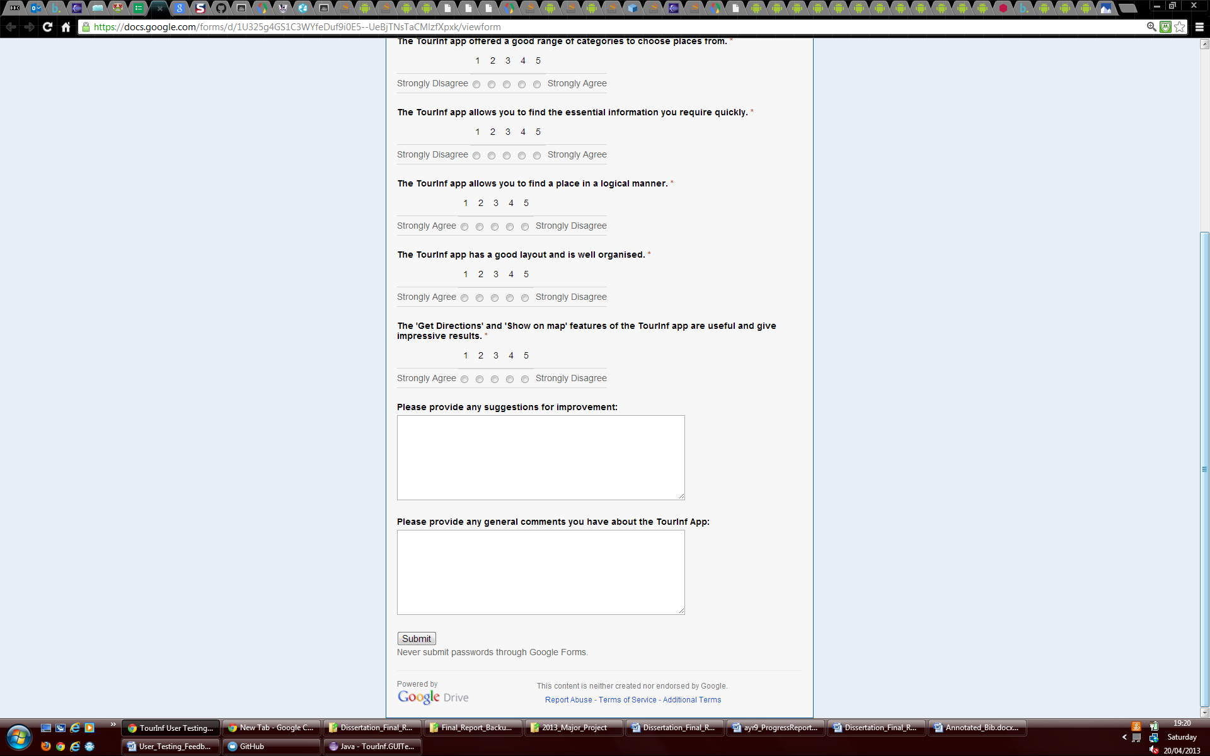

Figure E.17: The Google Form that was used as a questionnaire for potential users to fill in.

### E.4.2. Questionnaire Results

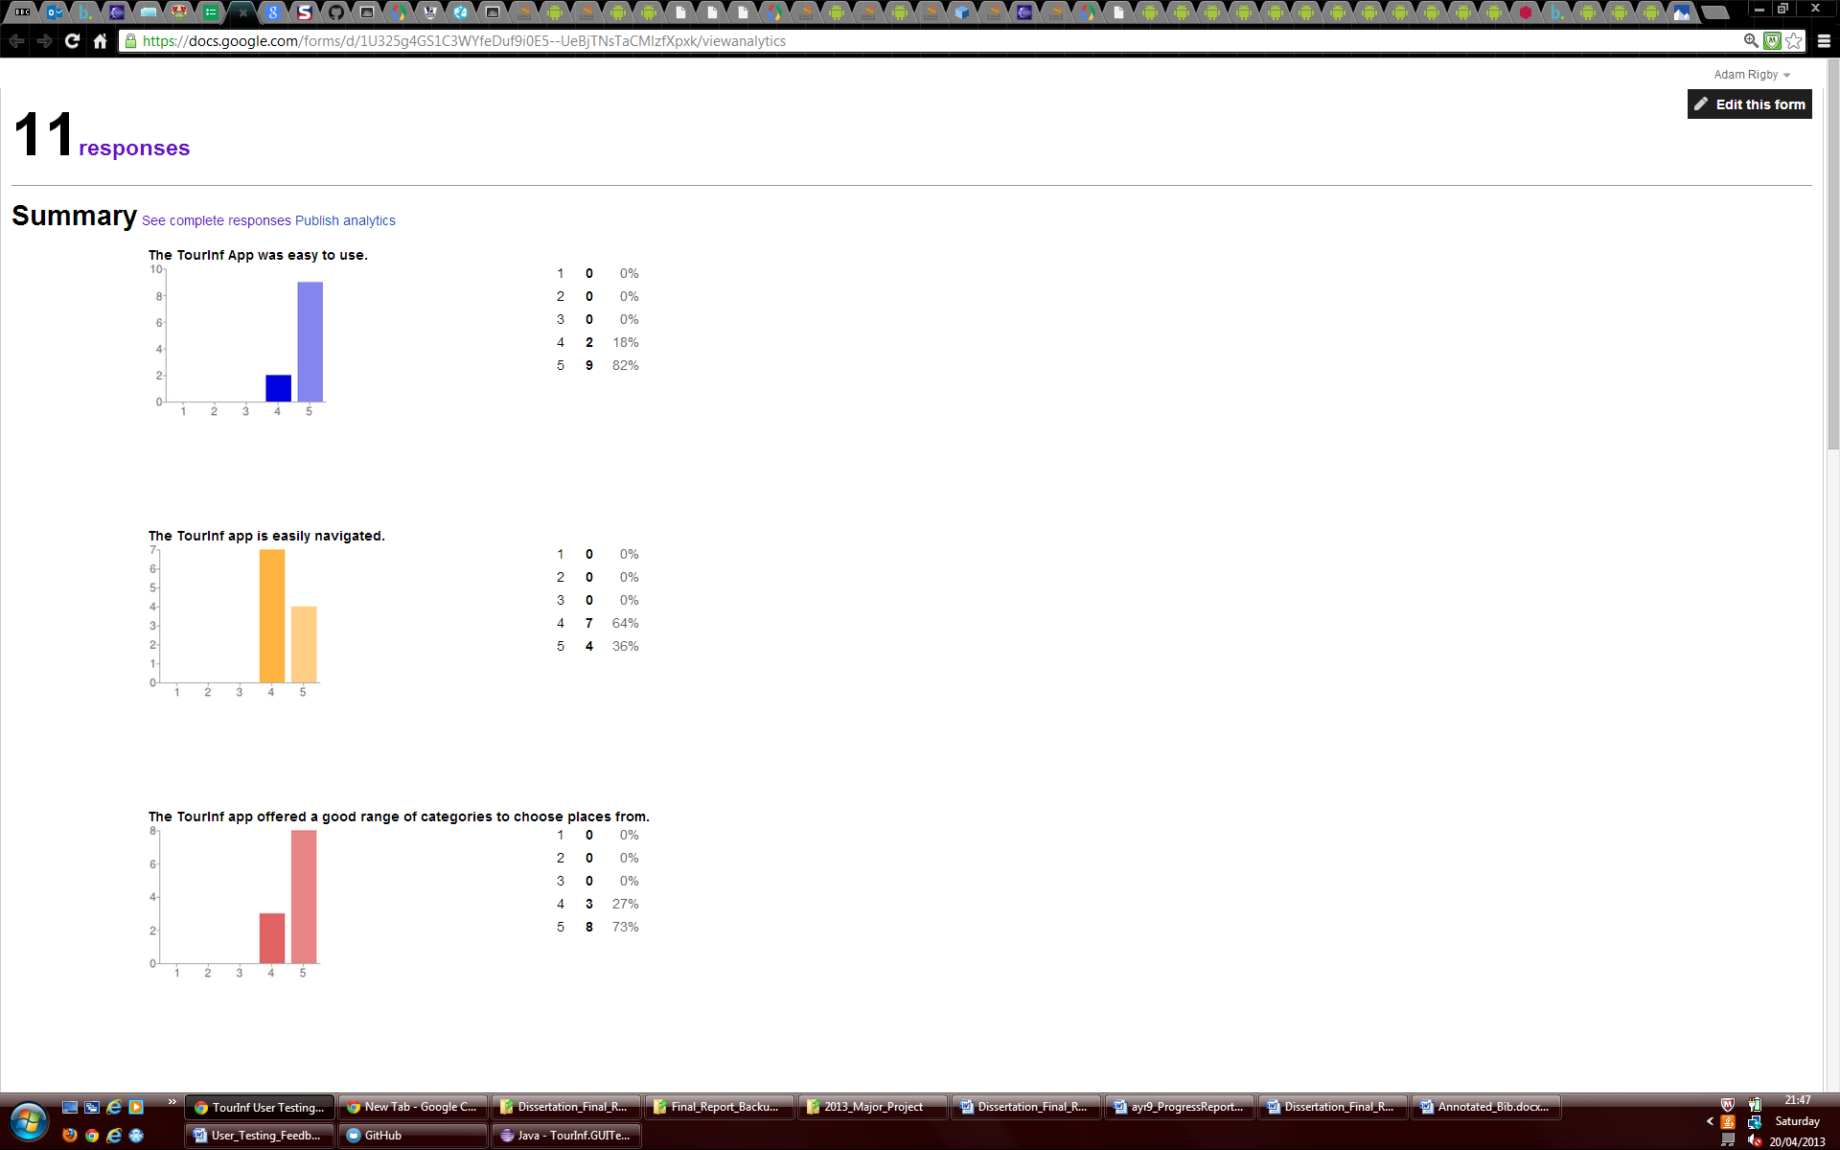

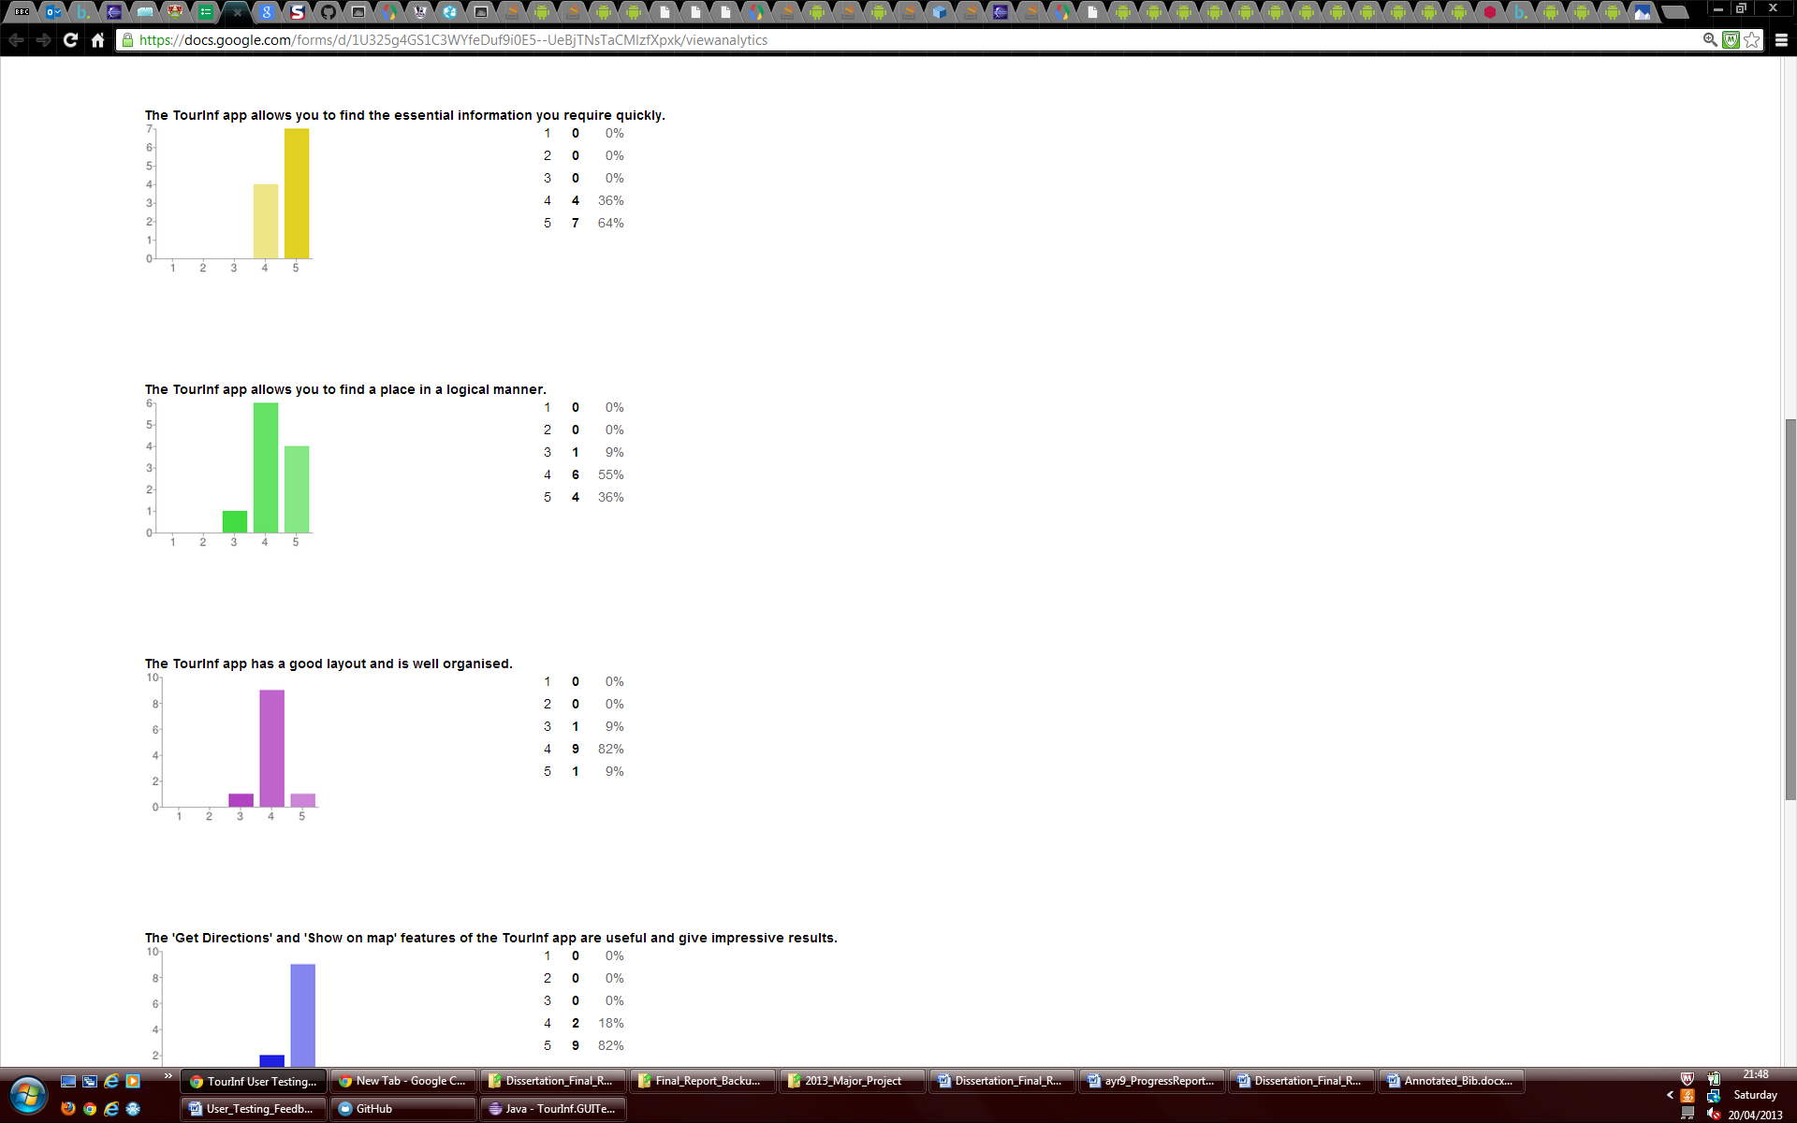

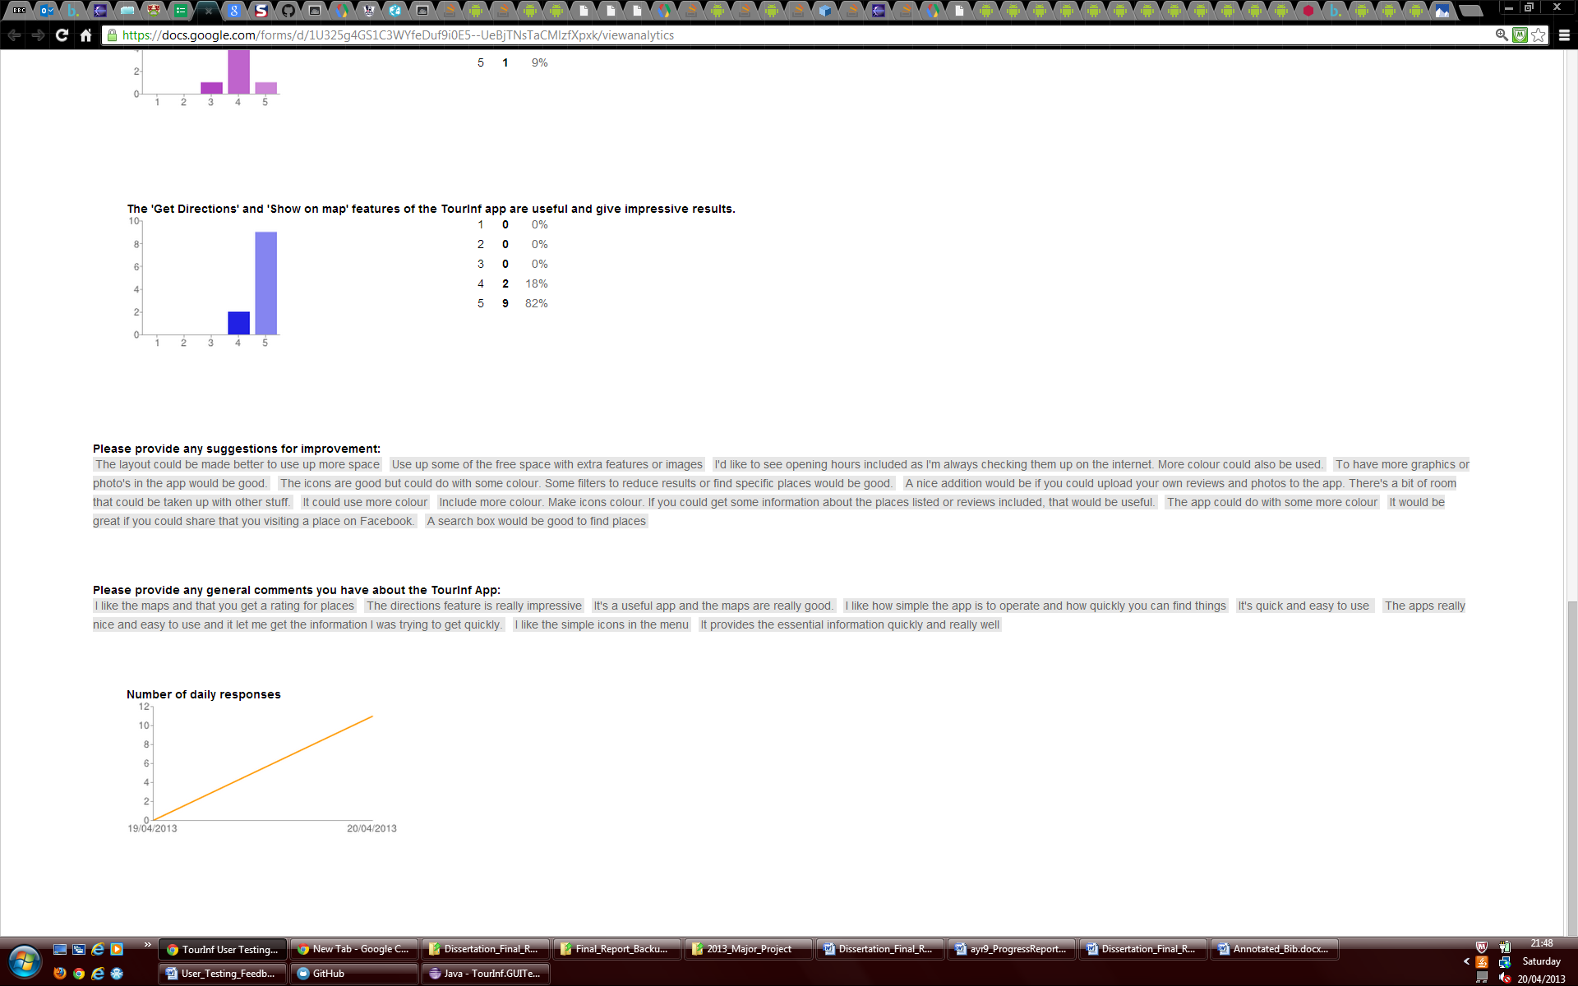

Figure E.18: The results of the Google Form questionnaire (Figure E.17) filled in.

# Annotated Bibliography

1. Google Places API. Various: <https://developers.google.com/places/documentation/>

The places search page was used to understand how nearby search request URLs needed to be formed, using the appropriate required and optional parameters. This page also improved understanding of the output in a search response, how it could be used in the application. The place details again offered the above but for detailed requests. Furthermore the place photo’s page was again evaluated and a lot was learned, how to get a photo reference and use it to make a Place photo request.

1. Google Maps Android API v2. Various: <https://developers.google.com/maps/documentation/android/>

The Google Maps for Android API was used extensively throughout the project. The getting started page was really helpful in setting up the environment needed and obtaining an API key. The map objects pages as well as the sample code the pages linked to were really useful when developing the mapping elements of the application.

1. East Riding of Yorkshire Council. Some recent evidence to support the theory that tourist information centre visitor numbers are in decline and technology is being increasingly used instead of these facilities. <http://www.eastriding.gov.uk/public_reports/TheCabinet/16March2010/Tourist%20Information%20Centres%20-%20Hornsea%20and%20Withernsea.pdf>

This article motivated me to create and develop an app that would offer the tourist information once provided by these centres in a modern format that could be used in the ‘technology age’.

1. CNET. An article which discusses how the Google Play Store is rapidly catching up with number of apps available on the apple app Store and how it could overtake it in the near future. <http://news.cnet.com/8301-1035_3-57521252-94/can-apples-app-store-maintain-its-lead-over-google-play/>

This article helped make the decision to develop for the emerging mobile platform that is Android rather than the iOS operating system

1. Google Play Store. Manchester Tourist Guide Android Application. <https://play.google.com/store/apps/details?id=com.mymobilemanchester&feature=search_result>

This application was evaluated when researching related works to the application being created.

1. Google Play Store. Pocket Britain Android Application. <https://play.google.com/store/apps/details?id=com.phonegap.pocketbritain&feature=search_result>

Another application that was evaluated when researching related works to the application being created.

1. Google Play Store. Yell Android Application. <https://play.google.com/store/apps/details?id=com.yell.launcher2&feature=top-free>

The last application that was evaluated when researching related works to the application being created.

1. GSM Arena. Mobile Device operating system market share figures for the 3rd quarter of 2012, showing iOS’ and particularly Androids dominance. <http://www.gsmarena.com/android_and_samsung_build_on_their_market_shares_in_q3_2012-news-5082.php>

This article helped make the decision to develop for the Android operating system.

1. Apple Developers. Shows that you can only develop for iOS on an Intel based Mac. [http://developer.apple.com/library/ios/#documentation/Xcode/Conceptual/ios_development_workflow/45-iOS_Development_FAQ/faq.html#//apple_ref/doc/uid/TP40007959-CH12-SW1](http://developer.apple.com/library/ios/#documentation/Xcode/Conceptual/ios_development_workflow/45-iOS_Development_FAQ/faq.html)

This resource again helped make the decision to develop for the Android operating system due to the restriction of having to use a Mac computer.

1. Wikipedia. Reveals methods of using Mac OS X on a non-Apple PC. <http://en.wikipedia.org/wiki/OSx86>

This web page helped describe how Mac OS X can be used on a non-Apple PC. This provided more evidence about why this should be something that should be avoided if possible and further supported the decision to develop for Android.

1. BBC. An article about the negative feedback and complaints made about Apple’s new Map app. <http://www.bbc.co.uk/news/technology-19659736>

This article is from the news and confirmed the notion that Apple had switched to using their own maps which were perceived as being inferior to Google Maps. This gave another reason to avoid developing for iOS as the future direction of the company with regards to mapping could not be confirmed. It was also unclear whether API for Apple’s maps would be made available, how good it would be and whether it would meet the needs of the project.

1. PC Mag. News article stating the possibility of a new Google Map app being launched for iOS 6. <http://www.pcmag.com/article2/0,2817,2412213,00.asp>

Background information on how Google Maps may still be supported on Apple devices by the use of an external app. Although the risk of developing for the iOS operating system with the hope that Google Maps would still be supported was too great.

1. The Android plugin for Net Beans. <http://kenai.com/projects/nbandroid>

The web page for an IDE that was researched when looking at development tools to use for the project.

1. IntelliJ Idea IDE with support for Android. <http://www.jetbrains.com/idea/features/android.html>

The web page for an IDE that was researched when looking at development tools to use for the project.

1. Android Developers. The Eclipse IDE with ADT was used throughout the development project. The download page that enables you to get the Eclipse IDE, Android SDK and ADT plugin: <http://developer.android.com/sdk/index.html>

This allows you to download all tools needed for Android Development in the Eclipse IDE. For this project the whole bundle wasn’t needed as the latest version of Eclipse had already been installed.

1. Android Developers. Installing the Eclipse ADT plugin. <http://developer.android.com/sdk/installing/installing-adt.html>

This tutorial shows how you can install the ADT plugin into Eclipse if you already have Eclipse installed.

1. Android Developers. ‘Building Your First App’ Android tutorial. <http://developer.android.com/training/basics/firstapp/index.html>

This resource from the Android developer’s website is a tutorial which helps create a ‘Hello World’ application and was the first app created on the project and helped show how Android projects and apps can be set up and structured.

1. Aberystwyth University. Android worksheets and presentations from workshops held by Chris Loftus and Andy Starr. <http://users.aber.ac.uk/cwl/workshop/>

These worksheets built on top of the very basic features learnt in the ‘building your first app’ tutorial from Google so that small applications could be built on the Android platform. More information on how different components work and were used together was understood.

1. GitHub. An online project hosting service where a free repository can be set up. A Windows application is also offered to make commits to your repository quicker.

<https://github.com/> and <http://windows.github.com/>

One of GitHubs free repositories was used to quickly and easily back up project work externally in the cloud. The windows application for GitHub was used to make commits to the repository quicker and easier.

1. Object Aid. A tool used to generate class diagrams automatically from source code in Eclipse. <http://www.objectaid.com/class-diagram>

This tool was used to create the class diagram for the application from the source code written for the project and can be seen in Appendix B.

1. Testdroid. The tool used to automatically test the user interface of the TourInf application. <http://testdroid.com/product/testdroid-recorder#0>

This tool allowed automatic user interface tests to be created by recordings of tests being made and then test code being automatically generated from the recording. This allowed the user interface to be tested more rigorously and independent of user opinion and error when testing.

1. Android developers. This web page details the fundamental Android application components. <http://developer.android.com/guide/components/fundamentals.html>

The page was used in initial understanding of Android development and its components. It was then further used to provide accurate definitions and explanations of components within this report.

1. Maki Icons. An open source project by MapBox. Maki is a clean point of interest icon set made for web cartography. <http://mapbox.com/maki/>

This icon set provided the images to be used to produce the main menu of the application. This set was used as the icons provided have a professional appearance, were available for free and no licensing. The images were also provided in vector format so they were easy to resize.

1. Ed Burnette, Hello, Android: Introducing Google’s Mobile Development Platform, Third Edition, for Android 2. Pragmatic bookshelf 2011.

This book was lent from a friend to research programming for Mobile Devices. Chapter 2 Key Concepts was really useful in understanding the structure and nature of Android programs. Parts of chapter 3 designing for the user interface, were useful in helping to create the user interface and helping to create it for different orientations and screen sizes (Section 13.5 also helped with this). Chapter 7 was read to find out about how intents can be used to launch web pages in a browser and how web services can be used in Android. Chapter 8 locating and sensing was also researched to find out about using devices’ inbuilt GPS. In Section 8.3, Bird’s Eye View was also read at the start of the project for mapping. Although the examples that were provided were using the old map API, the information provided still helped with learning the essentials and theory behind their use. Section 13.2 building for multiple versions also helped understand how features and methods should be checked to make sure they will be supported by multiple versions of the Android operating system to support as many devices as possible.

1. Android Developers. The strategy and theory of using Android’s Network Location Provider together with GPS to determine a user’s location. <http://developer.android.com/guide/topics/location/strategies.html>

The resource helped gain an insight into how the GPS part of the application could be built and what methods may be needed.

1. Android Developers. A training article that includes a button to download a sample location app. LocationAware.zip. <http://developer.android.com/training/basics/location/currentlocation.html>

The above sample project was downloaded to see what it produced and how it had been implemented, giving ideas to how these elements may be created in the final application.

1. Android Developers. An overview of what Grid View is on the Android Platform and how you can use it. <http://developer.android.com/guide/topics/ui/layout/gridview.html>

This resource was really helpful in setting up the basic initial grid view in the application, which formed the basis for the main menu.

1. Google Maps Android v1 API library. The original Android maps API. <https://developers.google.com/maps/documentation/android/v1/>

The news that this API had become deprecated and was being replaced by a new version was announced and seen on the above website.

1. Google Maps Android v2 API. How to install the maps API SDK and obtain a Maps API key. <https://developers.google.com/maps/documentation/android/start#installing_the_google_maps_android_v2_api>

This guide helped greatly in installing the required SDK and obtaining the Maps API key needed.

1. Google Play Services. How to install and setup the Google Play services SDK. <http://developer.android.com/google/play-services/setup.html>

This web page provided instructions on how to setup and install the Google Play services SDK.

1. Google API Console. Where settings can be allocated for Google APIs.

<https://code.google.com/apis/console/>

The Google API console was used to obtain an API key and request access to using the Google Maps Android v2 and Google Places APIs.

1. Google Map API Documentation. How to get sample code of the new maps API being used.

<https://developers.google.com/maps/documentation/android/intro#sample_code>

These instructions were used to download the sample app for the new Google Maps API.

1. AndroidHive. Android Google Places and Maps tutorial.

<http://www.androidhive.info/2012/08/android-working-with-google-places-and-maps-tutorial/>

This tutorial was followed and the majority of this 3rd party code was used to develop the Google Places aspect of the application which was then modified in areas for the finished application.

1. Google Places API documentation. The list of supported place types.

<https://developers.google.com/places/documentation/supported_types>

This list of supported types was used to know which categories could be used in the application. These type strings were then used in the application to make requests to the Google Places API, using the type associated with the category selected.

1. Android Developers. The reference page for the Geocoder API class.

<http://developer.android.com/reference/android/location/Geocoder.html>

Methods from this class were used to convert town/city names and postcodes into lat/long values inside the app so those values could be used to make a Google Places request.

1. Stack Overflow. This answer to question regarding whether directions could be got from using the standard Google Maps for Android v2 API

<http://stackoverflow.com/questions/14495030/google-map-api-v2-get-driving-directions>

The last answer to the question asked provides a solution to getting directions to be displayed on a Google map. However, this solution was very complicated and would not have produced a professional output and was therefore ignored.

1. Google Developers. The terms of service for Google Maps and Earth.

<https://developers.google.com/maps/terms>

After researching methods to get directions displayed on Android Maps it was found that there may be the possibility that Google’s terms of service would be broken by altering their maps to get the functionality programmatically. This web page was then found and read to confirm that it would indeed break their terms of service.

1. Google Developers. The terms list of intents that can be used on Android devices.

<http://developer.android.com/guide/appendix/g-app-intents.html>

This resource was read to investigate what intents can be used and sent by an application. It was then realised that the VIEW intent action for the browser could be used to show directions in a browser of a devices map app.

1. Stack Overflow. Information found on how to detect if a device can make a phone call.

<http://stackoverflow.com/questions/7429722/how-to-detect-if-device-is-capable-of-calling-and-messaging>

This post showed how to detect if a device is capable of making a phone call. By using this method, the button to make a call in the app would only be displayed if the device it was being run on was capable of making a call.

1. Android Developers. A training guide on how bitmaps should be processed on a separate thread to the user interface.

<http://developer.android.com/training/displaying-bitmaps/process-bitmap.html>

This training example was seen as an example of how to process bitmaps in a background thread using AsyncTask. It reminded the developer that BitmapFactory.decode methods should not run on the UI thread due to unpredictability in the time taken for an image to be read and loaded over a network.

1. Dibbus. A tutorial on how to change the colour of Android buttons by using 9 patch images.

<http://www.dibbus.com/2011/03/9patch-images-in-android/>

The tutorial was read and parts used. The selector XML file was used in the project, as were the blue and white matte images that were offered as no license was required.

1. Android Developers. The testing fundamentals for Android testing

<http://developer.android.com/tools/testing/testing_android.html>

This resource was read in order to gain a basic understanding of how testing for Android could be implemented and how the Android testing framework worked.

1. Gorilla Logic. The MonkeyTalk automated testing tool.

<http://www.gorillalogic.com/monkeytalk>

This automated testing tool was evaluated when trying to select a tool for usage.

1. Android Developers. Android’s own automated testing tool.

<http://developer.android.com/tools/help/monkeyrunner_concepts.html>

This automated testing tool was evaluated when trying to select a tool for usage.

1. Robotium. A test automation framework for Android.

<https://code.google.com/p/robotium/>

The Testdroid automated testing tool used in the project created Robotium test case code test cases.

1. Testdroid Cloud. A complementary tool to the Testdroid recorder.

<http://testdroid.com/product/testdroid-cloud#0>

The Testdroid Cloud allowed the automatic user interface tests that had been recorded to be run in the cloud on other devices to ensure compatibility with other devices. An app crawler test was also used to ensure views were displayed and could be navigated properly.

1. Google Drive. Where a Google Form can be created.

<https://drive.google.com/>

Google drive allowed a form to be created that could be filled as a questionnaire by potential users to complete user testing.

1. Google AdMob Ads SDK. An SDK which provides APIs that allow mobile app developers to easily display adverts in their application to monetise the app.

<https://developers.google.com/mobile-ads-sdk/>

The SDK was found when researching how to easily monetise apps with advertising.